Factors Report 20080102-20161230

**1. genticT19_0**

**截面指标累计曲线:**

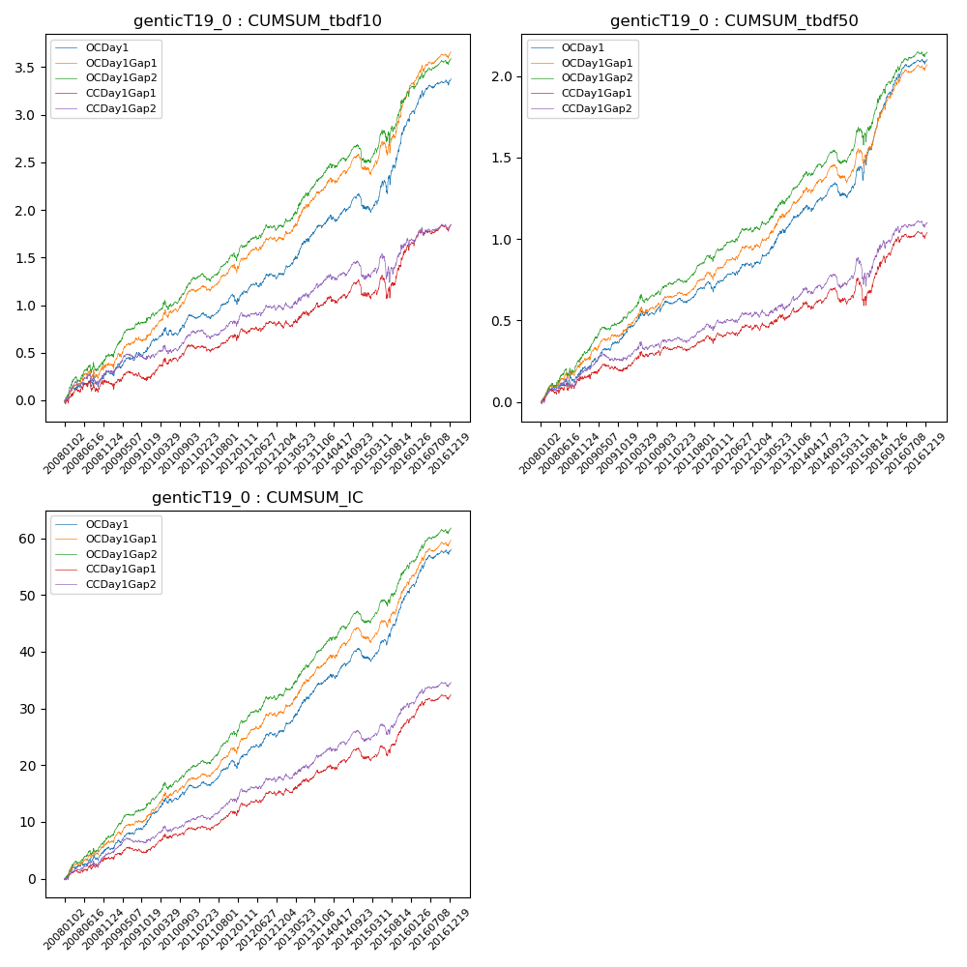

**因子换手率:** 32.86%

**截面指标_OCDay1:**

|  |  |  |  |  |  |  |  |  |
| --- | --- | --- | --- | --- | --- | --- | --- | --- |
| year | annret_tbdf10 | sharpe_tbdf10 | maxdd_tbdf10 | annret_tbdf50 | sharpe_tbdf50 | maxdd_tbdf50 | mean_IC | tstat_IC |
| 2008 | 0.3 | 1.82 | -0.11 | 0.21 | 2.57 | -0.05 | 0.02 | 3.11 |
| 2009 | 0.31 | 2.55 | -0.05 | 0.23 | 3.93 | -0.02 | 0.02 | 4.14 |
| 2010 | 0.28 | 2.56 | -0.08 | 0.17 | 2.75 | -0.03 | 0.02 | 3.37 |
| 2011 | 0.15 | 1.73 | -0.08 | 0.08 | 1.82 | -0.05 | 0.01 | 2.77 |
| 2012 | 0.3 | 2.81 | -0.06 | 0.16 | 3.0 | -0.03 | 0.03 | 3.89 |
| 2013 | 0.51 | 4.0 | -0.04 | 0.3 | 4.23 | -0.02 | 0.04 | 5.0 |
| 2014 | 0.19 | 1.57 | -0.15 | 0.13 | 1.99 | -0.08 | 0.02 | 2.81 |
| 2015 | 0.93 | 4.07 | -0.13 | 0.56 | 4.71 | -0.08 | 0.05 | 5.71 |
| 2016 | 0.44 | 3.5 | -0.06 | 0.28 | 4.04 | -0.03 | 0.03 | 4.6 |

**截面指标_CCDay1Gap1:**

|  |  |  |  |  |  |  |  |  |
| --- | --- | --- | --- | --- | --- | --- | --- | --- |
| year | annret_tbdf10 | sharpe_tbdf10 | maxdd_tbdf10 | annret_tbdf50 | sharpe_tbdf50 | maxdd_tbdf50 | mean_IC | tstat_IC |
| 2008 | 0.19 | 1.12 | -0.12 | 0.15 | 1.86 | -0.04 | 0.01 | 2.27 |
| 2009 | 0.07 | 0.53 | -0.1 | 0.07 | 1.04 | -0.04 | 0.01 | 1.34 |
| 2010 | 0.32 | 2.94 | -0.07 | 0.11 | 1.86 | -0.03 | 0.01 | 2.7 |
| 2011 | 0.06 | 0.65 | -0.07 | 0.03 | 0.7 | -0.05 | 0.01 | 1.82 |
| 2012 | 0.19 | 1.84 | -0.06 | 0.11 | 1.98 | -0.03 | 0.02 | 2.8 |
| 2013 | 0.18 | 1.4 | -0.06 | 0.09 | 1.23 | -0.04 | 0.01 | 2.09 |
| 2014 | 0.13 | 0.99 | -0.16 | 0.07 | 1.01 | -0.09 | 0.01 | 1.67 |
| 2015 | 0.49 | 2.19 | -0.22 | 0.26 | 2.06 | -0.16 | 0.03 | 3.31 |
| 2016 | 0.23 | 1.9 | -0.08 | 0.16 | 2.31 | -0.04 | 0.02 | 3.07 |

**风格暴露:**

|  |  |  |  |  |
| --- | --- | --- | --- | --- |
|  | long | short | corr_OCDay1 | corr_CCDay1Gap1 |
| liquidity10 | -0.61 | 0.58 | 0.51 | 0.57 |
| liquidity20 | -0.62 | 0.57 | 0.52 | 0.57 |
| liquidity5 | -0.63 | 0.6 | 0.51 | 0.57 |
| logmktcap | 1.21 | -1.18 | -0.64 | -0.66 |
| momentum15 | -0.03 | 0.03 | 0.05 | 0.11 |
| momentum30 | -0.01 | 0.01 | 0.04 | 0.07 |
| momentum5 | -0.09 | 0.09 | -0.01 | 0.06 |
| retvolatility30 | -0.82 | 0.75 | 0.57 | 0.59 |