Factors Report 20080102-20161230

**1. genticT19_3**

**截面指标累计曲线:**

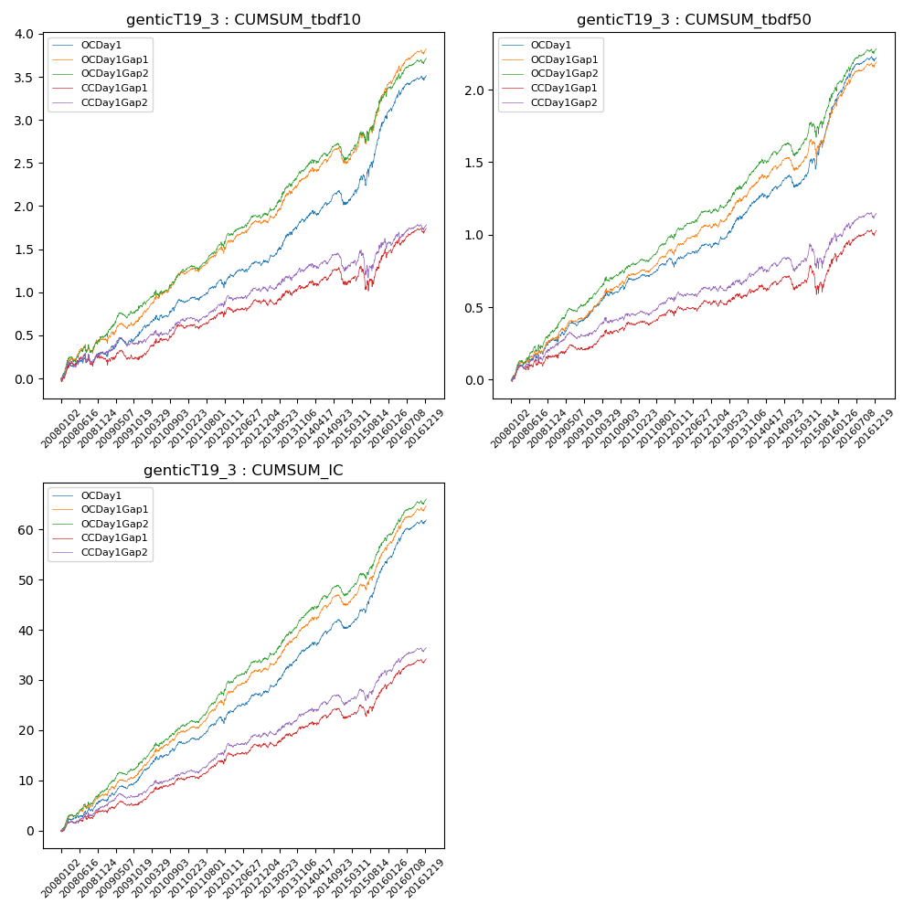

**因子换手率:** 32.1%

**截面指标_OCDay1:**

|  |  |  |  |  |  |  |  |  |
| --- | --- | --- | --- | --- | --- | --- | --- | --- |
| year | annret_tbdf10 | sharpe_tbdf10 | maxdd_tbdf10 | annret_tbdf50 | sharpe_tbdf50 | maxdd_tbdf50 | mean_IC | tstat_IC |
| 2008 | 0.29 | 1.8 | -0.13 | 0.27 | 3.43 | -0.04 | 0.02 | 3.54 |
| 2009 | 0.29 | 2.39 | -0.08 | 0.21 | 3.61 | -0.03 | 0.02 | 4.09 |
| 2010 | 0.32 | 3.03 | -0.06 | 0.21 | 3.49 | -0.03 | 0.02 | 3.96 |
| 2011 | 0.18 | 2.07 | -0.07 | 0.1 | 2.15 | -0.05 | 0.02 | 3.25 |
| 2012 | 0.28 | 2.71 | -0.05 | 0.15 | 2.7 | -0.03 | 0.02 | 3.81 |
| 2013 | 0.48 | 3.84 | -0.04 | 0.3 | 4.33 | -0.02 | 0.03 | 4.93 |
| 2014 | 0.2 | 1.62 | -0.16 | 0.11 | 1.58 | -0.08 | 0.02 | 2.74 |
| 2015 | 1.01 | 4.6 | -0.12 | 0.6 | 5.01 | -0.07 | 0.05 | 6.46 |
| 2016 | 0.49 | 3.89 | -0.06 | 0.3 | 4.26 | -0.03 | 0.03 | 5.17 |

**截面指标_CCDay1Gap1:**

|  |  |  |  |  |  |  |  |  |
| --- | --- | --- | --- | --- | --- | --- | --- | --- |
| year | annret_tbdf10 | sharpe_tbdf10 | maxdd_tbdf10 | annret_tbdf50 | sharpe_tbdf50 | maxdd_tbdf50 | mean_IC | tstat_IC |
| 2008 | 0.23 | 1.44 | -0.14 | 0.16 | 2.01 | -0.05 | 0.02 | 2.49 |
| 2009 | 0.03 | 0.24 | -0.11 | 0.07 | 1.2 | -0.04 | 0.01 | 1.61 |
| 2010 | 0.35 | 3.25 | -0.05 | 0.15 | 2.48 | -0.03 | 0.02 | 3.38 |
| 2011 | 0.11 | 1.18 | -0.06 | 0.05 | 1.12 | -0.04 | 0.01 | 2.31 |
| 2012 | 0.19 | 1.88 | -0.06 | 0.1 | 1.8 | -0.03 | 0.02 | 2.65 |
| 2013 | 0.15 | 1.12 | -0.06 | 0.07 | 0.94 | -0.04 | 0.01 | 1.99 |
| 2014 | 0.08 | 0.59 | -0.18 | 0.03 | 0.42 | -0.09 | 0.01 | 1.36 |
| 2015 | 0.34 | 1.42 | -0.26 | 0.22 | 1.63 | -0.19 | 0.03 | 2.98 |
| 2016 | 0.29 | 2.34 | -0.08 | 0.18 | 2.55 | -0.04 | 0.02 | 3.63 |

**风格暴露:**

|  |  |  |  |  |
| --- | --- | --- | --- | --- |
|  | long | short | corr_OCDay1 | corr_CCDay1Gap1 |
| liquidity10 | -0.65 | 0.62 | 0.55 | 0.61 |
| liquidity20 | -0.66 | 0.62 | 0.56 | 0.61 |
| liquidity5 | -0.67 | 0.64 | 0.55 | 0.62 |
| logmktcap | 1.22 | -1.2 | -0.66 | -0.69 |
| momentum15 | -0.05 | 0.05 | 0.05 | 0.08 |
| momentum30 | -0.05 | 0.05 | 0.05 | 0.07 |
| momentum5 | -0.08 | 0.09 | -0.01 | 0.03 |
| retvolatility30 | -0.88 | 0.81 | 0.61 | 0.64 |