Factors Report 20080102-20161230

**1. genticT19_17**

**截面指标累计曲线:**

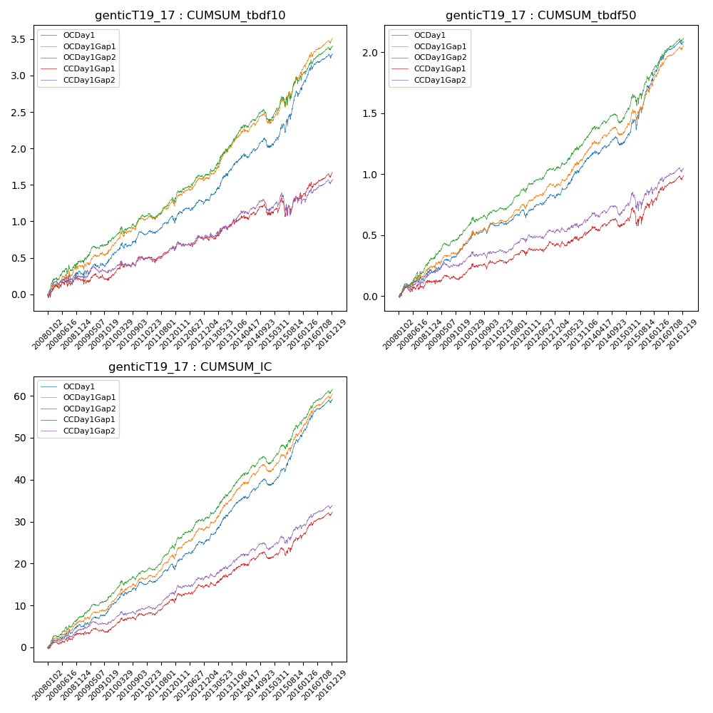

**因子换手率:** 32.28%

**截面指标_OCDay1:**

|  |  |  |  |  |  |  |  |  |
| --- | --- | --- | --- | --- | --- | --- | --- | --- |
| year | annret_tbdf10 | sharpe_tbdf10 | maxdd_tbdf10 | annret_tbdf50 | sharpe_tbdf50 | maxdd_tbdf50 | mean_IC | tstat_IC |
| 2008 | 0.31 | 1.94 | -0.1 | 0.21 | 2.72 | -0.04 | 0.02 | 3.23 |
| 2009 | 0.2 | 1.68 | -0.07 | 0.18 | 3.04 | -0.03 | 0.02 | 3.21 |
| 2010 | 0.33 | 3.09 | -0.08 | 0.19 | 3.18 | -0.04 | 0.02 | 3.62 |
| 2011 | 0.16 | 1.85 | -0.08 | 0.07 | 1.54 | -0.05 | 0.01 | 2.75 |
| 2012 | 0.29 | 2.66 | -0.06 | 0.17 | 3.14 | -0.03 | 0.03 | 4.1 |
| 2013 | 0.54 | 4.16 | -0.04 | 0.31 | 4.56 | -0.02 | 0.04 | 5.43 |
| 2014 | 0.21 | 1.81 | -0.13 | 0.11 | 1.78 | -0.07 | 0.02 | 2.73 |
| 2015 | 0.8 | 3.75 | -0.12 | 0.53 | 4.41 | -0.08 | 0.05 | 5.87 |
| 2016 | 0.49 | 3.88 | -0.06 | 0.32 | 4.52 | -0.03 | 0.04 | 5.41 |

**截面指标_CCDay1Gap1:**

|  |  |  |  |  |  |  |  |  |
| --- | --- | --- | --- | --- | --- | --- | --- | --- |
| year | annret_tbdf10 | sharpe_tbdf10 | maxdd_tbdf10 | annret_tbdf50 | sharpe_tbdf50 | maxdd_tbdf50 | mean_IC | tstat_IC |
| 2008 | 0.21 | 1.24 | -0.09 | 0.12 | 1.47 | -0.04 | 0.01 | 2.12 |
| 2009 | 0.04 | 0.32 | -0.09 | 0.05 | 0.75 | -0.04 | 0.01 | 0.97 |
| 2010 | 0.25 | 2.31 | -0.07 | 0.11 | 1.84 | -0.04 | 0.01 | 2.49 |
| 2011 | 0.1 | 1.18 | -0.06 | 0.06 | 1.21 | -0.04 | 0.01 | 2.29 |
| 2012 | 0.18 | 1.7 | -0.06 | 0.09 | 1.65 | -0.04 | 0.02 | 2.68 |
| 2013 | 0.23 | 1.65 | -0.06 | 0.1 | 1.33 | -0.04 | 0.02 | 2.46 |
| 2014 | 0.12 | 0.98 | -0.15 | 0.06 | 0.89 | -0.07 | 0.01 | 1.63 |
| 2015 | 0.23 | 1.02 | -0.23 | 0.2 | 1.54 | -0.14 | 0.02 | 2.58 |
| 2016 | 0.32 | 2.6 | -0.08 | 0.21 | 3.06 | -0.04 | 0.02 | 3.9 |

**风格暴露:**

|  |  |  |  |  |
| --- | --- | --- | --- | --- |
|  | long | short | corr_OCDay1 | corr_CCDay1Gap1 |
| liquidity10 | -0.68 | 0.55 | 0.53 | 0.59 |
| liquidity20 | -0.69 | 0.55 | 0.53 | 0.59 |
| liquidity5 | -0.7 | 0.58 | 0.53 | 0.59 |
| logmktcap | 1.25 | -1.18 | -0.64 | -0.67 |
| momentum15 | -0.03 | 0.03 | 0.03 | 0.09 |
| momentum30 | -0.02 | 0.01 | 0.02 | 0.06 |
| momentum5 | -0.09 | 0.1 | -0.02 | 0.03 |
| retvolatility30 | -0.87 | 0.7 | 0.58 | 0.6 |