Factors Report 20080102-20161230

**1. genticT20_2**

**截面指标累计曲线:**

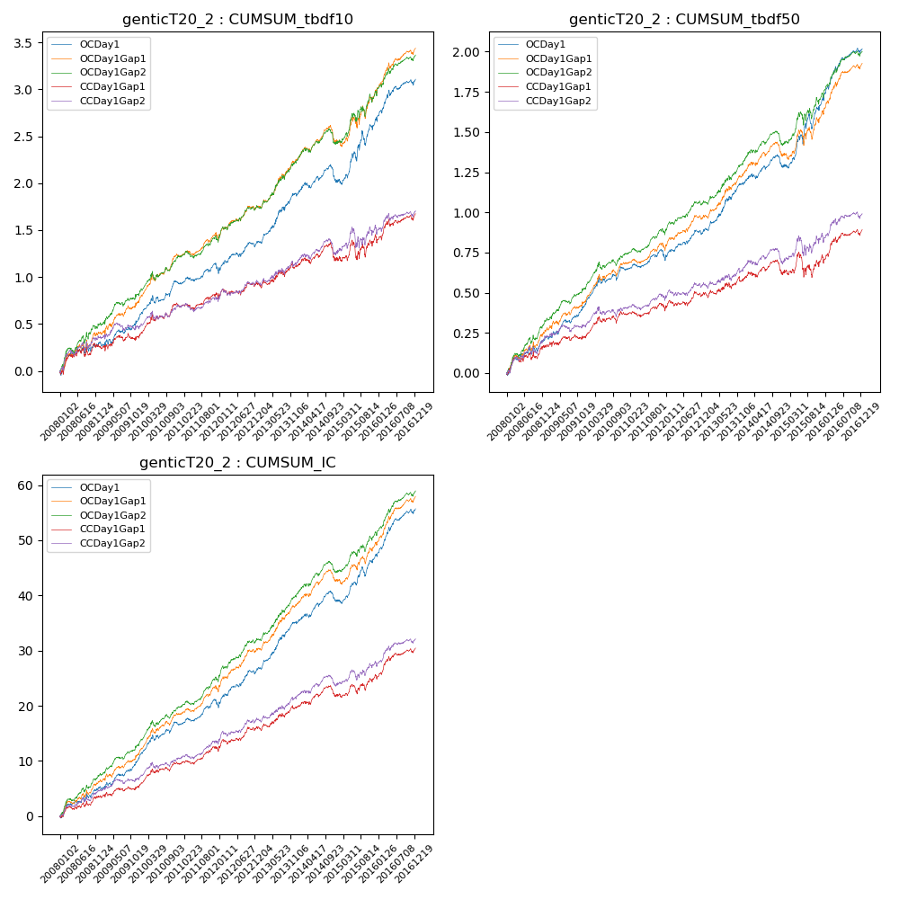

**因子换手率:** 33.17%

**截面指标_OCDay1:**

|  |  |  |  |  |  |  |  |  |
| --- | --- | --- | --- | --- | --- | --- | --- | --- |
| year | annret_tbdf10 | sharpe_tbdf10 | maxdd_tbdf10 | annret_tbdf50 | sharpe_tbdf50 | maxdd_tbdf50 | mean_IC | tstat_IC |
| 2008 | 0.3 | 1.9 | -0.09 | 0.22 | 2.86 | -0.04 | 0.02 | 3.18 |
| 2009 | 0.27 | 2.24 | -0.06 | 0.21 | 3.6 | -0.02 | 0.02 | 3.91 |
| 2010 | 0.36 | 3.24 | -0.08 | 0.21 | 3.33 | -0.04 | 0.02 | 3.89 |
| 2011 | 0.13 | 1.38 | -0.09 | 0.07 | 1.45 | -0.06 | 0.01 | 2.49 |
| 2012 | 0.31 | 2.93 | -0.05 | 0.17 | 3.16 | -0.03 | 0.03 | 4.2 |
| 2013 | 0.52 | 3.99 | -0.04 | 0.3 | 4.3 | -0.02 | 0.04 | 4.99 |
| 2014 | 0.14 | 1.19 | -0.18 | 0.1 | 1.69 | -0.08 | 0.02 | 2.52 |
| 2015 | 0.67 | 3.05 | -0.15 | 0.42 | 3.69 | -0.09 | 0.03 | 4.23 |
| 2016 | 0.44 | 3.26 | -0.06 | 0.32 | 4.46 | -0.03 | 0.03 | 4.97 |

**截面指标_CCDay1Gap1:**

|  |  |  |  |  |  |  |  |  |
| --- | --- | --- | --- | --- | --- | --- | --- | --- |
| year | annret_tbdf10 | sharpe_tbdf10 | maxdd_tbdf10 | annret_tbdf50 | sharpe_tbdf50 | maxdd_tbdf50 | mean_IC | tstat_IC |
| 2008 | 0.26 | 1.66 | -0.09 | 0.17 | 2.11 | -0.04 | 0.01 | 2.33 |
| 2009 | 0.12 | 0.96 | -0.07 | 0.07 | 1.05 | -0.03 | 0.01 | 1.5 |
| 2010 | 0.32 | 2.86 | -0.07 | 0.14 | 2.24 | -0.04 | 0.02 | 3.03 |
| 2011 | 0.07 | 0.75 | -0.07 | 0.02 | 0.35 | -0.05 | 0.01 | 1.72 |
| 2012 | 0.16 | 1.51 | -0.07 | 0.1 | 1.83 | -0.04 | 0.02 | 2.76 |
| 2013 | 0.2 | 1.41 | -0.07 | 0.09 | 1.23 | -0.04 | 0.02 | 2.24 |
| 2014 | 0.09 | 0.75 | -0.18 | 0.05 | 0.72 | -0.09 | 0.01 | 1.51 |
| 2015 | 0.22 | 1.06 | -0.19 | 0.09 | 0.77 | -0.15 | 0.01 | 1.83 |
| 2016 | 0.25 | 1.98 | -0.08 | 0.17 | 2.5 | -0.04 | 0.02 | 3.3 |

**风格暴露:**

|  |  |  |  |  |
| --- | --- | --- | --- | --- |
|  | long | short | corr_OCDay1 | corr_CCDay1Gap1 |
| liquidity10 | -0.6 | 0.56 | 0.48 | 0.53 |
| liquidity20 | -0.61 | 0.56 | 0.49 | 0.54 |
| liquidity5 | -0.63 | 0.59 | 0.48 | 0.55 |
| logmktcap | 1.19 | -1.16 | -0.61 | -0.63 |
| momentum15 | -0.03 | 0.03 | 0.06 | 0.11 |
| momentum30 | 0.0 | 0.0 | 0.05 | 0.09 |
| momentum5 | -0.08 | 0.09 | 0.02 | 0.07 |
| retvolatility30 | -0.81 | 0.72 | 0.53 | 0.54 |