Factors Report 20080102-20161230

**1. genticT20_4**

**截面指标累计曲线:**

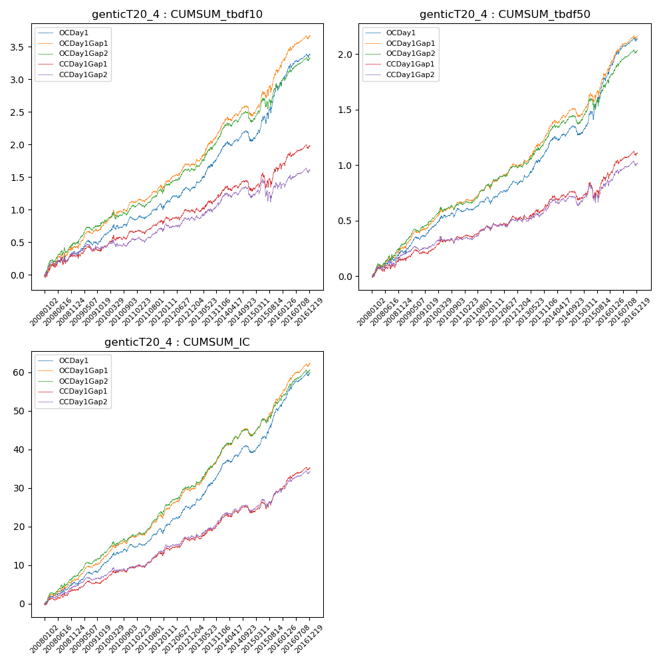

**因子换手率:** 31.7%

**截面指标_OCDay1:**

|  |  |  |  |  |  |  |  |  |
| --- | --- | --- | --- | --- | --- | --- | --- | --- |
| year | annret_tbdf10 | sharpe_tbdf10 | maxdd_tbdf10 | annret_tbdf50 | sharpe_tbdf50 | maxdd_tbdf50 | mean_IC | tstat_IC |
| 2008 | 0.35 | 2.21 | -0.09 | 0.23 | 2.89 | -0.04 | 0.02 | 3.31 |
| 2009 | 0.26 | 2.34 | -0.07 | 0.21 | 3.71 | -0.03 | 0.02 | 3.67 |
| 2010 | 0.25 | 2.41 | -0.07 | 0.16 | 2.73 | -0.04 | 0.02 | 3.16 |
| 2011 | 0.17 | 1.84 | -0.07 | 0.07 | 1.53 | -0.05 | 0.01 | 2.7 |
| 2012 | 0.3 | 2.89 | -0.06 | 0.18 | 3.41 | -0.03 | 0.03 | 4.32 |
| 2013 | 0.6 | 4.77 | -0.04 | 0.34 | 4.85 | -0.02 | 0.04 | 5.84 |
| 2014 | 0.14 | 1.17 | -0.15 | 0.1 | 1.47 | -0.08 | 0.02 | 2.45 |
| 2015 | 0.88 | 4.03 | -0.11 | 0.56 | 4.54 | -0.08 | 0.05 | 5.92 |
| 2016 | 0.46 | 3.44 | -0.06 | 0.32 | 4.28 | -0.03 | 0.04 | 5.05 |

**截面指标_CCDay1Gap1:**

|  |  |  |  |  |  |  |  |  |
| --- | --- | --- | --- | --- | --- | --- | --- | --- |
| year | annret_tbdf10 | sharpe_tbdf10 | maxdd_tbdf10 | annret_tbdf50 | sharpe_tbdf50 | maxdd_tbdf50 | mean_IC | tstat_IC |
| 2008 | 0.29 | 1.78 | -0.1 | 0.15 | 1.83 | -0.05 | 0.01 | 2.28 |
| 2009 | 0.14 | 1.24 | -0.08 | 0.09 | 1.56 | -0.04 | 0.01 | 2.14 |
| 2010 | 0.23 | 2.1 | -0.08 | 0.11 | 1.87 | -0.04 | 0.01 | 2.52 |
| 2011 | 0.12 | 1.34 | -0.07 | 0.06 | 1.32 | -0.04 | 0.01 | 2.42 |
| 2012 | 0.2 | 1.95 | -0.07 | 0.11 | 1.99 | -0.04 | 0.02 | 2.85 |
| 2013 | 0.28 | 2.05 | -0.06 | 0.15 | 1.94 | -0.04 | 0.02 | 2.96 |
| 2014 | 0.07 | 0.52 | -0.15 | 0.03 | 0.47 | -0.08 | 0.01 | 1.31 |
| 2015 | 0.37 | 1.62 | -0.21 | 0.22 | 1.72 | -0.14 | 0.02 | 2.94 |
| 2016 | 0.3 | 2.26 | -0.07 | 0.2 | 2.74 | -0.04 | 0.02 | 3.62 |

**风格暴露:**

|  |  |  |  |  |
| --- | --- | --- | --- | --- |
|  | long | short | corr_OCDay1 | corr_CCDay1Gap1 |
| liquidity10 | -0.71 | 0.57 | 0.55 | 0.6 |
| liquidity20 | -0.73 | 0.58 | 0.56 | 0.6 |
| liquidity5 | -0.72 | 0.59 | 0.54 | 0.6 |
| logmktcap | 1.27 | -1.2 | -0.68 | -0.69 |
| momentum15 | -0.02 | 0.02 | 0.03 | 0.08 |
| momentum30 | -0.02 | 0.01 | 0.03 | 0.06 |
| momentum5 | -0.07 | 0.08 | -0.04 | 0.01 |
| retvolatility30 | -0.93 | 0.76 | 0.61 | 0.62 |