Factors Report 20080102-20161230

**1. genticT20_16**

**截面指标累计曲线:**

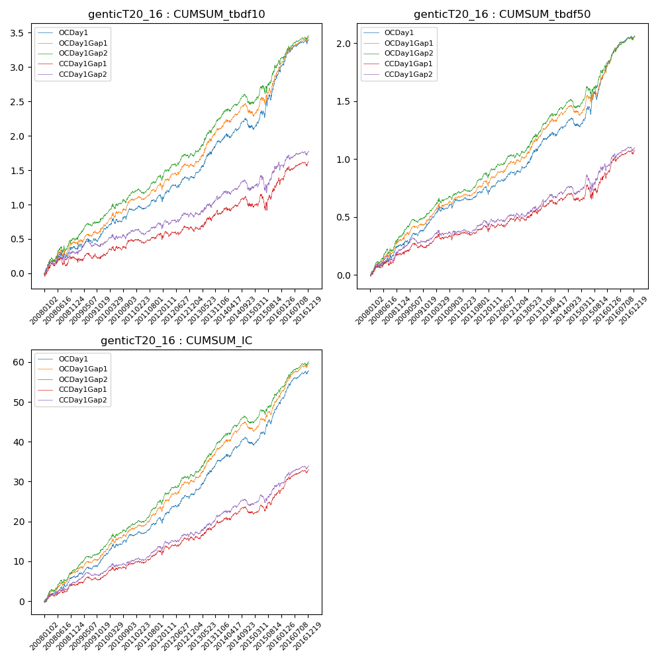

**因子换手率:** 33.12%

**截面指标_OCDay1:**

|  |  |  |  |  |  |  |  |  |
| --- | --- | --- | --- | --- | --- | --- | --- | --- |
| year | annret_tbdf10 | sharpe_tbdf10 | maxdd_tbdf10 | annret_tbdf50 | sharpe_tbdf50 | maxdd_tbdf50 | mean_IC | tstat_IC |
| 2008 | 0.37 | 2.38 | -0.09 | 0.25 | 3.29 | -0.03 | 0.03 | 3.69 |
| 2009 | 0.25 | 2.14 | -0.06 | 0.2 | 3.46 | -0.03 | 0.02 | 3.62 |
| 2010 | 0.3 | 2.9 | -0.08 | 0.19 | 3.04 | -0.04 | 0.02 | 3.69 |
| 2011 | 0.14 | 1.6 | -0.08 | 0.07 | 1.45 | -0.05 | 0.01 | 2.55 |
| 2012 | 0.34 | 3.21 | -0.06 | 0.18 | 3.34 | -0.03 | 0.03 | 4.35 |
| 2013 | 0.51 | 4.03 | -0.04 | 0.29 | 4.07 | -0.02 | 0.03 | 4.91 |
| 2014 | 0.22 | 1.81 | -0.14 | 0.12 | 1.91 | -0.07 | 0.02 | 2.83 |
| 2015 | 0.83 | 3.85 | -0.1 | 0.48 | 4.02 | -0.07 | 0.04 | 4.9 |
| 2016 | 0.46 | 3.58 | -0.06 | 0.3 | 4.42 | -0.03 | 0.03 | 5.08 |

**截面指标_CCDay1Gap1:**

|  |  |  |  |  |  |  |  |  |
| --- | --- | --- | --- | --- | --- | --- | --- | --- |
| year | annret_tbdf10 | sharpe_tbdf10 | maxdd_tbdf10 | annret_tbdf50 | sharpe_tbdf50 | maxdd_tbdf50 | mean_IC | tstat_IC |
| 2008 | 0.22 | 1.33 | -0.13 | 0.18 | 2.32 | -0.04 | 0.02 | 2.69 |
| 2009 | 0.05 | 0.39 | -0.09 | 0.09 | 1.45 | -0.04 | 0.01 | 1.64 |
| 2010 | 0.22 | 2.03 | -0.06 | 0.09 | 1.4 | -0.05 | 0.01 | 2.5 |
| 2011 | 0.01 | 0.09 | -0.09 | 0.02 | 0.37 | -0.06 | 0.01 | 1.61 |
| 2012 | 0.16 | 1.56 | -0.08 | 0.12 | 2.13 | -0.03 | 0.02 | 2.8 |
| 2013 | 0.21 | 1.53 | -0.07 | 0.11 | 1.44 | -0.04 | 0.02 | 2.31 |
| 2014 | 0.15 | 1.22 | -0.14 | 0.06 | 0.98 | -0.06 | 0.01 | 1.74 |
| 2015 | 0.34 | 1.53 | -0.22 | 0.21 | 1.71 | -0.12 | 0.02 | 2.69 |
| 2016 | 0.28 | 2.25 | -0.07 | 0.21 | 3.04 | -0.04 | 0.02 | 3.66 |

**风格暴露:**

|  |  |  |  |  |
| --- | --- | --- | --- | --- |
|  | long | short | corr_OCDay1 | corr_CCDay1Gap1 |
| liquidity10 | -0.6 | 0.57 | 0.5 | 0.56 |
| liquidity20 | -0.61 | 0.57 | 0.51 | 0.56 |
| liquidity5 | -0.62 | 0.59 | 0.49 | 0.55 |
| logmktcap | 1.17 | -1.14 | -0.6 | -0.63 |
| momentum15 | -0.01 | 0.01 | 0.03 | 0.09 |
| momentum30 | 0.01 | -0.0 | 0.02 | 0.04 |
| momentum5 | -0.07 | 0.08 | -0.01 | 0.05 |
| retvolatility30 | -0.81 | 0.76 | 0.56 | 0.58 |