Factors Report 20080102-20161230

**1. genticT11_19**

**截面指标累计曲线:**

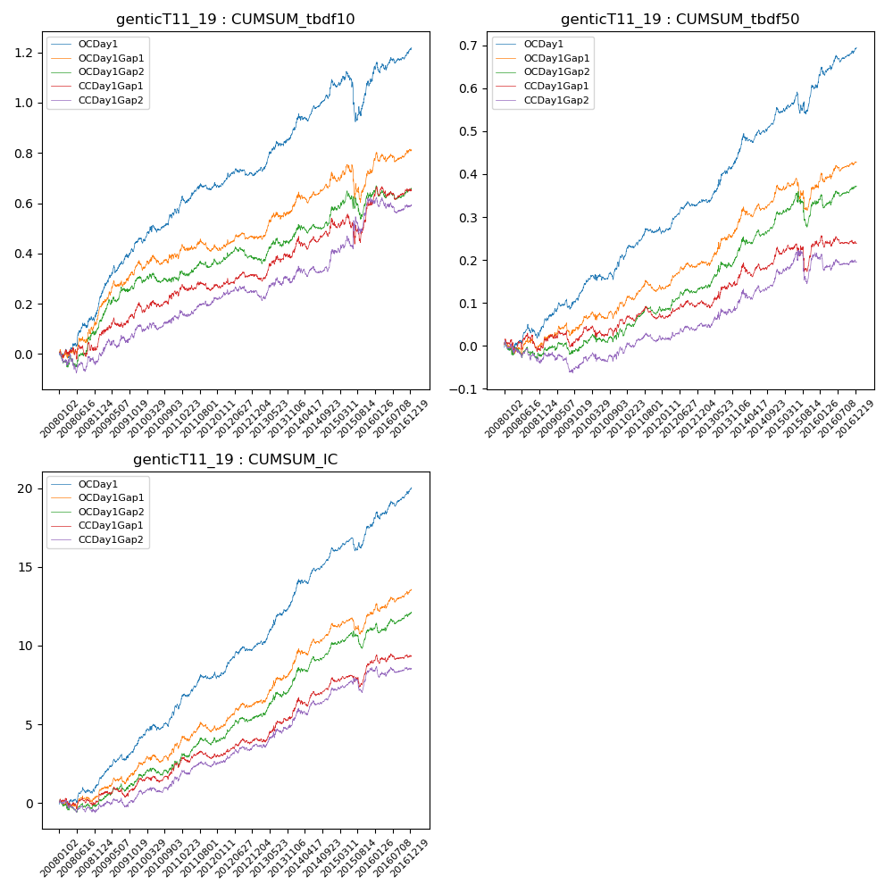

**因子换手率:** 25.01%

**截面指标_OCDay1:**

|  |  |  |  |  |  |  |  |  |
| --- | --- | --- | --- | --- | --- | --- | --- | --- |
| year | annret_tbdf10 | sharpe_tbdf10 | maxdd_tbdf10 | annret_tbdf50 | sharpe_tbdf50 | maxdd_tbdf50 | mean_IC | tstat_IC |
| 2008 | 0.2 | 2.86 | -0.03 | 0.05 | 1.31 | -0.03 | 0.01 | 1.83 |
| 2009 | 0.25 | 4.22 | -0.03 | 0.08 | 2.85 | -0.02 | 0.01 | 4.12 |
| 2010 | 0.13 | 2.39 | -0.03 | 0.08 | 2.45 | -0.02 | 0.01 | 3.36 |
| 2011 | 0.09 | 1.93 | -0.03 | 0.05 | 2.28 | -0.01 | 0.01 | 2.55 |
| 2012 | 0.05 | 1.17 | -0.03 | 0.07 | 3.37 | -0.01 | 0.01 | 3.53 |
| 2013 | 0.18 | 3.44 | -0.02 | 0.12 | 3.64 | -0.01 | 0.01 | 4.38 |
| 2014 | 0.18 | 3.26 | -0.03 | 0.1 | 3.36 | -0.02 | 0.01 | 4.15 |
| 2015 | 0.01 | 0.11 | -0.18 | 0.05 | 1.18 | -0.05 | 0.01 | 2.06 |
| 2016 | 0.13 | 2.4 | -0.04 | 0.09 | 3.15 | -0.02 | 0.01 | 3.59 |

**截面指标_CCDay1Gap1:**

|  |  |  |  |  |  |  |  |  |
| --- | --- | --- | --- | --- | --- | --- | --- | --- |
| year | annret_tbdf10 | sharpe_tbdf10 | maxdd_tbdf10 | annret_tbdf50 | sharpe_tbdf50 | maxdd_tbdf50 | mean_IC | tstat_IC |
| 2008 | 0.06 | 0.77 | -0.05 | 0.0 | 0.06 | -0.04 | 0.0 | 0.38 |
| 2009 | 0.14 | 2.3 | -0.04 | 0.03 | 0.98 | -0.04 | 0.0 | 1.87 |
| 2010 | 0.05 | 0.94 | -0.04 | 0.03 | 0.96 | -0.03 | 0.0 | 1.91 |
| 2011 | 0.02 | 0.5 | -0.03 | 0.0 | 0.1 | -0.03 | 0.0 | 0.6 |
| 2012 | 0.04 | 1.03 | -0.03 | 0.04 | 1.74 | -0.02 | 0.0 | 2.2 |
| 2013 | 0.09 | 1.67 | -0.03 | 0.06 | 1.73 | -0.02 | 0.01 | 2.39 |
| 2014 | 0.11 | 1.77 | -0.05 | 0.06 | 1.9 | -0.03 | 0.01 | 2.8 |
| 2015 | 0.08 | 0.73 | -0.12 | 0.02 | 0.32 | -0.06 | 0.0 | 1.55 |
| 2016 | 0.06 | 1.08 | -0.05 | 0.0 | 0.08 | -0.03 | 0.0 | 0.71 |

**风格暴露:**

|  |  |  |  |  |
| --- | --- | --- | --- | --- |
|  | long | short | corr_OCDay1 | corr_CCDay1Gap1 |
| liquidity10 | -0.35 | 0.29 | 0.53 | 0.55 |
| liquidity20 | -0.37 | 0.32 | 0.52 | 0.56 |
| liquidity5 | -0.3 | 0.26 | 0.51 | 0.52 |
| logmktcap | 0.01 | -0.01 | -0.12 | -0.22 |
| momentum15 | -0.2 | 0.19 | 0.28 | 0.26 |
| momentum30 | -0.33 | 0.31 | 0.37 | 0.39 |
| momentum5 | -0.0 | 0.01 | 0.1 | 0.07 |
| retvolatility30 | -0.46 | 0.4 | 0.46 | 0.51 |