Factors Report 20080102-20161230

**1. genticT13_3**

**截面指标累计曲线:**

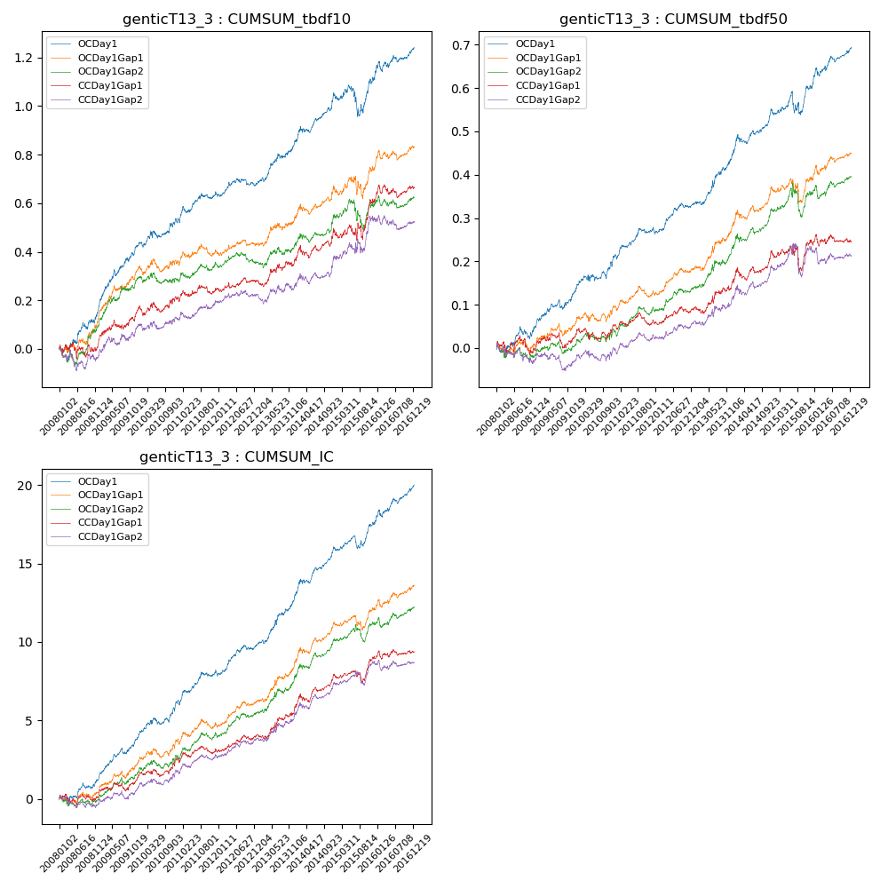

**因子换手率:** 24.99%

**截面指标_OCDay1:**

|  |  |  |  |  |  |  |  |  |
| --- | --- | --- | --- | --- | --- | --- | --- | --- |
| year | annret_tbdf10 | sharpe_tbdf10 | maxdd_tbdf10 | annret_tbdf50 | sharpe_tbdf50 | maxdd_tbdf50 | mean_IC | tstat_IC |
| 2008 | 0.18 | 2.54 | -0.03 | 0.05 | 1.44 | -0.03 | 0.01 | 1.91 |
| 2009 | 0.25 | 4.23 | -0.03 | 0.08 | 2.81 | -0.02 | 0.01 | 4.3 |
| 2010 | 0.11 | 1.97 | -0.03 | 0.08 | 2.5 | -0.02 | 0.01 | 3.16 |
| 2011 | 0.1 | 2.07 | -0.03 | 0.05 | 2.22 | -0.01 | 0.01 | 2.45 |
| 2012 | 0.05 | 1.13 | -0.03 | 0.07 | 3.14 | -0.01 | 0.01 | 3.39 |
| 2013 | 0.18 | 3.49 | -0.02 | 0.12 | 3.68 | -0.01 | 0.01 | 4.33 |
| 2014 | 0.18 | 3.26 | -0.03 | 0.1 | 3.32 | -0.02 | 0.01 | 4.21 |
| 2015 | 0.07 | 0.75 | -0.12 | 0.05 | 1.2 | -0.05 | 0.01 | 2.2 |
| 2016 | 0.13 | 2.34 | -0.04 | 0.1 | 3.19 | -0.02 | 0.01 | 3.65 |

**截面指标_CCDay1Gap1:**

|  |  |  |  |  |  |  |  |  |
| --- | --- | --- | --- | --- | --- | --- | --- | --- |
| year | annret_tbdf10 | sharpe_tbdf10 | maxdd_tbdf10 | annret_tbdf50 | sharpe_tbdf50 | maxdd_tbdf50 | mean_IC | tstat_IC |
| 2008 | 0.04 | 0.48 | -0.07 | 0.0 | 0.06 | -0.04 | 0.0 | 0.38 |
| 2009 | 0.14 | 2.22 | -0.04 | 0.03 | 1.01 | -0.04 | 0.01 | 2.08 |
| 2010 | 0.04 | 0.76 | -0.04 | 0.02 | 0.71 | -0.03 | 0.0 | 1.76 |
| 2011 | 0.03 | 0.68 | -0.04 | 0.0 | 0.0 | -0.03 | 0.0 | 0.62 |
| 2012 | 0.04 | 0.89 | -0.02 | 0.04 | 1.77 | -0.02 | 0.0 | 2.05 |
| 2013 | 0.09 | 1.5 | -0.03 | 0.06 | 1.84 | -0.02 | 0.01 | 2.41 |
| 2014 | 0.1 | 1.7 | -0.05 | 0.06 | 1.98 | -0.03 | 0.01 | 2.8 |
| 2015 | 0.13 | 1.43 | -0.07 | 0.03 | 0.52 | -0.06 | 0.0 | 1.6 |
| 2016 | 0.06 | 1.12 | -0.05 | 0.0 | 0.12 | -0.03 | 0.0 | 0.7 |

**风格暴露:**

|  |  |  |  |  |
| --- | --- | --- | --- | --- |
|  | long | short | corr_OCDay1 | corr_CCDay1Gap1 |
| liquidity10 | -0.35 | 0.29 | 0.52 | 0.53 |
| liquidity20 | -0.37 | 0.32 | 0.52 | 0.54 |
| liquidity5 | -0.3 | 0.26 | 0.51 | 0.51 |
| logmktcap | 0.01 | -0.01 | -0.1 | -0.16 |
| momentum15 | -0.2 | 0.2 | 0.28 | 0.29 |
| momentum30 | -0.33 | 0.31 | 0.37 | 0.41 |
| momentum5 | -0.0 | 0.01 | 0.1 | 0.08 |
| retvolatility30 | -0.46 | 0.4 | 0.45 | 0.47 |