Factors Report 20080102-20161230

**1. maqiuhaoC62**

**截面指标累计曲线:**

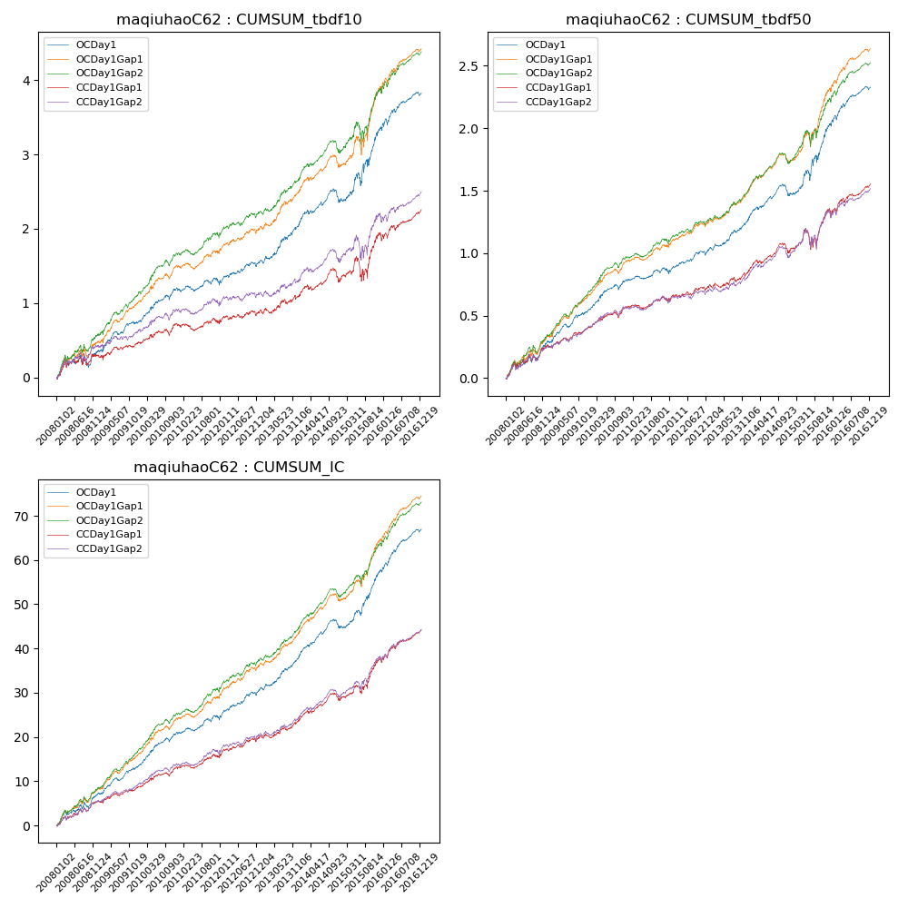

**因子换手率:** 31.04%

**截面指标_OCDay1:**

|  |  |  |  |  |  |  |  |  |
| --- | --- | --- | --- | --- | --- | --- | --- | --- |
| year | annret_tbdf10 | sharpe_tbdf10 | maxdd_tbdf10 | annret_tbdf50 | sharpe_tbdf50 | maxdd_tbdf50 | mean_IC | tstat_IC |
| 2008 | 0.35 | 1.82 | -0.17 | 0.29 | 3.24 | -0.05 | 0.03 | 3.69 |
| 2009 | 0.4 | 3.52 | -0.05 | 0.25 | 4.27 | -0.03 | 0.03 | 4.77 |
| 2010 | 0.45 | 3.83 | -0.06 | 0.26 | 4.26 | -0.04 | 0.03 | 4.98 |
| 2011 | 0.08 | 0.83 | -0.07 | 0.06 | 1.26 | -0.04 | 0.01 | 2.31 |
| 2012 | 0.28 | 2.52 | -0.06 | 0.18 | 3.26 | -0.03 | 0.03 | 4.0 |
| 2013 | 0.54 | 3.92 | -0.05 | 0.26 | 3.98 | -0.02 | 0.03 | 4.73 |
| 2014 | 0.29 | 2.29 | -0.17 | 0.18 | 2.95 | -0.09 | 0.03 | 3.94 |
| 2015 | 0.99 | 3.5 | -0.17 | 0.57 | 4.16 | -0.08 | 0.05 | 5.37 |
| 2016 | 0.48 | 3.37 | -0.08 | 0.3 | 4.2 | -0.03 | 0.04 | 5.49 |

**截面指标_CCDay1Gap1:**

|  |  |  |  |  |  |  |  |  |
| --- | --- | --- | --- | --- | --- | --- | --- | --- |
| year | annret_tbdf10 | sharpe_tbdf10 | maxdd_tbdf10 | annret_tbdf50 | sharpe_tbdf50 | maxdd_tbdf50 | mean_IC | tstat_IC |
| 2008 | 0.29 | 1.61 | -0.12 | 0.26 | 2.91 | -0.05 | 0.02 | 3.12 |
| 2009 | 0.18 | 1.51 | -0.07 | 0.14 | 2.51 | -0.03 | 0.01 | 2.82 |
| 2010 | 0.24 | 2.15 | -0.08 | 0.17 | 2.92 | -0.05 | 0.02 | 3.36 |
| 2011 | 0.01 | 0.07 | -0.09 | 0.04 | 0.73 | -0.04 | 0.01 | 1.54 |
| 2012 | 0.16 | 1.42 | -0.07 | 0.12 | 2.17 | -0.03 | 0.02 | 2.96 |
| 2013 | 0.23 | 1.64 | -0.07 | 0.13 | 1.85 | -0.04 | 0.02 | 2.5 |
| 2014 | 0.21 | 1.53 | -0.18 | 0.16 | 2.46 | -0.08 | 0.02 | 3.0 |
| 2015 | 0.6 | 1.95 | -0.29 | 0.32 | 2.04 | -0.16 | 0.04 | 3.69 |
| 2016 | 0.35 | 2.47 | -0.08 | 0.22 | 3.08 | -0.04 | 0.03 | 4.29 |

**风格暴露:**

|  |  |  |  |  |
| --- | --- | --- | --- | --- |
|  | long | short | corr_OCDay1 | corr_CCDay1Gap1 |
| liquidity10 | -0.72 | 0.7 | 0.59 | 0.63 |
| liquidity20 | -0.74 | 0.72 | 0.62 | 0.64 |
| liquidity5 | -0.73 | 0.71 | 0.58 | 0.62 |
| logmktcap | 1.67 | -1.65 | -0.79 | -0.81 |
| momentum15 | 0.0 | -0.0 | -0.02 | 0.01 |
| momentum30 | 0.05 | -0.05 | -0.01 | -0.01 |
| momentum5 | -0.07 | 0.08 | -0.09 | -0.02 |
| retvolatility30 | -0.77 | 0.74 | 0.64 | 0.68 |