Factors Report 20080102-20161230

**1. genticT2_10**

**截面指标累计曲线:**

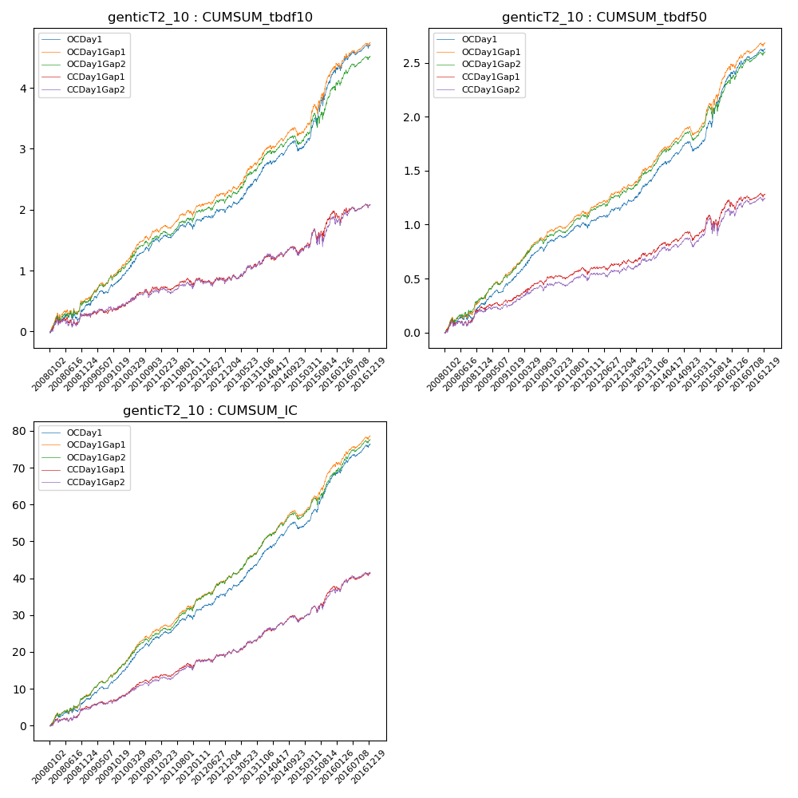

**因子换手率:** 27.77%

**截面指标_OCDay1:**

|  |  |  |  |  |  |  |  |  |
| --- | --- | --- | --- | --- | --- | --- | --- | --- |
| year | annret_tbdf10 | sharpe_tbdf10 | maxdd_tbdf10 | annret_tbdf50 | sharpe_tbdf50 | maxdd_tbdf50 | mean_IC | tstat_IC |
| 2008 | 0.43 | 2.11 | -0.14 | 0.25 | 2.82 | -0.06 | 0.03 | 3.49 |
| 2009 | 0.45 | 3.75 | -0.05 | 0.27 | 4.48 | -0.03 | 0.03 | 5.18 |
| 2010 | 0.66 | 5.14 | -0.07 | 0.34 | 5.15 | -0.04 | 0.04 | 6.04 |
| 2011 | 0.18 | 1.64 | -0.09 | 0.12 | 2.28 | -0.04 | 0.02 | 3.23 |
| 2012 | 0.33 | 2.6 | -0.06 | 0.2 | 3.31 | -0.03 | 0.03 | 4.2 |
| 2013 | 0.68 | 4.46 | -0.04 | 0.34 | 4.72 | -0.02 | 0.04 | 5.52 |
| 2014 | 0.28 | 2.05 | -0.16 | 0.17 | 2.56 | -0.09 | 0.03 | 3.88 |
| 2015 | 1.31 | 4.65 | -0.13 | 0.7 | 5.32 | -0.07 | 0.06 | 6.4 |
| 2016 | 0.44 | 2.6 | -0.08 | 0.25 | 3.02 | -0.03 | 0.03 | 4.15 |

**截面指标_CCDay1Gap1:**

|  |  |  |  |  |  |  |  |  |
| --- | --- | --- | --- | --- | --- | --- | --- | --- |
| year | annret_tbdf10 | sharpe_tbdf10 | maxdd_tbdf10 | annret_tbdf50 | sharpe_tbdf50 | maxdd_tbdf50 | mean_IC | tstat_IC |
| 2008 | 0.29 | 1.48 | -0.14 | 0.23 | 2.52 | -0.06 | 0.02 | 2.77 |
| 2009 | 0.12 | 0.95 | -0.07 | 0.1 | 1.69 | -0.04 | 0.01 | 2.22 |
| 2010 | 0.33 | 2.54 | -0.09 | 0.19 | 2.97 | -0.04 | 0.02 | 3.77 |
| 2011 | 0.0 | 0.0 | -0.13 | 0.01 | 0.21 | -0.07 | 0.01 | 1.31 |
| 2012 | 0.14 | 1.05 | -0.11 | 0.12 | 1.83 | -0.04 | 0.02 | 2.51 |
| 2013 | 0.32 | 1.96 | -0.07 | 0.14 | 1.78 | -0.03 | 0.02 | 2.9 |
| 2014 | 0.12 | 0.86 | -0.14 | 0.08 | 1.23 | -0.08 | 0.01 | 2.18 |
| 2015 | 0.64 | 2.14 | -0.22 | 0.34 | 2.24 | -0.14 | 0.04 | 3.76 |
| 2016 | 0.14 | 0.83 | -0.15 | 0.07 | 0.88 | -0.07 | 0.02 | 2.07 |

**风格暴露:**

|  |  |  |  |  |
| --- | --- | --- | --- | --- |
|  | long | short | corr_OCDay1 | corr_CCDay1Gap1 |
| liquidity10 | -0.96 | 0.96 | 0.66 | 0.69 |
| liquidity20 | -1.0 | 1.0 | 0.69 | 0.7 |
| liquidity5 | -0.97 | 0.97 | 0.65 | 0.68 |
| logmktcap | 1.62 | -1.61 | -0.78 | -0.8 |
| momentum15 | -0.02 | 0.02 | -0.02 | -0.0 |
| momentum30 | -0.04 | 0.04 | 0.03 | 0.0 |
| momentum5 | -0.05 | 0.06 | -0.08 | -0.04 |
| retvolatility30 | -1.07 | 1.07 | 0.71 | 0.72 |