Factors Report 20080102-20161230

**1. genticT4_9**

**截面指标累计曲线:**

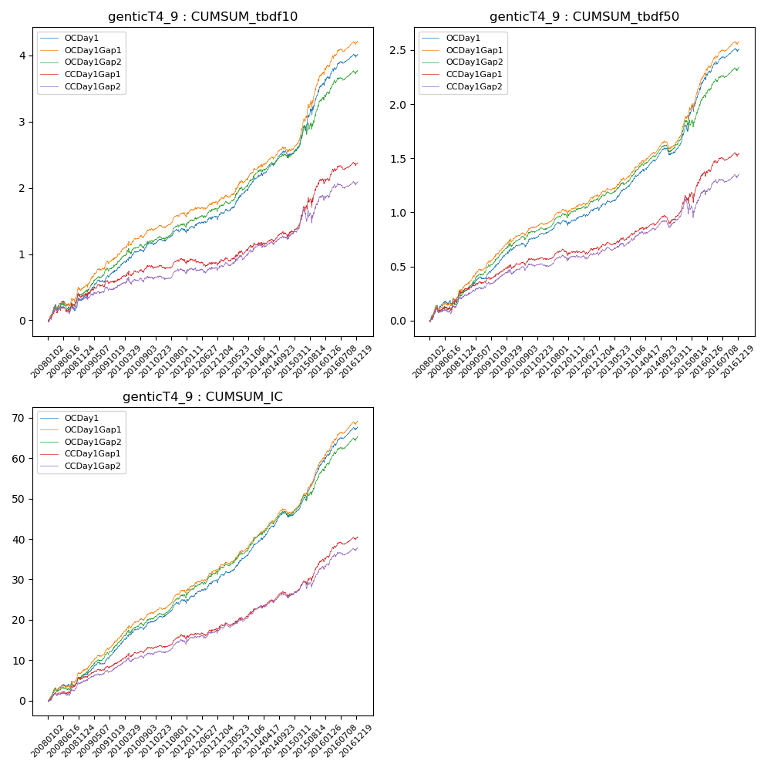

**因子换手率:** 30.4%

**截面指标_OCDay1:**

|  |  |  |  |  |  |  |  |  |
| --- | --- | --- | --- | --- | --- | --- | --- | --- |
| year | annret_tbdf10 | sharpe_tbdf10 | maxdd_tbdf10 | annret_tbdf50 | sharpe_tbdf50 | maxdd_tbdf50 | mean_IC | tstat_IC |
| 2008 | 0.34 | 2.21 | -0.14 | 0.28 | 3.46 | -0.05 | 0.03 | 3.57 |
| 2009 | 0.44 | 4.01 | -0.04 | 0.25 | 4.43 | -0.02 | 0.03 | 5.24 |
| 2010 | 0.4 | 3.76 | -0.04 | 0.23 | 4.07 | -0.04 | 0.03 | 4.76 |
| 2011 | 0.16 | 2.01 | -0.05 | 0.13 | 2.98 | -0.04 | 0.02 | 3.91 |
| 2012 | 0.27 | 2.56 | -0.05 | 0.17 | 3.11 | -0.03 | 0.03 | 4.03 |
| 2013 | 0.57 | 5.15 | -0.03 | 0.29 | 5.48 | -0.01 | 0.03 | 5.98 |
| 2014 | 0.33 | 3.11 | -0.09 | 0.19 | 3.48 | -0.07 | 0.03 | 4.85 |
| 2015 | 1.09 | 5.31 | -0.09 | 0.71 | 6.35 | -0.06 | 0.06 | 7.21 |
| 2016 | 0.45 | 3.6 | -0.05 | 0.27 | 4.07 | -0.03 | 0.03 | 5.35 |

**截面指标_CCDay1Gap1:**

|  |  |  |  |  |  |  |  |  |
| --- | --- | --- | --- | --- | --- | --- | --- | --- |
| year | annret_tbdf10 | sharpe_tbdf10 | maxdd_tbdf10 | annret_tbdf50 | sharpe_tbdf50 | maxdd_tbdf50 | mean_IC | tstat_IC |
| 2008 | 0.37 | 2.46 | -0.08 | 0.28 | 3.49 | -0.05 | 0.02 | 3.63 |
| 2009 | 0.23 | 2.01 | -0.05 | 0.16 | 2.78 | -0.02 | 0.02 | 3.11 |
| 2010 | 0.23 | 2.07 | -0.07 | 0.13 | 2.25 | -0.04 | 0.02 | 2.95 |
| 2011 | 0.02 | 0.26 | -0.08 | 0.03 | 0.7 | -0.06 | 0.01 | 1.68 |
| 2012 | 0.04 | 0.41 | -0.11 | 0.09 | 1.65 | -0.03 | 0.01 | 2.17 |
| 2013 | 0.28 | 2.38 | -0.05 | 0.14 | 2.52 | -0.03 | 0.02 | 3.24 |
| 2014 | 0.14 | 1.29 | -0.08 | 0.08 | 1.39 | -0.08 | 0.01 | 2.53 |
| 2015 | 0.81 | 3.81 | -0.14 | 0.45 | 3.79 | -0.09 | 0.04 | 4.62 |
| 2016 | 0.27 | 2.15 | -0.06 | 0.18 | 2.72 | -0.04 | 0.02 | 3.84 |

**风格暴露:**

|  |  |  |  |  |
| --- | --- | --- | --- | --- |
|  | long | short | corr_OCDay1 | corr_CCDay1Gap1 |
| liquidity10 | -0.66 | 0.66 | 0.57 | 0.6 |
| liquidity20 | -0.7 | 0.71 | 0.59 | 0.61 |
| liquidity5 | -0.68 | 0.68 | 0.55 | 0.58 |
| logmktcap | 1.62 | -1.61 | -0.78 | -0.78 |
| momentum15 | -0.05 | 0.06 | -0.0 | -0.0 |
| momentum30 | -0.05 | 0.06 | 0.04 | 0.05 |
| momentum5 | -0.08 | 0.09 | -0.04 | -0.02 |
| retvolatility30 | -0.68 | 0.68 | 0.57 | 0.59 |