Factors Report 20080102-20161230

**1. genticT4_15**

**截面指标累计曲线:**

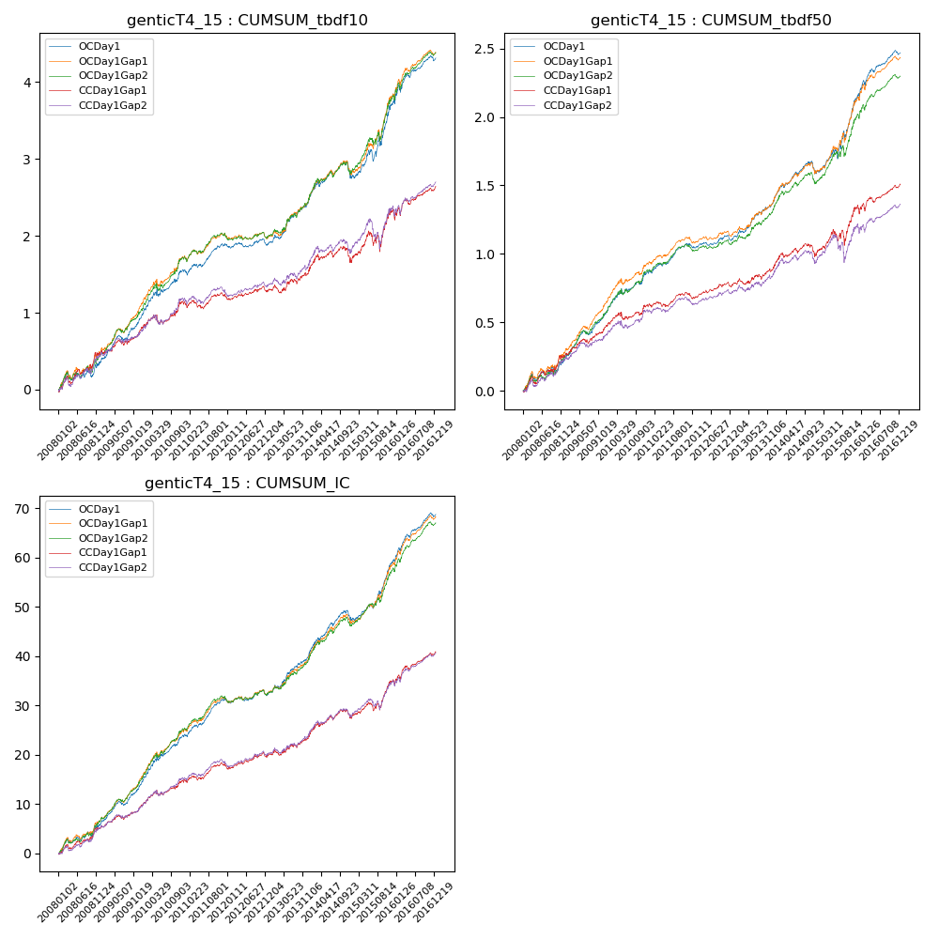

**因子换手率:** 31.54%

**截面指标_OCDay1:**

|  |  |  |  |  |  |  |  |  |
| --- | --- | --- | --- | --- | --- | --- | --- | --- |
| year | annret_tbdf10 | sharpe_tbdf10 | maxdd_tbdf10 | annret_tbdf50 | sharpe_tbdf50 | maxdd_tbdf50 | mean_IC | tstat_IC |
| 2008 | 0.37 | 2.08 | -0.11 | 0.24 | 2.85 | -0.05 | 0.02 | 3.33 |
| 2009 | 0.62 | 5.29 | -0.06 | 0.34 | 5.99 | -0.03 | 0.04 | 6.25 |
| 2010 | 0.58 | 3.48 | -0.09 | 0.29 | 3.82 | -0.04 | 0.04 | 4.96 |
| 2011 | 0.33 | 3.33 | -0.07 | 0.19 | 4.19 | -0.02 | 0.03 | 5.26 |
| 2012 | 0.01 | 0.15 | -0.08 | 0.05 | 1.19 | -0.04 | 0.01 | 1.05 |
| 2013 | 0.62 | 4.36 | -0.05 | 0.3 | 4.33 | -0.02 | 0.04 | 4.78 |
| 2014 | 0.25 | 1.53 | -0.2 | 0.19 | 2.55 | -0.09 | 0.03 | 3.42 |
| 2015 | 0.99 | 4.06 | -0.14 | 0.57 | 4.8 | -0.07 | 0.05 | 5.62 |
| 2016 | 0.58 | 3.52 | -0.1 | 0.32 | 4.31 | -0.04 | 0.04 | 5.28 |

**截面指标_CCDay1Gap1:**

|  |  |  |  |  |  |  |  |  |
| --- | --- | --- | --- | --- | --- | --- | --- | --- |
| year | annret_tbdf10 | sharpe_tbdf10 | maxdd_tbdf10 | annret_tbdf50 | sharpe_tbdf50 | maxdd_tbdf50 | mean_IC | tstat_IC |
| 2008 | 0.48 | 2.8 | -0.1 | 0.26 | 3.0 | -0.06 | 0.02 | 3.1 |
| 2009 | 0.33 | 2.77 | -0.06 | 0.22 | 3.62 | -0.03 | 0.02 | 3.45 |
| 2010 | 0.33 | 1.95 | -0.12 | 0.16 | 1.99 | -0.05 | 0.02 | 2.91 |
| 2011 | 0.06 | 0.57 | -0.11 | 0.05 | 1.07 | -0.04 | 0.01 | 1.95 |
| 2012 | 0.09 | 1.09 | -0.07 | 0.09 | 2.16 | -0.03 | 0.01 | 2.04 |
| 2013 | 0.29 | 1.96 | -0.1 | 0.14 | 1.93 | -0.04 | 0.02 | 2.43 |
| 2014 | 0.1 | 0.59 | -0.2 | 0.09 | 1.12 | -0.09 | 0.01 | 1.9 |
| 2015 | 0.61 | 2.35 | -0.25 | 0.33 | 2.65 | -0.11 | 0.03 | 3.39 |
| 2016 | 0.35 | 2.21 | -0.1 | 0.18 | 2.49 | -0.06 | 0.02 | 3.77 |

**风格暴露:**

|  |  |  |  |  |
| --- | --- | --- | --- | --- |
|  | long | short | corr_OCDay1 | corr_CCDay1Gap1 |
| liquidity10 | -0.52 | 0.52 | 0.56 | 0.58 |
| liquidity20 | -0.52 | 0.52 | 0.58 | 0.59 |
| liquidity5 | -0.51 | 0.51 | 0.54 | 0.58 |
| logmktcap | 1.61 | -1.6 | -0.72 | -0.7 |
| momentum15 | -0.22 | 0.23 | 0.14 | 0.19 |
| momentum30 | -0.26 | 0.26 | 0.18 | 0.2 |
| momentum5 | -0.14 | 0.15 | -0.0 | 0.05 |
| retvolatility30 | -0.53 | 0.53 | 0.53 | 0.53 |