Factors Report 20080102-20161230

**1. genticT9_18**

**截面指标累计曲线:**

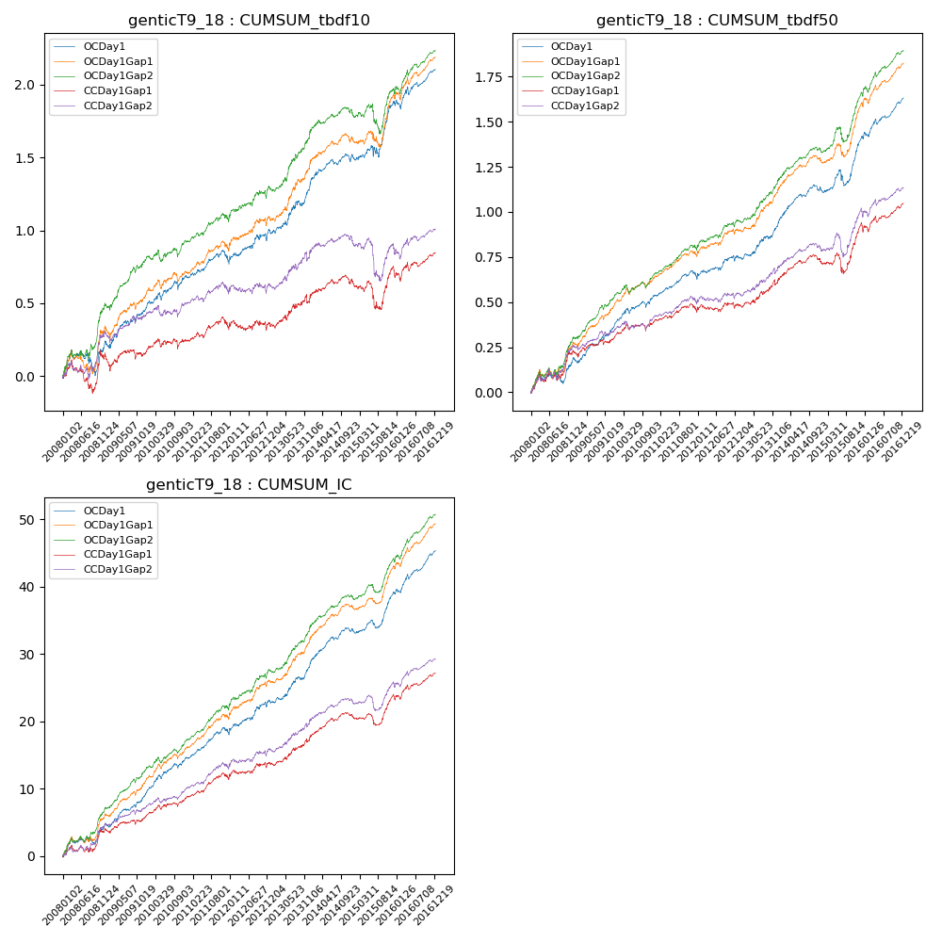

**因子换手率:** 33.61%

**截面指标_OCDay1:**

|  |  |  |  |  |  |  |  |  |
| --- | --- | --- | --- | --- | --- | --- | --- | --- |
| year | annret_tbdf10 | sharpe_tbdf10 | maxdd_tbdf10 | annret_tbdf50 | sharpe_tbdf50 | maxdd_tbdf50 | mean_IC | tstat_IC |
| 2008 | 0.22 | 1.58 | -0.17 | 0.18 | 2.39 | -0.07 | 0.02 | 2.95 |
| 2009 | 0.25 | 2.91 | -0.05 | 0.19 | 3.9 | -0.03 | 0.02 | 4.43 |
| 2010 | 0.21 | 2.59 | -0.06 | 0.18 | 3.45 | -0.03 | 0.02 | 4.44 |
| 2011 | 0.1 | 1.49 | -0.08 | 0.1 | 2.65 | -0.04 | 0.01 | 3.43 |
| 2012 | 0.21 | 2.3 | -0.05 | 0.11 | 2.2 | -0.03 | 0.02 | 3.26 |
| 2013 | 0.36 | 3.32 | -0.04 | 0.21 | 3.49 | -0.02 | 0.02 | 4.08 |
| 2014 | 0.18 | 2.87 | -0.05 | 0.19 | 4.44 | -0.03 | 0.02 | 4.96 |
| 2015 | 0.35 | 2.77 | -0.08 | 0.27 | 3.54 | -0.09 | 0.02 | 4.22 |
| 2016 | 0.23 | 2.83 | -0.06 | 0.22 | 4.35 | -0.03 | 0.03 | 5.41 |

**截面指标_CCDay1Gap1:**

|  |  |  |  |  |  |  |  |  |
| --- | --- | --- | --- | --- | --- | --- | --- | --- |
| year | annret_tbdf10 | sharpe_tbdf10 | maxdd_tbdf10 | annret_tbdf50 | sharpe_tbdf50 | maxdd_tbdf50 | mean_IC | tstat_IC |
| 2008 | 0.14 | 1.05 | -0.21 | 0.22 | 3.02 | -0.05 | 0.02 | 2.7 |
| 2009 | 0.02 | 0.23 | -0.12 | 0.08 | 1.55 | -0.04 | 0.01 | 2.03 |
| 2010 | 0.08 | 1.01 | -0.07 | 0.1 | 2.09 | -0.04 | 0.01 | 2.87 |
| 2011 | 0.07 | 1.0 | -0.09 | 0.04 | 1.01 | -0.05 | 0.01 | 2.33 |
| 2012 | 0.03 | 0.3 | -0.07 | 0.04 | 0.74 | -0.04 | 0.01 | 1.71 |
| 2013 | 0.22 | 1.94 | -0.06 | 0.15 | 2.44 | -0.03 | 0.02 | 2.96 |
| 2014 | 0.08 | 1.24 | -0.06 | 0.09 | 2.1 | -0.04 | 0.01 | 2.95 |
| 2015 | 0.08 | 0.58 | -0.18 | 0.2 | 2.26 | -0.11 | 0.01 | 2.27 |
| 2016 | 0.13 | 1.59 | -0.07 | 0.13 | 2.42 | -0.04 | 0.01 | 3.23 |

**风格暴露:**

|  |  |  |  |  |
| --- | --- | --- | --- | --- |
|  | long | short | corr_OCDay1 | corr_CCDay1Gap1 |
| liquidity10 | -0.64 | 0.64 | 0.5 | 0.47 |
| liquidity20 | -0.66 | 0.67 | 0.52 | 0.49 |
| liquidity5 | -0.63 | 0.63 | 0.48 | 0.44 |
| logmktcap | 1.21 | -1.2 | -0.59 | -0.56 |
| momentum15 | -0.12 | 0.13 | 0.09 | 0.06 |
| momentum30 | -0.15 | 0.16 | 0.16 | 0.17 |
| momentum5 | -0.06 | 0.06 | -0.02 | 0.0 |
| retvolatility30 | -0.53 | 0.54 | 0.44 | 0.42 |