Factors Report 20080102-20161230

**1. alpha5T**

**截面指标累计曲线:**

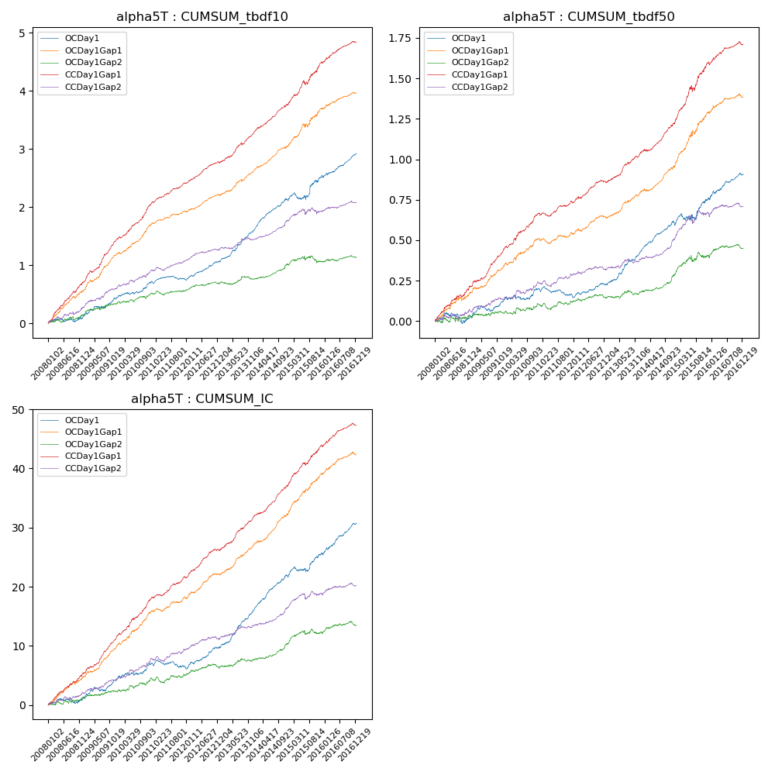

**因子换手率:** 91.53%

**截面指标_OCDay1:**

|  |  |  |  |  |  |  |  |  |
| --- | --- | --- | --- | --- | --- | --- | --- | --- |
| year | annret_tbdf10 | sharpe_tbdf10 | maxdd_tbdf10 | annret_tbdf50 | sharpe_tbdf50 | maxdd_tbdf50 | mean_IC | tstat_IC |
| 2008 | 0.09 | 0.99 | -0.07 | 0.02 | 0.48 | -0.07 | 0.0 | 1.13 |
| 2009 | 0.35 | 3.91 | -0.08 | 0.11 | 2.85 | -0.05 | 0.01 | 3.92 |
| 2010 | 0.26 | 3.02 | -0.3 | 0.07 | 1.86 | -0.1 | 0.01 | 2.62 |
| 2011 | 0.06 | 1.01 | -0.31 | -0.04 | -1.44 | -0.14 | -0.0 | -0.81 |
| 2012 | 0.32 | 5.12 | -0.31 | 0.07 | 2.56 | -0.11 | 0.01 | 4.18 |
| 2013 | 0.53 | 7.56 | -0.3 | 0.2 | 5.93 | -0.11 | 0.03 | 7.18 |
| 2014 | 0.53 | 7.86 | -0.4 | 0.17 | 5.86 | -0.18 | 0.02 | 7.64 |
| 2015 | 0.42 | 2.48 | -0.43 | 0.16 | 2.37 | -0.19 | 0.02 | 3.03 |
| 2016 | 0.39 | 5.26 | -0.45 | 0.16 | 3.97 | -0.18 | 0.02 | 5.73 |

**截面指标_CCDay1Gap1:**

|  |  |  |  |  |  |  |  |  |
| --- | --- | --- | --- | --- | --- | --- | --- | --- |
| year | annret_tbdf10 | sharpe_tbdf10 | maxdd_tbdf10 | annret_tbdf50 | sharpe_tbdf50 | maxdd_tbdf50 | mean_IC | tstat_IC |
| 2008 | 0.7 | 7.66 | -0.02 | 0.21 | 5.01 | -0.02 | 0.02 | 6.67 |
| 2009 | 0.75 | 8.67 | -0.51 | 0.23 | 6.76 | -0.2 | 0.03 | 8.4 |
| 2010 | 0.6 | 7.19 | -0.53 | 0.22 | 5.41 | -0.21 | 0.03 | 7.12 |
| 2011 | 0.36 | 6.46 | -0.52 | 0.07 | 2.4 | -0.22 | 0.01 | 4.99 |
| 2012 | 0.36 | 6.25 | -0.53 | 0.12 | 4.43 | -0.21 | 0.02 | 6.01 |
| 2013 | 0.51 | 6.24 | -0.53 | 0.18 | 5.63 | -0.21 | 0.02 | 7.11 |
| 2014 | 0.51 | 7.28 | -0.52 | 0.19 | 5.67 | -0.21 | 0.02 | 7.03 |
| 2015 | 0.73 | 5.15 | -0.53 | 0.38 | 5.57 | -0.2 | 0.03 | 6.57 |
| 2016 | 0.35 | 4.96 | -0.53 | 0.11 | 3.23 | -0.32 | 0.01 | 4.51 |

**风格暴露:**

|  |  |  |  |  |
| --- | --- | --- | --- | --- |
|  | long | short | corr_OCDay1 | corr_CCDay1Gap1 |
| liquidity10 | -0.04 | 0.04 | 0.25 | 0.14 |
| liquidity20 | -0.02 | 0.03 | 0.23 | 0.13 |
| liquidity5 | -0.04 | 0.05 | 0.26 | 0.16 |
| logmktcap | -0.07 | 0.07 | -0.12 | -0.04 |
| momentum15 | -0.17 | 0.17 | 0.12 | 0.07 |
| momentum30 | -0.14 | 0.15 | 0.13 | 0.04 |
| momentum5 | -0.12 | 0.13 | 0.06 | -0.04 |
| retvolatility30 | -0.06 | 0.06 | 0.28 | 0.16 |