Factors Report 20080102-20161230

**1. alpha5_1T**

**截面指标累计曲线:**

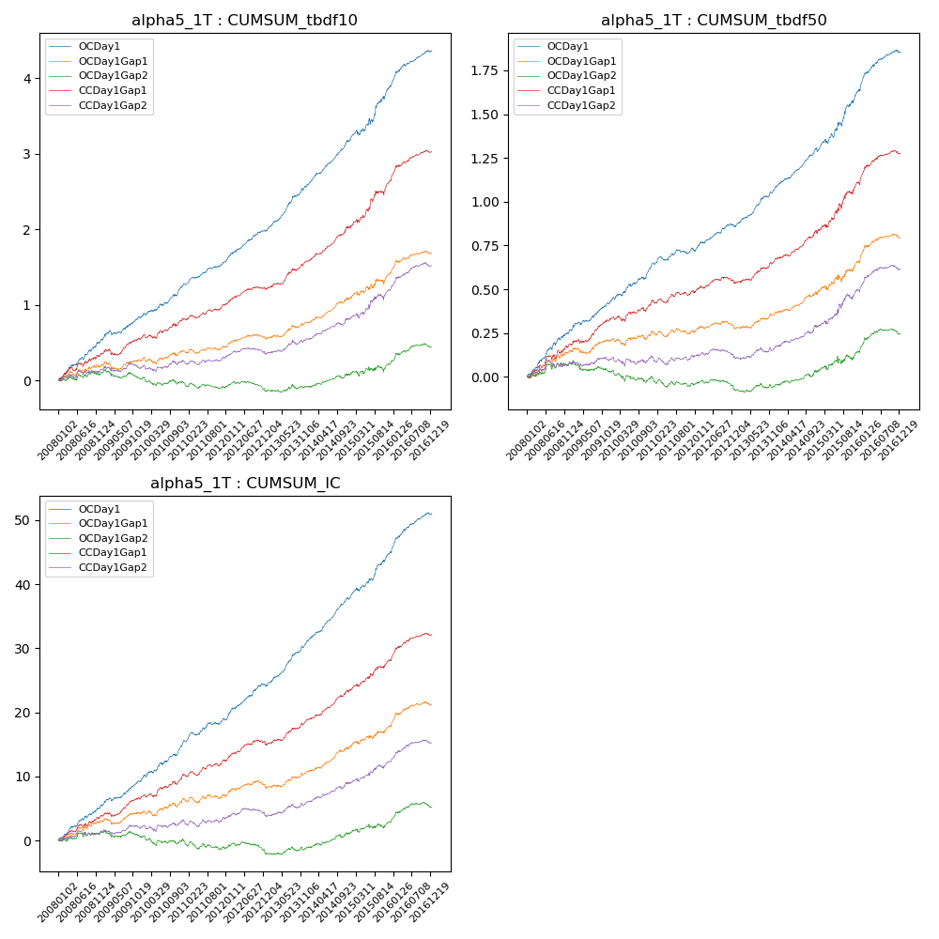

**因子换手率:** 49.45%

**截面指标_OCDay1:**

|  |  |  |  |  |  |  |  |  |
| --- | --- | --- | --- | --- | --- | --- | --- | --- |
| year | annret_tbdf10 | sharpe_tbdf10 | maxdd_tbdf10 | annret_tbdf50 | sharpe_tbdf50 | maxdd_tbdf50 | mean_IC | tstat_IC |
| 2008 | 0.51 | 6.04 | -0.03 | 0.25 | 5.67 | -0.02 | 0.02 | 5.82 |
| 2009 | 0.34 | 4.04 | -0.39 | 0.18 | 4.83 | -0.22 | 0.02 | 5.24 |
| 2010 | 0.42 | 5.17 | -0.4 | 0.21 | 5.29 | -0.22 | 0.02 | 5.62 |
| 2011 | 0.32 | 5.89 | -0.4 | 0.09 | 2.82 | -0.22 | 0.01 | 4.34 |
| 2012 | 0.42 | 6.53 | -0.4 | 0.13 | 4.31 | -0.23 | 0.02 | 5.95 |
| 2013 | 0.61 | 7.94 | -0.41 | 0.23 | 7.32 | -0.23 | 0.03 | 8.22 |
| 2014 | 0.57 | 9.25 | -0.45 | 0.2 | 6.52 | -0.22 | 0.03 | 8.68 |
| 2015 | 0.73 | 4.57 | -0.45 | 0.35 | 5.16 | -0.22 | 0.03 | 5.49 |
| 2016 | 0.48 | 6.67 | -0.51 | 0.22 | 5.51 | -0.3 | 0.02 | 6.68 |

**截面指标_CCDay1Gap1:**

|  |  |  |  |  |  |  |  |  |
| --- | --- | --- | --- | --- | --- | --- | --- | --- |
| year | annret_tbdf10 | sharpe_tbdf10 | maxdd_tbdf10 | annret_tbdf50 | sharpe_tbdf50 | maxdd_tbdf50 | mean_IC | tstat_IC |
| 2008 | 0.34 | 3.7 | -0.05 | 0.18 | 3.68 | -0.02 | 0.02 | 4.22 |
| 2009 | 0.23 | 2.88 | -0.29 | 0.15 | 3.81 | -0.17 | 0.01 | 3.8 |
| 2010 | 0.24 | 2.89 | -0.3 | 0.11 | 2.67 | -0.18 | 0.01 | 3.68 |
| 2011 | 0.19 | 3.35 | -0.3 | 0.05 | 1.46 | -0.18 | 0.01 | 2.76 |
| 2012 | 0.22 | 3.76 | -0.29 | 0.06 | 1.77 | -0.17 | 0.01 | 3.18 |
| 2013 | 0.37 | 5.01 | -0.3 | 0.14 | 4.4 | -0.17 | 0.02 | 4.86 |
| 2014 | 0.44 | 6.25 | -0.31 | 0.15 | 4.3 | -0.17 | 0.02 | 5.73 |
| 2015 | 0.62 | 4.46 | -0.37 | 0.28 | 4.19 | -0.16 | 0.02 | 4.61 |
| 2016 | 0.38 | 5.07 | -0.46 | 0.17 | 4.17 | -0.26 | 0.02 | 4.83 |

**风格暴露:**

|  |  |  |  |  |
| --- | --- | --- | --- | --- |
|  | long | short | corr_OCDay1 | corr_CCDay1Gap1 |
| liquidity10 | -0.05 | 0.05 | 0.11 | 0.03 |
| liquidity20 | -0.03 | 0.03 | 0.1 | 0.03 |
| liquidity5 | -0.06 | 0.07 | 0.13 | 0.04 |
| logmktcap | -0.04 | 0.04 | -0.06 | 0.03 |
| momentum15 | -0.04 | 0.04 | -0.09 | -0.13 |
| momentum30 | -0.05 | 0.06 | -0.08 | -0.12 |
| momentum5 | -0.01 | 0.01 | -0.05 | -0.19 |
| retvolatility30 | -0.05 | 0.06 | 0.13 | 0.05 |