Factors Report 20080102-20161230

**1. alpha5_2**

**截面指标累计曲线:**

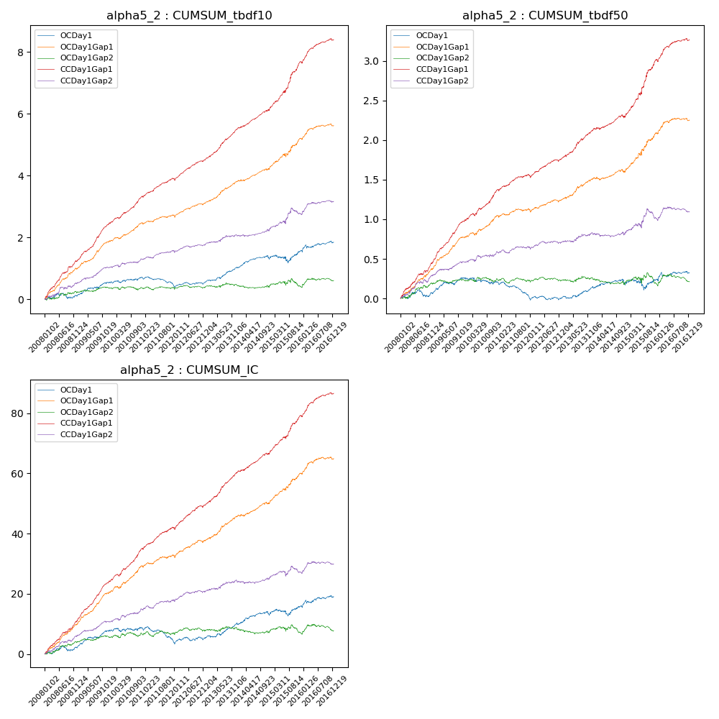

**因子换手率:** 83.68%

**截面指标_OCDay1:**

|  |  |  |  |  |  |  |  |  |
| --- | --- | --- | --- | --- | --- | --- | --- | --- |
| year | annret_tbdf10 | sharpe_tbdf10 | maxdd_tbdf10 | annret_tbdf50 | sharpe_tbdf50 | maxdd_tbdf50 | mean_IC | tstat_IC |
| 2008 | 0.11 | 0.7 | -0.16 | 0.07 | 0.86 | -0.09 | 0.01 | 1.33 |
| 2009 | 0.45 | 3.39 | -0.16 | 0.19 | 3.29 | -0.1 | 0.02 | 3.99 |
| 2010 | 0.15 | 1.15 | -0.38 | -0.05 | -0.76 | -0.24 | 0.0 | 0.48 |
| 2011 | -0.24 | -2.46 | -0.5 | -0.2 | -3.88 | -0.32 | -0.02 | -3.22 |
| 2012 | 0.11 | 1.07 | -0.41 | -0.0 | -0.08 | -0.21 | 0.01 | 1.0 |
| 2013 | 0.48 | 3.95 | -0.36 | 0.15 | 2.43 | -0.18 | 0.02 | 3.26 |
| 2014 | 0.25 | 2.12 | -0.39 | 0.02 | 0.23 | -0.2 | 0.01 | 1.6 |
| 2015 | 0.28 | 1.1 | -0.46 | 0.07 | 0.57 | -0.23 | 0.01 | 1.46 |
| 2016 | 0.28 | 1.74 | -0.39 | 0.09 | 1.16 | -0.19 | 0.01 | 1.82 |

**截面指标_CCDay1Gap1:**

|  |  |  |  |  |  |  |  |  |
| --- | --- | --- | --- | --- | --- | --- | --- | --- |
| year | annret_tbdf10 | sharpe_tbdf10 | maxdd_tbdf10 | annret_tbdf50 | sharpe_tbdf50 | maxdd_tbdf50 | mean_IC | tstat_IC |
| 2008 | 1.26 | 7.64 | -0.05 | 0.46 | 6.42 | -0.03 | 0.05 | 7.7 |
| 2009 | 1.21 | 9.04 | -0.72 | 0.53 | 8.87 | -0.37 | 0.05 | 9.86 |
| 2010 | 0.85 | 6.83 | -0.72 | 0.39 | 5.58 | -0.41 | 0.04 | 7.37 |
| 2011 | 0.58 | 5.67 | -0.72 | 0.18 | 3.61 | -0.42 | 0.03 | 5.2 |
| 2012 | 0.64 | 6.24 | -0.73 | 0.22 | 4.52 | -0.42 | 0.03 | 5.71 |
| 2013 | 1.0 | 7.73 | -0.71 | 0.38 | 5.57 | -0.41 | 0.05 | 6.89 |
| 2014 | 0.65 | 5.27 | -0.71 | 0.17 | 2.85 | -0.41 | 0.03 | 4.72 |
| 2015 | 1.52 | 6.17 | -0.71 | 0.71 | 5.71 | -0.41 | 0.05 | 6.17 |
| 2016 | 0.74 | 5.48 | -0.79 | 0.26 | 4.22 | -0.52 | 0.03 | 5.22 |

**风格暴露:**

|  |  |  |  |  |
| --- | --- | --- | --- | --- |
|  | long | short | corr_OCDay1 | corr_CCDay1Gap1 |
| liquidity10 | -0.03 | 0.04 | 0.05 | -0.01 |
| liquidity20 | -0.13 | 0.13 | 0.1 | 0.03 |
| liquidity5 | 0.06 | -0.06 | 0.02 | -0.04 |
| logmktcap | -0.17 | 0.17 | -0.1 | -0.0 |
| momentum15 | 0.82 | -0.81 | -0.47 | -0.49 |
| momentum30 | 0.44 | -0.44 | -0.38 | -0.39 |
| momentum5 | 0.92 | -0.91 | -0.52 | -0.58 |
| retvolatility30 | -0.2 | 0.2 | 0.2 | 0.11 |