Factors Report 20080102-20161230

**1. alpha5_3T**

**截面指标累计曲线:**

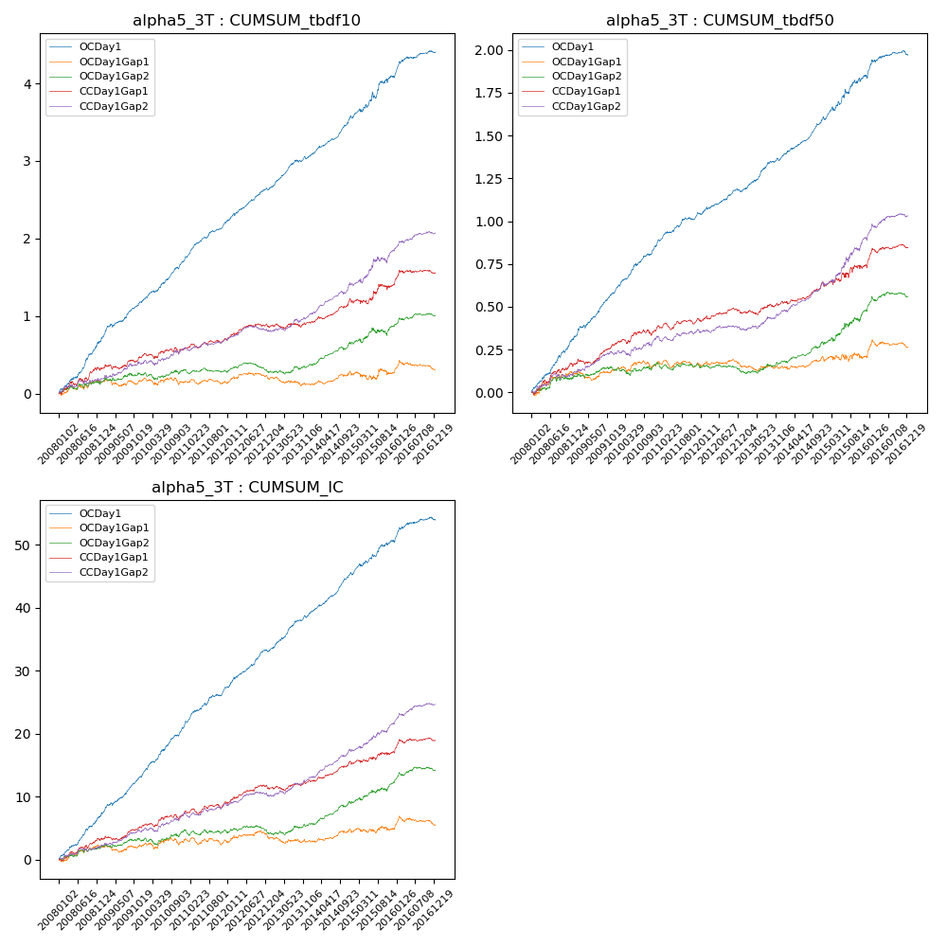

**因子换手率:** 69.46%

**截面指标_OCDay1:**

|  |  |  |  |  |  |  |  |  |
| --- | --- | --- | --- | --- | --- | --- | --- | --- |
| year | annret_tbdf10 | sharpe_tbdf10 | maxdd_tbdf10 | annret_tbdf50 | sharpe_tbdf50 | maxdd_tbdf50 | mean_IC | tstat_IC |
| 2008 | 0.69 | 7.22 | -0.02 | 0.32 | 6.64 | -0.01 | 0.03 | 7.5 |
| 2009 | 0.51 | 6.08 | -0.49 | 0.28 | 6.86 | -0.27 | 0.03 | 7.05 |
| 2010 | 0.53 | 6.77 | -0.5 | 0.28 | 7.01 | -0.27 | 0.03 | 7.71 |
| 2011 | 0.5 | 8.0 | -0.49 | 0.17 | 4.92 | -0.27 | 0.02 | 6.4 |
| 2012 | 0.41 | 6.02 | -0.5 | 0.13 | 4.32 | -0.28 | 0.02 | 6.23 |
| 2013 | 0.44 | 5.99 | -0.5 | 0.21 | 5.57 | -0.28 | 0.02 | 6.38 |
| 2014 | 0.5 | 6.98 | -0.5 | 0.22 | 6.68 | -0.27 | 0.03 | 7.76 |
| 2015 | 0.53 | 3.19 | -0.5 | 0.26 | 3.7 | -0.27 | 0.02 | 4.08 |
| 2016 | 0.31 | 3.86 | -0.51 | 0.12 | 2.75 | -0.28 | 0.01 | 3.32 |

**截面指标_CCDay1Gap1:**

|  |  |  |  |  |  |  |  |  |
| --- | --- | --- | --- | --- | --- | --- | --- | --- |
| year | annret_tbdf10 | sharpe_tbdf10 | maxdd_tbdf10 | annret_tbdf50 | sharpe_tbdf50 | maxdd_tbdf50 | mean_IC | tstat_IC |
| 2008 | 0.33 | 3.01 | -0.05 | 0.17 | 3.2 | -0.02 | 0.01 | 3.53 |
| 2009 | 0.17 | 1.92 | -0.3 | 0.12 | 2.96 | -0.16 | 0.01 | 2.32 |
| 2010 | 0.08 | 0.87 | -0.32 | 0.1 | 2.26 | -0.16 | 0.01 | 2.11 |
| 2011 | 0.12 | 1.88 | -0.28 | 0.04 | 1.12 | -0.17 | 0.01 | 1.75 |
| 2012 | 0.18 | 2.56 | -0.29 | 0.05 | 1.42 | -0.16 | 0.01 | 2.77 |
| 2013 | 0.05 | 0.68 | -0.31 | 0.07 | 1.77 | -0.17 | 0.01 | 1.44 |
| 2014 | 0.26 | 3.5 | -0.3 | 0.09 | 2.53 | -0.17 | 0.01 | 3.19 |
| 2015 | 0.22 | 1.51 | -0.31 | 0.12 | 1.66 | -0.16 | 0.01 | 1.7 |
| 2016 | 0.15 | 1.83 | -0.29 | 0.1 | 2.38 | -0.17 | 0.01 | 2.01 |

**风格暴露:**

|  |  |  |  |  |
| --- | --- | --- | --- | --- |
|  | long | short | corr_OCDay1 | corr_CCDay1Gap1 |
| liquidity10 | 0.0 | 0.0 | 0.03 | -0.01 |
| liquidity20 | 0.01 | -0.0 | 0.03 | -0.0 |
| liquidity5 | 0.01 | -0.0 | 0.03 | -0.02 |
| logmktcap | -0.03 | 0.03 | -0.01 | 0.01 |
| momentum15 | 0.06 | -0.06 | -0.17 | -0.19 |
| momentum30 | 0.03 | -0.02 | -0.15 | -0.16 |
| momentum5 | 0.14 | -0.13 | -0.17 | -0.28 |
| retvolatility30 | -0.01 | 0.01 | 0.03 | -0.0 |