Factors Report 20080102-20161230

**1. beta01**

**截面指标累计曲线:**

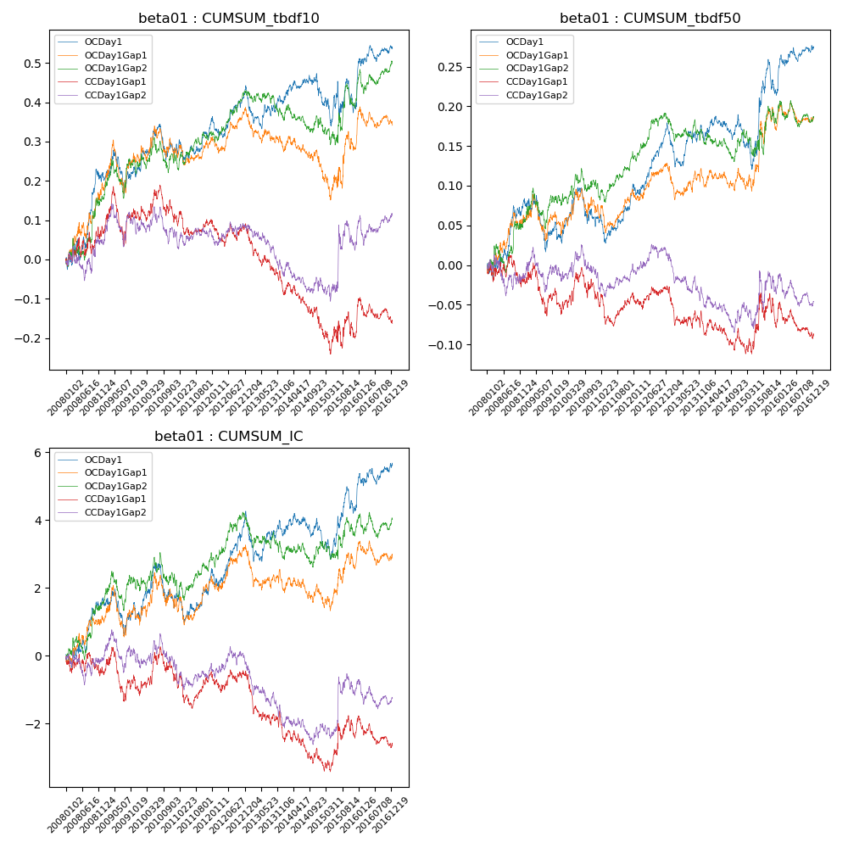

**因子换手率:** 51.38%

**截面指标_OCDay1:**

|  |  |  |  |  |  |  |  |  |
| --- | --- | --- | --- | --- | --- | --- | --- | --- |
| year | annret_tbdf10 | sharpe_tbdf10 | maxdd_tbdf10 | annret_tbdf50 | sharpe_tbdf50 | maxdd_tbdf50 | mean_IC | tstat_IC |
| 2008 | 0.21 | 2.37 | -0.05 | 0.08 | 1.96 | -0.02 | 0.01 | 2.05 |
| 2009 | 0.02 | 0.28 | -0.24 | -0.04 | -1.15 | -0.13 | -0.0 | -0.46 |
| 2010 | 0.04 | 0.66 | -0.21 | 0.02 | 0.55 | -0.09 | 0.0 | 0.48 |
| 2011 | 0.08 | 1.37 | -0.22 | 0.04 | 1.48 | -0.11 | 0.0 | 1.08 |
| 2012 | 0.06 | 1.12 | -0.24 | 0.07 | 2.67 | -0.08 | 0.01 | 1.86 |
| 2013 | -0.01 | -0.15 | -0.26 | -0.01 | -0.2 | -0.12 | -0.0 | -0.34 |
| 2014 | 0.02 | 0.42 | -0.21 | 0.01 | 0.57 | -0.08 | 0.0 | 0.24 |
| 2015 | -0.03 | -0.35 | -0.27 | 0.04 | 0.83 | -0.13 | 0.0 | 0.75 |
| 2016 | 0.14 | 2.37 | -0.21 | 0.06 | 2.18 | -0.08 | 0.01 | 1.96 |

**截面指标_CCDay1Gap1:**

|  |  |  |  |  |  |  |  |  |
| --- | --- | --- | --- | --- | --- | --- | --- | --- |
| year | annret_tbdf10 | sharpe_tbdf10 | maxdd_tbdf10 | annret_tbdf50 | sharpe_tbdf50 | maxdd_tbdf50 | mean_IC | tstat_IC |
| 2008 | 0.08 | 0.94 | -0.05 | -0.02 | -0.49 | -0.04 | -0.0 | -0.61 |
| 2009 | 0.03 | 0.34 | -0.14 | -0.03 | -0.87 | -0.07 | -0.0 | -0.71 |
| 2010 | -0.0 | -0.02 | -0.11 | 0.01 | 0.28 | -0.04 | 0.0 | 0.44 |
| 2011 | -0.01 | -0.19 | -0.14 | 0.01 | 0.2 | -0.08 | 0.0 | 0.29 |
| 2012 | -0.03 | -0.65 | -0.16 | 0.0 | 0.17 | -0.07 | -0.0 | -0.28 |
| 2013 | -0.15 | -2.89 | -0.22 | -0.06 | -1.95 | -0.1 | -0.01 | -2.72 |
| 2014 | -0.09 | -1.62 | -0.18 | -0.01 | -0.42 | -0.06 | -0.0 | -1.1 |
| 2015 | -0.02 | -0.17 | -0.16 | 0.03 | 0.54 | -0.06 | 0.0 | 0.85 |
| 2016 | 0.03 | 0.45 | -0.09 | -0.02 | -0.76 | -0.08 | -0.0 | -0.78 |

**风格暴露:**

|  |  |  |  |  |
| --- | --- | --- | --- | --- |
|  | long | short | corr_OCDay1 | corr_CCDay1Gap1 |
| liquidity10 | 0.01 | -0.0 | 0.03 | -0.04 |
| liquidity20 | 0.01 | -0.0 | 0.0 | -0.05 |
| liquidity5 | 0.0 | 0.0 | 0.03 | -0.03 |
| logmktcap | -0.04 | 0.05 | 0.18 | 0.17 |
| momentum15 | -0.04 | 0.05 | 0.13 | 0.1 |
| momentum30 | -0.04 | 0.05 | 0.15 | 0.08 |
| momentum5 | -0.01 | 0.02 | 0.14 | 0.09 |
| retvolatility30 | 0.01 | -0.0 | 0.02 | -0.03 |