Factors Report 20080102-20161230

**1. beta02F**

**截面指标累计曲线:**

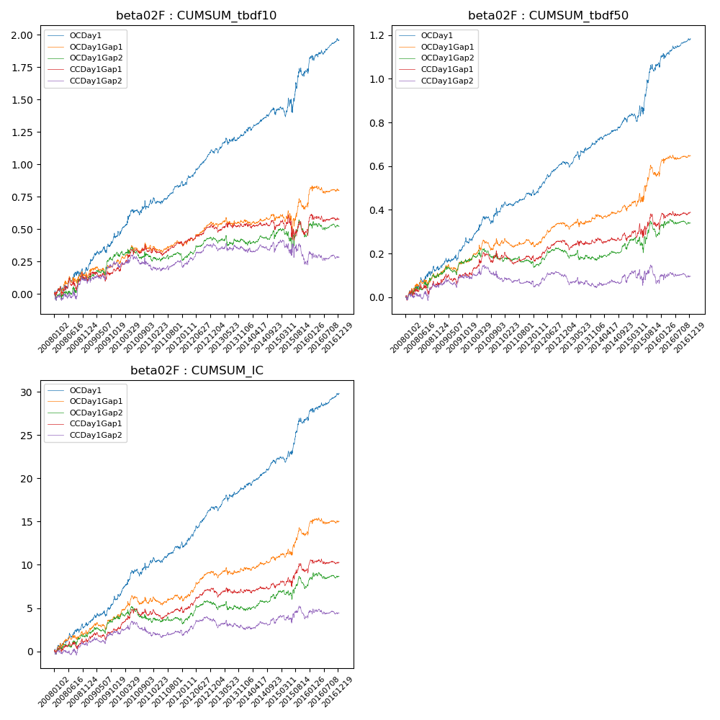

**因子换手率:** 47.68%

**截面指标_OCDay1:**

|  |  |  |  |  |  |  |  |  |
| --- | --- | --- | --- | --- | --- | --- | --- | --- |
| year | annret_tbdf10 | sharpe_tbdf10 | maxdd_tbdf10 | annret_tbdf50 | sharpe_tbdf50 | maxdd_tbdf50 | mean_IC | tstat_IC |
| 2008 | 0.2 | 1.64 | -0.05 | 0.13 | 2.15 | -0.02 | 0.01 | 2.55 |
| 2009 | 0.28 | 2.56 | -0.19 | 0.13 | 2.35 | -0.14 | 0.01 | 2.63 |
| 2010 | 0.22 | 1.97 | -0.25 | 0.14 | 2.32 | -0.14 | 0.01 | 2.55 |
| 2011 | 0.17 | 2.43 | -0.23 | 0.07 | 2.06 | -0.13 | 0.01 | 2.3 |
| 2012 | 0.24 | 3.56 | -0.25 | 0.14 | 3.56 | -0.14 | 0.02 | 4.09 |
| 2013 | 0.13 | 1.73 | -0.25 | 0.09 | 1.94 | -0.15 | 0.01 | 2.15 |
| 2014 | 0.15 | 1.93 | -0.24 | 0.1 | 2.56 | -0.14 | 0.01 | 3.02 |
| 2015 | 0.36 | 1.9 | -0.25 | 0.27 | 2.76 | -0.13 | 0.02 | 3.33 |
| 2016 | 0.22 | 2.37 | -0.32 | 0.11 | 2.22 | -0.25 | 0.01 | 2.42 |

**截面指标_CCDay1Gap1:**

|  |  |  |  |  |  |  |  |  |
| --- | --- | --- | --- | --- | --- | --- | --- | --- |
| year | annret_tbdf10 | sharpe_tbdf10 | maxdd_tbdf10 | annret_tbdf50 | sharpe_tbdf50 | maxdd_tbdf50 | mean_IC | tstat_IC |
| 2008 | 0.14 | 1.25 | -0.09 | 0.07 | 1.16 | -0.05 | 0.01 | 1.34 |
| 2009 | 0.06 | 0.66 | -0.19 | 0.04 | 0.88 | -0.08 | 0.01 | 1.26 |
| 2010 | 0.13 | 1.38 | -0.17 | 0.07 | 1.16 | -0.08 | 0.01 | 1.39 |
| 2011 | 0.06 | 1.02 | -0.19 | 0.0 | 0.08 | -0.12 | 0.0 | 0.77 |
| 2012 | 0.12 | 2.16 | -0.18 | 0.08 | 2.33 | -0.11 | 0.01 | 2.69 |
| 2013 | 0.0 | 0.05 | -0.2 | -0.01 | -0.15 | -0.13 | -0.0 | -0.46 |
| 2014 | -0.01 | -0.07 | -0.18 | 0.02 | 0.46 | -0.1 | 0.0 | 0.86 |
| 2015 | -0.02 | -0.09 | -0.25 | 0.07 | 0.78 | -0.1 | 0.01 | 1.32 |
| 2016 | 0.08 | 0.81 | -0.2 | 0.05 | 1.0 | -0.13 | 0.0 | 0.73 |

**风格暴露:**

|  |  |  |  |  |
| --- | --- | --- | --- | --- |
|  | long | short | corr_OCDay1 | corr_CCDay1Gap1 |
| liquidity10 | -0.12 | 0.13 | 0.14 | 0.08 |
| liquidity20 | -0.05 | 0.06 | 0.12 | 0.05 |
| liquidity5 | -0.15 | 0.15 | 0.17 | 0.09 |
| logmktcap | -0.03 | 0.03 | -0.1 | -0.1 |
| momentum15 | -0.03 | 0.03 | 0.01 | -0.09 |
| momentum30 | 0.01 | -0.0 | -0.0 | -0.13 |
| momentum5 | -0.02 | 0.02 | 0.06 | -0.02 |
| retvolatility30 | -0.05 | 0.05 | 0.24 | 0.18 |