Factors Report 20080102-20161230

**1. beta02**

**截面指标累计曲线:**

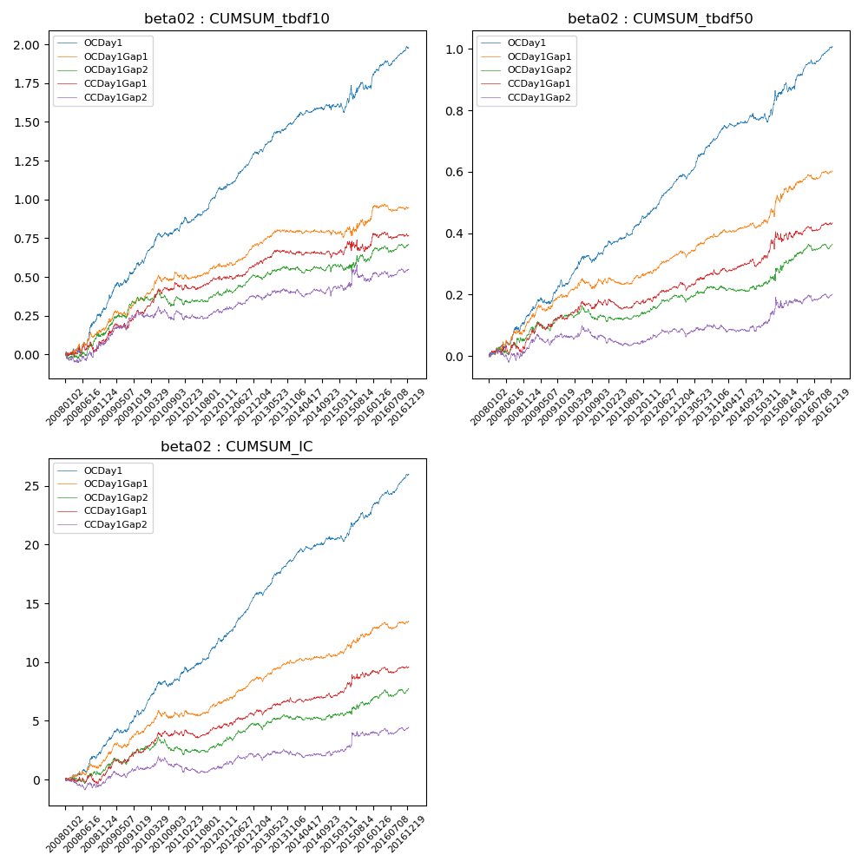

**因子换手率:** 50.4%

**截面指标_OCDay1:**

|  |  |  |  |  |  |  |  |  |
| --- | --- | --- | --- | --- | --- | --- | --- | --- |
| year | annret_tbdf10 | sharpe_tbdf10 | maxdd_tbdf10 | annret_tbdf50 | sharpe_tbdf50 | maxdd_tbdf50 | mean_IC | tstat_IC |
| 2008 | 0.29 | 3.36 | -0.04 | 0.13 | 3.21 | -0.02 | 0.01 | 3.59 |
| 2009 | 0.31 | 4.12 | -0.26 | 0.11 | 3.09 | -0.13 | 0.01 | 3.93 |
| 2010 | 0.22 | 3.46 | -0.28 | 0.11 | 3.39 | -0.13 | 0.01 | 3.72 |
| 2011 | 0.25 | 4.54 | -0.26 | 0.11 | 4.23 | -0.12 | 0.01 | 4.47 |
| 2012 | 0.23 | 5.0 | -0.27 | 0.14 | 5.8 | -0.13 | 0.02 | 6.16 |
| 2013 | 0.21 | 4.25 | -0.27 | 0.13 | 5.17 | -0.13 | 0.01 | 4.92 |
| 2014 | 0.1 | 1.89 | -0.27 | 0.06 | 2.36 | -0.13 | 0.01 | 2.9 |
| 2015 | 0.13 | 1.32 | -0.3 | 0.11 | 2.05 | -0.14 | 0.01 | 2.71 |
| 2016 | 0.24 | 4.1 | -0.28 | 0.13 | 4.94 | -0.14 | 0.01 | 5.22 |

**截面指标_CCDay1Gap1:**

|  |  |  |  |  |  |  |  |  |
| --- | --- | --- | --- | --- | --- | --- | --- | --- |
| year | annret_tbdf10 | sharpe_tbdf10 | maxdd_tbdf10 | annret_tbdf50 | sharpe_tbdf50 | maxdd_tbdf50 | mean_IC | tstat_IC |
| 2008 | 0.1 | 1.07 | -0.07 | 0.06 | 1.31 | -0.03 | 0.0 | 0.55 |
| 2009 | 0.17 | 2.36 | -0.1 | 0.07 | 2.08 | -0.06 | 0.01 | 2.7 |
| 2010 | 0.17 | 2.61 | -0.18 | 0.05 | 1.57 | -0.08 | 0.01 | 2.25 |
| 2011 | 0.06 | 1.22 | -0.2 | 0.0 | 0.19 | -0.1 | 0.0 | 1.07 |
| 2012 | 0.09 | 1.89 | -0.19 | 0.06 | 2.45 | -0.08 | 0.01 | 2.2 |
| 2013 | 0.07 | 1.42 | -0.18 | 0.03 | 1.14 | -0.1 | 0.0 | 1.23 |
| 2014 | -0.01 | -0.2 | -0.2 | 0.03 | 1.16 | -0.08 | 0.0 | 0.9 |
| 2015 | 0.07 | 0.6 | -0.18 | 0.11 | 1.93 | -0.08 | 0.01 | 2.13 |
| 2016 | 0.05 | 0.94 | -0.18 | 0.04 | 1.48 | -0.11 | 0.0 | 0.92 |

**风格暴露:**

|  |  |  |  |  |
| --- | --- | --- | --- | --- |
|  | long | short | corr_OCDay1 | corr_CCDay1Gap1 |
| liquidity10 | -0.01 | 0.02 | -0.01 | -0.06 |
| liquidity20 | -0.01 | 0.02 | -0.04 | -0.07 |
| liquidity5 | -0.01 | 0.02 | 0.01 | -0.03 |
| logmktcap | -0.03 | 0.04 | 0.21 | 0.16 |
| momentum15 | -0.05 | 0.06 | 0.17 | 0.12 |
| momentum30 | -0.05 | 0.05 | 0.18 | 0.1 |
| momentum5 | -0.01 | 0.02 | 0.17 | 0.17 |
| retvolatility30 | -0.01 | 0.02 | -0.03 | -0.07 |