Factors Report 20080102-20161230

**1. beta03**

**截面指标累计曲线:**

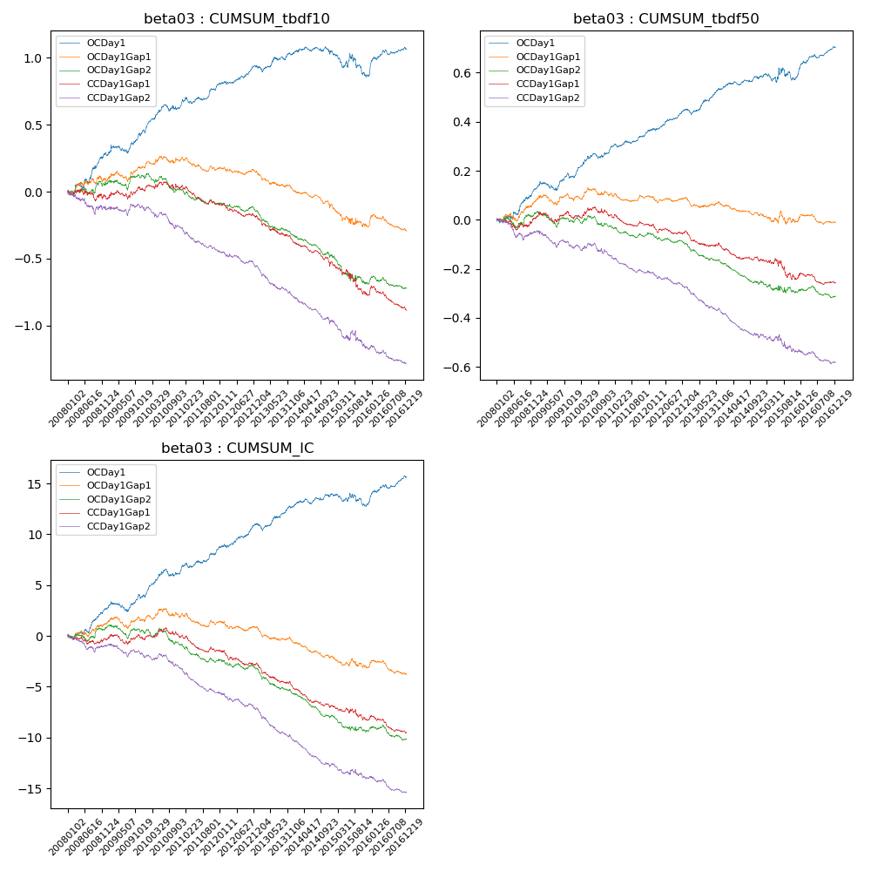

**因子换手率:** 48.51%

**截面指标_OCDay1:**

|  |  |  |  |  |  |  |  |  |
| --- | --- | --- | --- | --- | --- | --- | --- | --- |
| year | annret_tbdf10 | sharpe_tbdf10 | maxdd_tbdf10 | annret_tbdf50 | sharpe_tbdf50 | maxdd_tbdf50 | mean_IC | tstat_IC |
| 2008 | 0.29 | 3.15 | -0.05 | 0.12 | 3.1 | -0.02 | 0.01 | 3.34 |
| 2009 | 0.18 | 2.28 | -0.26 | 0.05 | 1.64 | -0.12 | 0.01 | 1.83 |
| 2010 | 0.18 | 2.7 | -0.27 | 0.11 | 3.36 | -0.12 | 0.01 | 3.06 |
| 2011 | 0.16 | 2.91 | -0.25 | 0.07 | 3.14 | -0.12 | 0.01 | 3.18 |
| 2012 | 0.13 | 2.81 | -0.25 | 0.09 | 3.8 | -0.11 | 0.01 | 3.53 |
| 2013 | 0.11 | 1.77 | -0.28 | 0.09 | 3.15 | -0.13 | 0.01 | 2.68 |
| 2014 | 0.02 | 0.28 | -0.26 | 0.05 | 2.27 | -0.12 | 0.0 | 2.08 |
| 2015 | -0.18 | -1.78 | -0.39 | 0.01 | 0.1 | -0.14 | -0.0 | -0.9 |
| 2016 | 0.19 | 3.36 | -0.25 | 0.11 | 4.54 | -0.11 | 0.01 | 3.84 |

**截面指标_CCDay1Gap1:**

|  |  |  |  |  |  |  |  |  |
| --- | --- | --- | --- | --- | --- | --- | --- | --- |
| year | annret_tbdf10 | sharpe_tbdf10 | maxdd_tbdf10 | annret_tbdf50 | sharpe_tbdf50 | maxdd_tbdf50 | mean_IC | tstat_IC |
| 2008 | -0.04 | -0.42 | -0.09 | 0.01 | 0.17 | -0.04 | -0.0 | -0.43 |
| 2009 | 0.05 | 0.69 | -0.06 | 0.0 | 0.02 | -0.04 | -0.0 | -0.05 |
| 2010 | 0.02 | 0.28 | -0.08 | 0.01 | 0.28 | -0.04 | 0.0 | 0.31 |
| 2011 | -0.12 | -2.69 | -0.18 | -0.03 | -1.63 | -0.08 | -0.01 | -2.38 |
| 2012 | -0.09 | -1.9 | -0.16 | -0.03 | -1.28 | -0.08 | -0.01 | -2.2 |
| 2013 | -0.2 | -3.68 | -0.23 | -0.07 | -2.74 | -0.11 | -0.01 | -4.02 |
| 2014 | -0.15 | -2.94 | -0.22 | -0.05 | -2.21 | -0.09 | -0.01 | -3.48 |
| 2015 | -0.25 | -2.38 | -0.28 | -0.07 | -1.43 | -0.12 | -0.01 | -1.67 |
| 2016 | -0.12 | -2.17 | -0.17 | -0.02 | -0.94 | -0.07 | -0.01 | -2.51 |

**风格暴露:**

|  |  |  |  |  |
| --- | --- | --- | --- | --- |
|  | long | short | corr_OCDay1 | corr_CCDay1Gap1 |
| liquidity10 | 0.02 | -0.02 | -0.05 | -0.1 |
| liquidity20 | 0.01 | -0.01 | -0.08 | -0.11 |
| liquidity5 | 0.02 | -0.01 | -0.03 | -0.07 |
| logmktcap | -0.03 | 0.03 | 0.2 | 0.12 |
| momentum15 | -0.01 | 0.01 | 0.06 | 0.03 |
| momentum30 | -0.01 | 0.02 | 0.08 | 0.01 |
| momentum5 | 0.02 | -0.01 | 0.12 | 0.08 |
| retvolatility30 | 0.01 | 0.0 | -0.06 | -0.1 |