Factors Report 20080102-20161230

**1. beta04**

**截面指标累计曲线:**

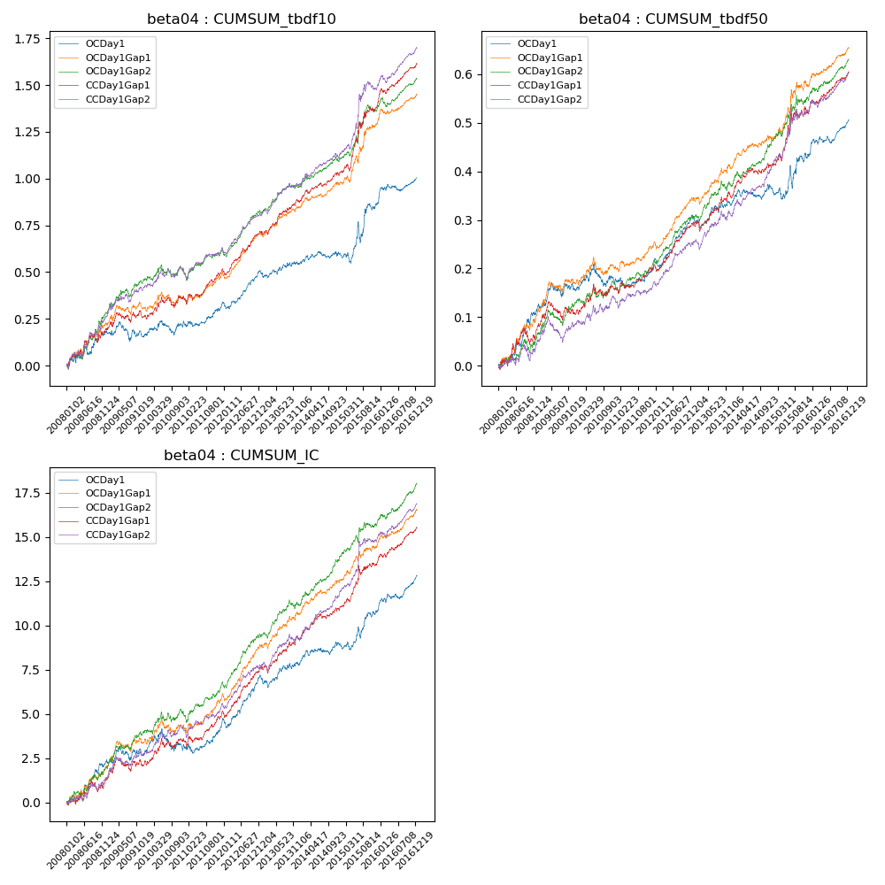

**因子换手率:** 49.6%

**截面指标_OCDay1:**

|  |  |  |  |  |  |  |  |  |
| --- | --- | --- | --- | --- | --- | --- | --- | --- |
| year | annret_tbdf10 | sharpe_tbdf10 | maxdd_tbdf10 | annret_tbdf50 | sharpe_tbdf50 | maxdd_tbdf50 | mean_IC | tstat_IC |
| 2008 | 0.18 | 2.12 | -0.05 | 0.12 | 3.1 | -0.01 | 0.01 | 2.96 |
| 2009 | -0.01 | -0.2 | -0.21 | 0.04 | 1.12 | -0.12 | 0.0 | 0.75 |
| 2010 | 0.07 | 1.04 | -0.17 | 0.02 | 0.49 | -0.12 | 0.0 | 0.39 |
| 2011 | 0.11 | 2.09 | -0.19 | 0.04 | 1.9 | -0.13 | 0.01 | 2.4 |
| 2012 | 0.15 | 3.17 | -0.2 | 0.09 | 3.81 | -0.13 | 0.01 | 3.51 |
| 2013 | 0.06 | 1.11 | -0.19 | 0.03 | 1.07 | -0.13 | 0.0 | 1.33 |
| 2014 | 0.05 | 1.07 | -0.17 | 0.04 | 1.44 | -0.12 | 0.0 | 1.92 |
| 2015 | 0.27 | 2.33 | -0.21 | 0.07 | 1.4 | -0.14 | 0.01 | 2.31 |
| 2016 | 0.14 | 2.58 | -0.23 | 0.07 | 3.06 | -0.12 | 0.01 | 3.58 |

**截面指标_CCDay1Gap1:**

|  |  |  |  |  |  |  |  |  |
| --- | --- | --- | --- | --- | --- | --- | --- | --- |
| year | annret_tbdf10 | sharpe_tbdf10 | maxdd_tbdf10 | annret_tbdf50 | sharpe_tbdf50 | maxdd_tbdf50 | mean_IC | tstat_IC |
| 2008 | 0.2 | 2.05 | -0.05 | 0.08 | 1.98 | -0.03 | 0.01 | 1.69 |
| 2009 | 0.07 | 1.03 | -0.18 | 0.03 | 1.03 | -0.08 | 0.0 | 1.49 |
| 2010 | 0.1 | 1.45 | -0.19 | 0.04 | 1.34 | -0.09 | 0.0 | 1.57 |
| 2011 | 0.15 | 2.89 | -0.21 | 0.05 | 2.18 | -0.09 | 0.01 | 2.73 |
| 2012 | 0.2 | 4.35 | -0.2 | 0.09 | 3.77 | -0.09 | 0.01 | 4.17 |
| 2013 | 0.17 | 3.39 | -0.19 | 0.05 | 1.93 | -0.1 | 0.01 | 2.52 |
| 2014 | 0.14 | 3.07 | -0.19 | 0.07 | 2.86 | -0.08 | 0.01 | 3.36 |
| 2015 | 0.39 | 3.84 | -0.19 | 0.12 | 2.28 | -0.08 | 0.01 | 2.98 |
| 2016 | 0.21 | 4.26 | -0.31 | 0.07 | 3.65 | -0.11 | 0.01 | 3.99 |

**风格暴露:**

|  |  |  |  |  |
| --- | --- | --- | --- | --- |
|  | long | short | corr_OCDay1 | corr_CCDay1Gap1 |
| liquidity10 | -0.02 | 0.02 | 0.05 | -0.01 |
| liquidity20 | -0.01 | 0.01 | 0.03 | -0.01 |
| liquidity5 | -0.02 | 0.02 | 0.05 | 0.02 |
| logmktcap | -0.04 | 0.05 | 0.2 | 0.19 |
| momentum15 | -0.06 | 0.07 | 0.17 | 0.14 |
| momentum30 | -0.05 | 0.06 | 0.17 | 0.15 |
| momentum5 | -0.03 | 0.03 | 0.13 | 0.11 |
| retvolatility30 | -0.01 | 0.02 | 0.01 | -0.05 |