Factors Report 20080102-20161230

**1. beta12**

**截面指标累计曲线:**

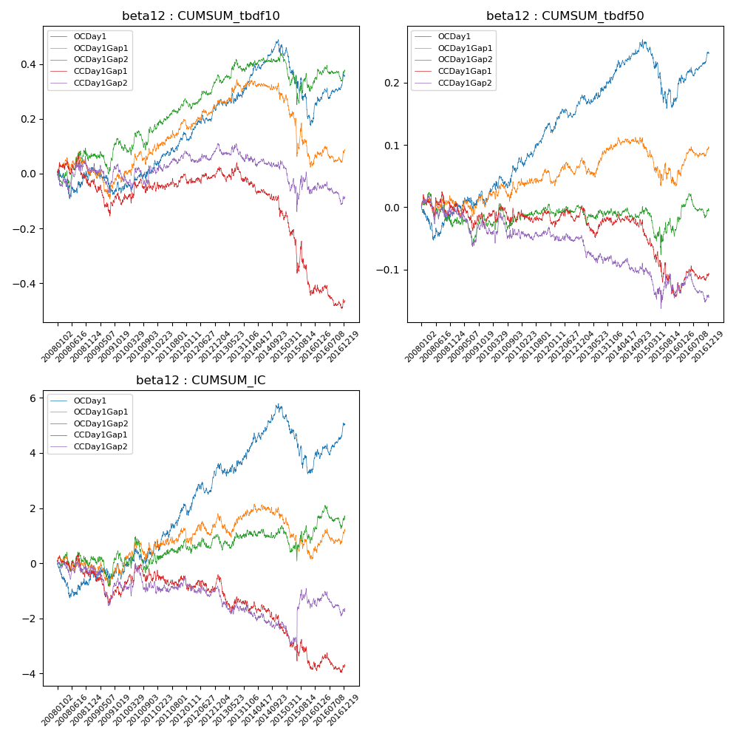

**因子换手率:** 51.48%

**截面指标_OCDay1:**

|  |  |  |  |  |  |  |  |  |
| --- | --- | --- | --- | --- | --- | --- | --- | --- |
| year | annret_tbdf10 | sharpe_tbdf10 | maxdd_tbdf10 | annret_tbdf50 | sharpe_tbdf50 | maxdd_tbdf50 | mean_IC | tstat_IC |
| 2008 | -0.0 | -0.01 | -0.1 | -0.0 | -0.09 | -0.05 | -0.0 | -0.9 |
| 2009 | -0.06 | -0.74 | -0.11 | 0.01 | 0.43 | -0.02 | 0.0 | 0.36 |
| 2010 | 0.07 | 1.12 | -0.05 | 0.05 | 1.74 | -0.03 | 0.0 | 0.97 |
| 2011 | 0.13 | 2.58 | -0.08 | 0.07 | 3.09 | -0.05 | 0.01 | 2.66 |
| 2012 | 0.11 | 2.21 | -0.15 | 0.04 | 1.96 | -0.08 | 0.01 | 2.27 |
| 2013 | 0.09 | 1.4 | -0.13 | 0.03 | 1.14 | -0.08 | 0.0 | 0.81 |
| 2014 | 0.13 | 2.4 | -0.13 | 0.06 | 2.4 | -0.07 | 0.01 | 2.68 |
| 2015 | -0.28 | -2.64 | -0.36 | -0.09 | -2.08 | -0.17 | -0.01 | -2.57 |
| 2016 | 0.17 | 3.1 | -0.14 | 0.07 | 3.16 | -0.07 | 0.01 | 2.95 |

**截面指标_CCDay1Gap1:**

|  |  |  |  |  |  |  |  |  |
| --- | --- | --- | --- | --- | --- | --- | --- | --- |
| year | annret_tbdf10 | sharpe_tbdf10 | maxdd_tbdf10 | annret_tbdf50 | sharpe_tbdf50 | maxdd_tbdf50 | mean_IC | tstat_IC |
| 2008 | -0.04 | -0.44 | -0.11 | -0.0 | -0.07 | -0.04 | -0.0 | -0.64 |
| 2009 | -0.07 | -0.93 | -0.17 | -0.02 | -0.75 | -0.06 | -0.0 | -0.92 |
| 2010 | 0.05 | 0.81 | -0.07 | 0.01 | 0.24 | -0.03 | 0.0 | 0.72 |
| 2011 | 0.04 | 0.81 | -0.09 | 0.01 | 0.45 | -0.03 | 0.0 | 0.05 |
| 2012 | 0.02 | 0.5 | -0.11 | 0.01 | 0.39 | -0.05 | 0.0 | 0.06 |
| 2013 | -0.05 | -0.81 | -0.13 | -0.03 | -1.08 | -0.08 | -0.01 | -1.95 |
| 2014 | -0.1 | -1.85 | -0.19 | -0.02 | -0.66 | -0.05 | -0.0 | -1.16 |
| 2015 | -0.29 | -2.54 | -0.33 | -0.09 | -1.96 | -0.12 | -0.01 | -1.53 |
| 2016 | -0.04 | -0.68 | -0.14 | 0.03 | 1.23 | -0.03 | 0.0 | 0.12 |

**风格暴露:**

|  |  |  |  |  |
| --- | --- | --- | --- | --- |
|  | long | short | corr_OCDay1 | corr_CCDay1Gap1 |
| liquidity10 | 0.01 | -0.01 | -0.07 | -0.04 |
| liquidity20 | 0.01 | -0.01 | -0.08 | -0.05 |
| liquidity5 | 0.03 | -0.02 | -0.06 | -0.02 |
| logmktcap | -0.02 | 0.03 | 0.16 | 0.12 |
| momentum15 | -0.02 | 0.02 | 0.11 | 0.16 |
| momentum30 | -0.02 | 0.03 | 0.12 | 0.15 |
| momentum5 | 0.03 | -0.02 | 0.1 | 0.18 |
| retvolatility30 | 0.02 | -0.01 | -0.06 | -0.05 |