Factors Report 20080102-20161230

**1. beta13**

**截面指标累计曲线:**

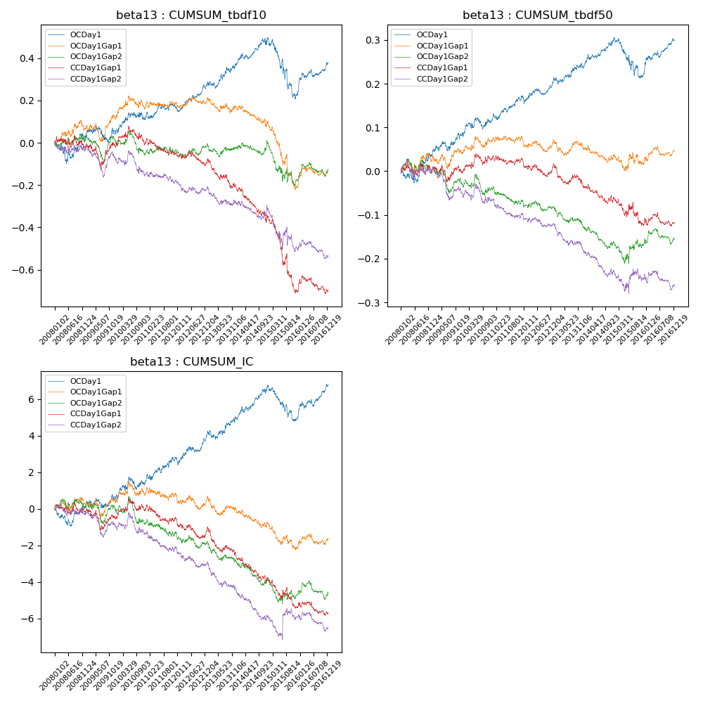

**因子换手率:** 49.14%

**截面指标_OCDay1:**

|  |  |  |  |  |  |  |  |  |
| --- | --- | --- | --- | --- | --- | --- | --- | --- |
| year | annret_tbdf10 | sharpe_tbdf10 | maxdd_tbdf10 | annret_tbdf50 | sharpe_tbdf50 | maxdd_tbdf50 | mean_IC | tstat_IC |
| 2008 | 0.03 | 0.33 | -0.1 | 0.04 | 1.01 | -0.03 | 0.0 | 0.1 |
| 2009 | 0.03 | 0.4 | -0.07 | 0.05 | 1.54 | -0.04 | 0.0 | 0.86 |
| 2010 | 0.07 | 0.99 | -0.06 | 0.03 | 1.08 | -0.05 | 0.0 | 1.15 |
| 2011 | 0.05 | 0.98 | -0.09 | 0.05 | 2.29 | -0.05 | 0.01 | 1.92 |
| 2012 | 0.1 | 2.29 | -0.11 | 0.03 | 1.59 | -0.07 | 0.01 | 2.01 |
| 2013 | 0.1 | 1.7 | -0.11 | 0.03 | 1.28 | -0.06 | 0.0 | 1.36 |
| 2014 | 0.12 | 2.25 | -0.1 | 0.06 | 2.78 | -0.06 | 0.01 | 2.91 |
| 2015 | -0.27 | -2.56 | -0.34 | -0.08 | -1.92 | -0.14 | -0.01 | -2.26 |
| 2016 | 0.15 | 2.85 | -0.11 | 0.08 | 3.16 | -0.06 | 0.01 | 2.95 |

**截面指标_CCDay1Gap1:**

|  |  |  |  |  |  |  |  |  |
| --- | --- | --- | --- | --- | --- | --- | --- | --- |
| year | annret_tbdf10 | sharpe_tbdf10 | maxdd_tbdf10 | annret_tbdf50 | sharpe_tbdf50 | maxdd_tbdf50 | mean_IC | tstat_IC |
| 2008 | -0.02 | -0.22 | -0.06 | -0.0 | -0.05 | -0.03 | -0.0 | -0.27 |
| 2009 | -0.0 | -0.07 | -0.12 | -0.0 | -0.1 | -0.04 | -0.0 | -0.58 |
| 2010 | 0.03 | 0.39 | -0.09 | 0.03 | 1.13 | -0.03 | 0.0 | 0.87 |
| 2011 | -0.05 | -1.1 | -0.15 | -0.0 | -0.07 | -0.06 | -0.0 | -0.94 |
| 2012 | -0.04 | -0.96 | -0.15 | -0.01 | -0.64 | -0.08 | -0.0 | -1.08 |
| 2013 | -0.13 | -2.37 | -0.21 | -0.05 | -1.89 | -0.09 | -0.01 | -2.68 |
| 2014 | -0.13 | -2.37 | -0.23 | -0.03 | -1.24 | -0.08 | -0.0 | -2.02 |
| 2015 | -0.35 | -3.31 | -0.37 | -0.06 | -1.32 | -0.1 | -0.01 | -1.89 |
| 2016 | 0.0 | 0.03 | -0.11 | 0.0 | 0.11 | -0.05 | -0.0 | -0.65 |

**风格暴露:**

|  |  |  |  |  |
| --- | --- | --- | --- | --- |
|  | long | short | corr_OCDay1 | corr_CCDay1Gap1 |
| liquidity10 | 0.03 | -0.03 | -0.14 | -0.12 |
| liquidity20 | 0.03 | -0.02 | -0.15 | -0.13 |
| liquidity5 | 0.05 | -0.04 | -0.13 | -0.1 |
| logmktcap | -0.03 | 0.03 | 0.22 | 0.17 |
| momentum15 | -0.01 | 0.01 | 0.07 | 0.11 |
| momentum30 | -0.0 | 0.01 | 0.1 | 0.1 |
| momentum5 | 0.05 | -0.05 | 0.07 | 0.14 |
| retvolatility30 | 0.03 | -0.02 | -0.16 | -0.15 |