Factors Report 20080102-20161230

**1. beta14**

**截面指标累计曲线:**

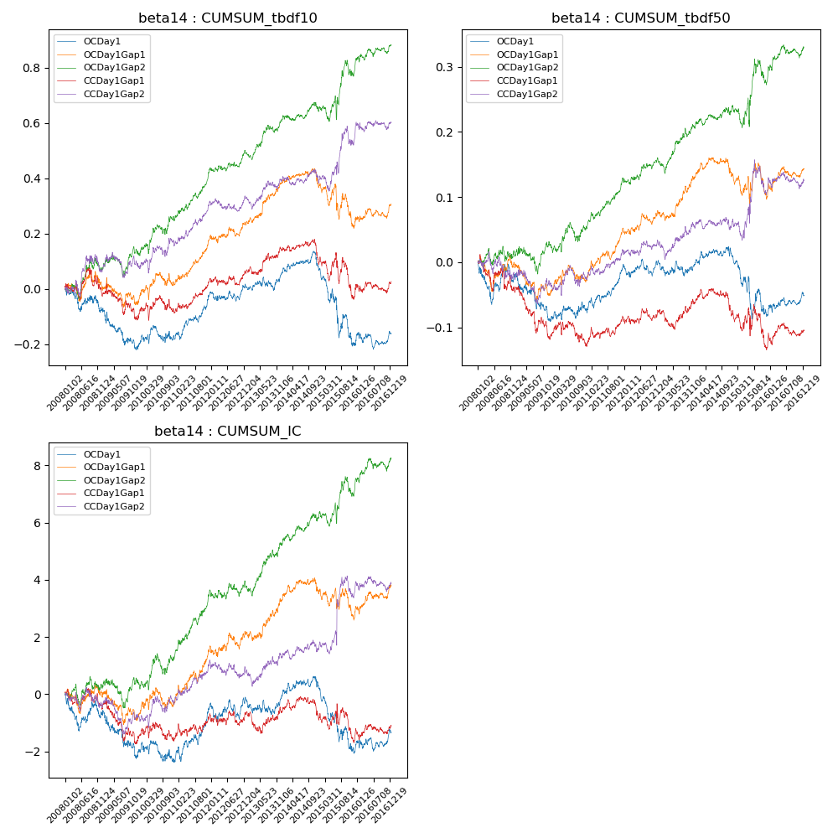

**因子换手率:** 49.16%

**截面指标_OCDay1:**

|  |  |  |  |  |  |  |  |  |
| --- | --- | --- | --- | --- | --- | --- | --- | --- |
| year | annret_tbdf10 | sharpe_tbdf10 | maxdd_tbdf10 | annret_tbdf50 | sharpe_tbdf50 | maxdd_tbdf50 | mean_IC | tstat_IC |
| 2008 | -0.08 | -0.99 | -0.09 | -0.02 | -0.58 | -0.06 | -0.0 | -0.93 |
| 2009 | -0.13 | -1.93 | -0.14 | -0.07 | -1.92 | -0.07 | -0.01 | -1.81 |
| 2010 | 0.04 | 0.59 | -0.06 | 0.01 | 0.37 | -0.02 | -0.0 | -0.42 |
| 2011 | 0.16 | 3.35 | -0.08 | 0.07 | 3.11 | -0.03 | 0.01 | 3.17 |
| 2012 | 0.02 | 0.4 | -0.18 | 0.0 | 0.2 | -0.08 | 0.0 | 0.21 |
| 2013 | 0.06 | 1.12 | -0.16 | -0.0 | -0.05 | -0.09 | 0.0 | 0.3 |
| 2014 | 0.02 | 0.32 | -0.15 | 0.02 | 0.7 | -0.07 | 0.0 | 0.59 |
| 2015 | -0.27 | -2.62 | -0.36 | -0.1 | -2.02 | -0.16 | -0.01 | -2.73 |
| 2016 | 0.04 | 0.71 | -0.17 | 0.03 | 1.41 | -0.07 | 0.0 | 1.25 |

**截面指标_CCDay1Gap1:**

|  |  |  |  |  |  |  |  |  |
| --- | --- | --- | --- | --- | --- | --- | --- | --- |
| year | annret_tbdf10 | sharpe_tbdf10 | maxdd_tbdf10 | annret_tbdf50 | sharpe_tbdf50 | maxdd_tbdf50 | mean_IC | tstat_IC |
| 2008 | -0.01 | -0.15 | -0.09 | -0.04 | -0.94 | -0.06 | -0.0 | -0.59 |
| 2009 | -0.08 | -1.18 | -0.16 | -0.07 | -2.13 | -0.09 | -0.0 | -1.58 |
| 2010 | 0.01 | 0.14 | -0.09 | -0.02 | -0.59 | -0.04 | -0.0 | -0.26 |
| 2011 | 0.13 | 2.86 | -0.07 | 0.05 | 2.08 | -0.02 | 0.0 | 1.6 |
| 2012 | 0.03 | 0.62 | -0.14 | 0.01 | 0.49 | -0.06 | 0.0 | 0.22 |
| 2013 | 0.08 | 1.47 | -0.13 | 0.01 | 0.43 | -0.07 | 0.0 | 0.01 |
| 2014 | -0.05 | -1.09 | -0.16 | -0.02 | -0.82 | -0.06 | -0.0 | -0.55 |
| 2015 | -0.11 | -1.03 | -0.23 | -0.05 | -0.82 | -0.1 | -0.0 | -0.63 |
| 2016 | 0.04 | 0.77 | -0.12 | 0.02 | 0.98 | -0.04 | 0.0 | 0.89 |

**风格暴露:**

|  |  |  |  |  |
| --- | --- | --- | --- | --- |
|  | long | short | corr_OCDay1 | corr_CCDay1Gap1 |
| liquidity10 | -0.01 | 0.02 | 0.01 | -0.01 |
| liquidity20 | -0.01 | 0.01 | -0.01 | -0.02 |
| liquidity5 | -0.0 | 0.01 | 0.03 | 0.03 |
| logmktcap | -0.02 | 0.03 | 0.15 | 0.16 |
| momentum15 | -0.03 | 0.03 | 0.17 | 0.18 |
| momentum30 | -0.04 | 0.05 | 0.15 | 0.17 |
| momentum5 | -0.0 | 0.01 | 0.16 | 0.15 |
| retvolatility30 | -0.0 | 0.01 | -0.01 | -0.06 |