Factors Report 20080102-20161230

**1. beta23**

**截面指标累计曲线:**

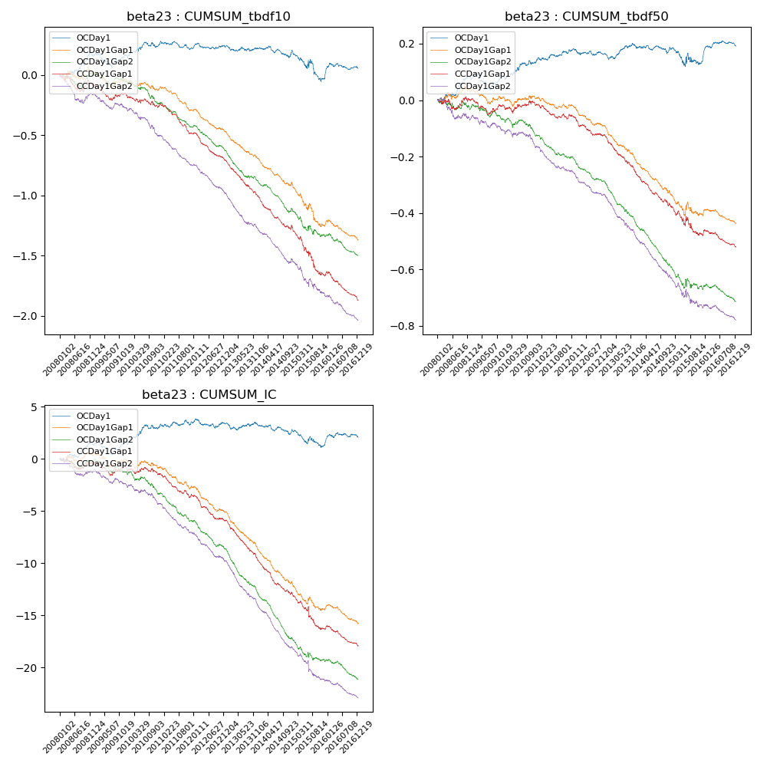

**因子换手率:** 47.54%

**截面指标_OCDay1:**

|  |  |  |  |  |  |  |  |  |
| --- | --- | --- | --- | --- | --- | --- | --- | --- |
| year | annret_tbdf10 | sharpe_tbdf10 | maxdd_tbdf10 | annret_tbdf50 | sharpe_tbdf50 | maxdd_tbdf50 | mean_IC | tstat_IC |
| 2008 | 0.16 | 2.03 | -0.04 | 0.08 | 2.13 | -0.01 | 0.01 | 1.88 |
| 2009 | 0.01 | 0.1 | -0.26 | 0.01 | 0.26 | -0.12 | 0.0 | 0.52 |
| 2010 | 0.09 | 1.32 | -0.19 | 0.06 | 1.98 | -0.09 | 0.01 | 1.86 |
| 2011 | -0.04 | -0.79 | -0.21 | 0.03 | 1.36 | -0.08 | 0.0 | 0.62 |
| 2012 | 0.02 | 0.46 | -0.18 | -0.01 | -0.51 | -0.1 | -0.0 | -0.11 |
| 2013 | -0.02 | -0.4 | -0.21 | 0.03 | 1.09 | -0.1 | -0.0 | -0.29 |
| 2014 | -0.02 | -0.37 | -0.24 | -0.01 | -0.26 | -0.1 | -0.0 | -0.88 |
| 2015 | -0.23 | -2.16 | -0.36 | -0.05 | -0.9 | -0.14 | -0.01 | -1.86 |
| 2016 | 0.09 | 1.39 | -0.14 | 0.05 | 2.08 | -0.07 | 0.0 | 1.27 |

**截面指标_CCDay1Gap1:**

|  |  |  |  |  |  |  |  |  |
| --- | --- | --- | --- | --- | --- | --- | --- | --- |
| year | annret_tbdf10 | sharpe_tbdf10 | maxdd_tbdf10 | annret_tbdf50 | sharpe_tbdf50 | maxdd_tbdf50 | mean_IC | tstat_IC |
| 2008 | -0.1 | -1.1 | -0.14 | 0.0 | 0.0 | -0.04 | -0.0 | -0.76 |
| 2009 | -0.08 | -1.27 | -0.12 | -0.02 | -0.91 | -0.06 | -0.0 | -0.77 |
| 2010 | -0.08 | -1.39 | -0.11 | 0.01 | 0.24 | -0.03 | -0.0 | -0.87 |
| 2011 | -0.23 | -5.89 | -0.22 | -0.04 | -1.82 | -0.07 | -0.01 | -4.13 |
| 2012 | -0.22 | -5.27 | -0.21 | -0.07 | -3.45 | -0.09 | -0.01 | -4.45 |
| 2013 | -0.31 | -6.68 | -0.27 | -0.14 | -5.81 | -0.14 | -0.02 | -7.2 |
| 2014 | -0.25 | -4.93 | -0.26 | -0.11 | -4.76 | -0.13 | -0.01 | -6.14 |
| 2015 | -0.41 | -4.22 | -0.35 | -0.11 | -2.45 | -0.13 | -0.01 | -3.65 |
| 2016 | -0.2 | -4.55 | -0.22 | -0.04 | -1.93 | -0.06 | -0.01 | -3.47 |

**风格暴露:**

|  |  |  |  |  |
| --- | --- | --- | --- | --- |
|  | long | short | corr_OCDay1 | corr_CCDay1Gap1 |
| liquidity10 | 0.07 | -0.06 | -0.07 | -0.14 |
| liquidity20 | 0.05 | -0.04 | -0.08 | -0.14 |
| liquidity5 | 0.06 | -0.05 | -0.07 | -0.13 |
| logmktcap | -0.02 | 0.02 | 0.01 | 0.06 |
| momentum15 | 0.05 | -0.04 | -0.05 | -0.09 |
| momentum30 | 0.04 | -0.04 | -0.01 | -0.1 |
| momentum5 | 0.04 | -0.04 | -0.0 | -0.02 |
| retvolatility30 | 0.03 | -0.03 | -0.06 | -0.12 |