Factors Report 20080102-20161230

**1. beta24**

**截面指标累计曲线:**

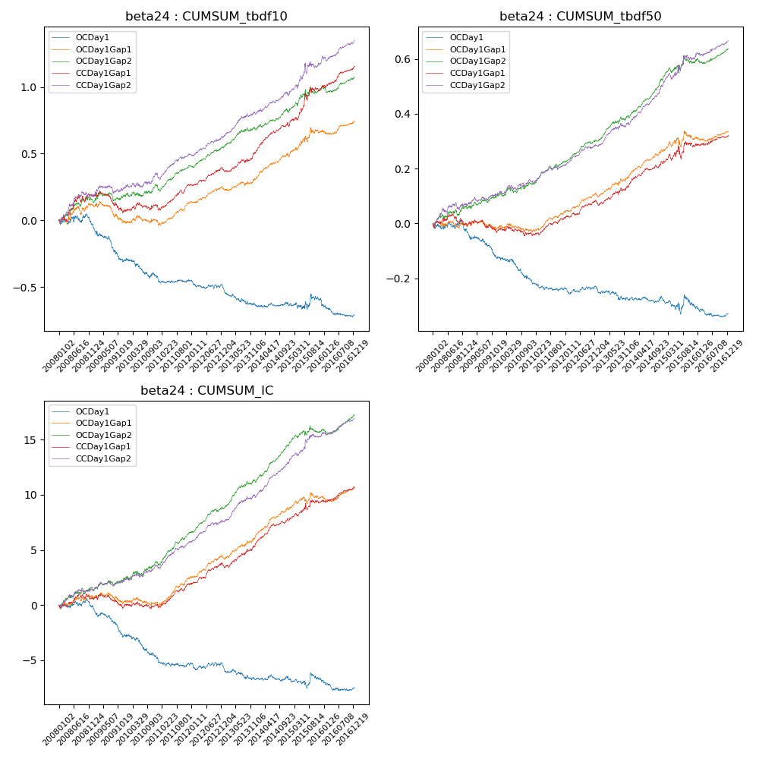

**因子换手率:** 48.66%

**截面指标_OCDay1:**

|  |  |  |  |  |  |  |  |  |
| --- | --- | --- | --- | --- | --- | --- | --- | --- |
| year | annret_tbdf10 | sharpe_tbdf10 | maxdd_tbdf10 | annret_tbdf50 | sharpe_tbdf50 | maxdd_tbdf50 | mean_IC | tstat_IC |
| 2008 | -0.03 | -0.4 | -0.08 | -0.02 | -0.56 | -0.04 | -0.0 | -0.13 |
| 2009 | -0.27 | -3.96 | -0.28 | -0.11 | -3.41 | -0.11 | -0.01 | -3.74 |
| 2010 | -0.12 | -1.88 | -0.17 | -0.08 | -2.71 | -0.09 | -0.01 | -2.63 |
| 2011 | -0.02 | -0.57 | -0.09 | -0.03 | -1.31 | -0.05 | -0.0 | -0.76 |
| 2012 | -0.06 | -1.39 | -0.11 | -0.0 | -0.17 | -0.04 | -0.0 | -0.6 |
| 2013 | -0.13 | -2.48 | -0.16 | -0.04 | -1.49 | -0.05 | -0.0 | -1.82 |
| 2014 | 0.0 | 0.03 | -0.06 | 0.0 | 0.15 | -0.02 | 0.0 | 0.16 |
| 2015 | 0.03 | 0.34 | -0.08 | -0.03 | -0.63 | -0.07 | -0.0 | -0.2 |
| 2016 | -0.1 | -1.62 | -0.18 | -0.02 | -1.0 | -0.05 | -0.0 | -1.08 |

**截面指标_CCDay1Gap1:**

|  |  |  |  |  |  |  |  |  |
| --- | --- | --- | --- | --- | --- | --- | --- | --- |
| year | annret_tbdf10 | sharpe_tbdf10 | maxdd_tbdf10 | annret_tbdf50 | sharpe_tbdf50 | maxdd_tbdf50 | mean_IC | tstat_IC |
| 2008 | 0.19 | 2.04 | -0.05 | -0.0 | -0.06 | -0.04 | 0.0 | 0.83 |
| 2009 | -0.11 | -1.51 | -0.28 | -0.02 | -0.58 | -0.06 | -0.0 | -0.76 |
| 2010 | 0.02 | 0.26 | -0.19 | -0.02 | -0.66 | -0.06 | -0.0 | -0.29 |
| 2011 | 0.17 | 3.54 | -0.2 | 0.06 | 2.84 | -0.04 | 0.01 | 3.74 |
| 2012 | 0.11 | 2.61 | -0.18 | 0.06 | 2.6 | -0.06 | 0.01 | 2.9 |
| 2013 | 0.13 | 2.5 | -0.19 | 0.07 | 2.55 | -0.07 | 0.01 | 3.15 |
| 2014 | 0.2 | 4.29 | -0.18 | 0.08 | 3.53 | -0.07 | 0.01 | 4.55 |
| 2015 | 0.29 | 2.81 | -0.21 | 0.06 | 1.13 | -0.08 | 0.01 | 1.91 |
| 2016 | 0.16 | 3.17 | -0.25 | 0.03 | 1.49 | -0.08 | 0.0 | 2.39 |

**风格暴露:**

|  |  |  |  |  |
| --- | --- | --- | --- | --- |
|  | long | short | corr_OCDay1 | corr_CCDay1Gap1 |
| liquidity10 | -0.02 | 0.03 | 0.15 | 0.05 |
| liquidity20 | -0.0 | 0.01 | 0.15 | 0.06 |
| liquidity5 | -0.03 | 0.04 | 0.15 | 0.08 |
| logmktcap | -0.02 | 0.03 | 0.02 | 0.11 |
| momentum15 | -0.05 | 0.06 | 0.1 | 0.05 |
| momentum30 | -0.04 | 0.05 | 0.09 | 0.08 |
| momentum5 | -0.06 | 0.06 | 0.05 | 0.02 |
| retvolatility30 | -0.01 | 0.02 | 0.12 | 0.05 |