Factors Report 20080102-20161230

**1. beta34**

**截面指标累计曲线:**

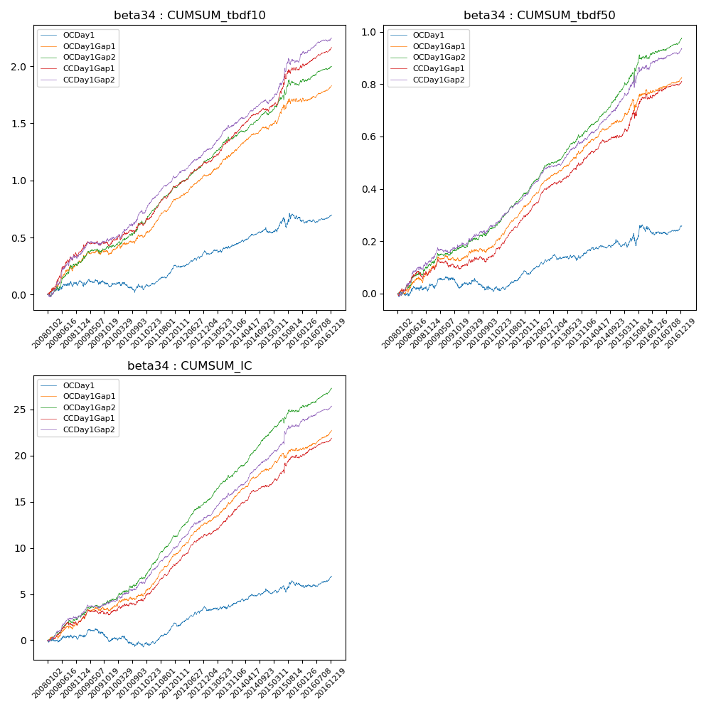

**因子换手率:** 47.55%

**截面指标_OCDay1:**

|  |  |  |  |  |  |  |  |  |
| --- | --- | --- | --- | --- | --- | --- | --- | --- |
| year | annret_tbdf10 | sharpe_tbdf10 | maxdd_tbdf10 | annret_tbdf50 | sharpe_tbdf50 | maxdd_tbdf50 | mean_IC | tstat_IC |
| 2008 | 0.11 | 1.43 | -0.05 | 0.03 | 0.83 | -0.02 | 0.0 | 0.69 |
| 2009 | -0.04 | -0.63 | -0.15 | -0.0 | -0.14 | -0.04 | -0.0 | -0.7 |
| 2010 | -0.0 | -0.0 | -0.16 | -0.01 | -0.37 | -0.05 | -0.0 | -0.59 |
| 2011 | 0.18 | 4.0 | -0.14 | 0.07 | 3.25 | -0.04 | 0.01 | 3.9 |
| 2012 | 0.12 | 2.79 | -0.18 | 0.05 | 2.65 | -0.08 | 0.01 | 2.78 |
| 2013 | 0.08 | 1.56 | -0.18 | 0.02 | 0.71 | -0.08 | 0.0 | 0.96 |
| 2014 | 0.1 | 2.15 | -0.17 | 0.03 | 1.44 | -0.07 | 0.0 | 2.14 |
| 2015 | 0.13 | 1.24 | -0.17 | 0.05 | 0.94 | -0.09 | 0.0 | 0.9 |
| 2016 | 0.02 | 0.39 | -0.21 | 0.02 | 0.77 | -0.09 | 0.0 | 1.67 |

**截面指标_CCDay1Gap1:**

|  |  |  |  |  |  |  |  |  |
| --- | --- | --- | --- | --- | --- | --- | --- | --- |
| year | annret_tbdf10 | sharpe_tbdf10 | maxdd_tbdf10 | annret_tbdf50 | sharpe_tbdf50 | maxdd_tbdf50 | mean_IC | tstat_IC |
| 2008 | 0.37 | 4.13 | -0.04 | 0.08 | 2.06 | -0.03 | 0.01 | 2.83 |
| 2009 | 0.08 | 1.25 | -0.31 | 0.02 | 0.71 | -0.08 | 0.0 | 1.62 |
| 2010 | 0.16 | 2.38 | -0.32 | 0.04 | 1.26 | -0.08 | 0.01 | 1.82 |
| 2011 | 0.33 | 6.86 | -0.32 | 0.15 | 7.23 | -0.08 | 0.02 | 7.25 |
| 2012 | 0.21 | 5.05 | -0.31 | 0.13 | 6.01 | -0.15 | 0.01 | 5.82 |
| 2013 | 0.27 | 5.3 | -0.31 | 0.1 | 3.86 | -0.15 | 0.01 | 4.64 |
| 2014 | 0.19 | 4.22 | -0.31 | 0.08 | 3.39 | -0.14 | 0.01 | 4.86 |
| 2015 | 0.39 | 3.78 | -0.31 | 0.15 | 2.92 | -0.14 | 0.01 | 3.32 |
| 2016 | 0.18 | 3.78 | -0.32 | 0.06 | 2.87 | -0.16 | 0.01 | 4.45 |

**风格暴露:**

|  |  |  |  |  |
| --- | --- | --- | --- | --- |
|  | long | short | corr_OCDay1 | corr_CCDay1Gap1 |
| liquidity10 | -0.01 | 0.02 | 0.12 | 0.08 |
| liquidity20 | -0.0 | 0.01 | 0.12 | 0.08 |
| liquidity5 | -0.01 | 0.02 | 0.12 | 0.08 |
| logmktcap | -0.02 | 0.02 | 0.04 | 0.06 |
| momentum15 | -0.04 | 0.04 | 0.14 | 0.12 |
| momentum30 | -0.03 | 0.03 | 0.13 | 0.14 |
| momentum5 | -0.01 | 0.02 | 0.09 | 0.05 |
| retvolatility30 | 0.0 | 0.0 | 0.1 | 0.07 |