Factors Report 20080102-20161230

**1. gama03**

**截面指标累计曲线:**

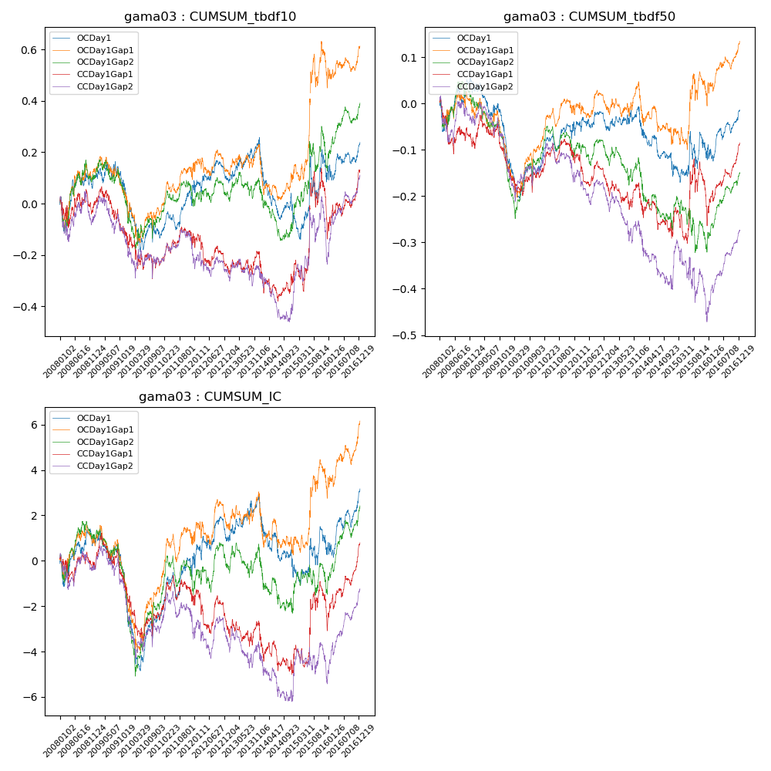

**因子换手率:** 38.04%

**截面指标_OCDay1:**

|  |  |  |  |  |  |  |  |  |
| --- | --- | --- | --- | --- | --- | --- | --- | --- |
| year | annret_tbdf10 | sharpe_tbdf10 | maxdd_tbdf10 | annret_tbdf50 | sharpe_tbdf50 | maxdd_tbdf50 | mean_IC | tstat_IC |
| 2008 | 0.1 | 0.72 | -0.13 | 0.04 | 0.58 | -0.07 | 0.0 | 0.68 |
| 2009 | -0.11 | -0.94 | -0.2 | -0.14 | -2.63 | -0.18 | -0.01 | -2.45 |
| 2010 | -0.13 | -1.02 | -0.26 | -0.04 | -0.59 | -0.15 | -0.0 | -0.25 |
| 2011 | 0.2 | 2.22 | -0.1 | 0.09 | 2.01 | -0.05 | 0.01 | 2.11 |
| 2012 | 0.03 | 0.37 | -0.2 | -0.01 | -0.13 | -0.11 | 0.0 | 0.67 |
| 2013 | 0.15 | 1.76 | -0.2 | 0.04 | 0.86 | -0.09 | 0.01 | 1.57 |
| 2014 | -0.32 | -2.76 | -0.41 | -0.14 | -2.39 | -0.21 | -0.01 | -2.41 |
| 2015 | 0.16 | 0.87 | -0.23 | 0.04 | 0.43 | -0.1 | 0.0 | 0.61 |
| 2016 | 0.15 | 1.52 | -0.24 | 0.1 | 1.94 | -0.1 | 0.01 | 2.43 |

**截面指标_CCDay1Gap1:**

|  |  |  |  |  |  |  |  |  |
| --- | --- | --- | --- | --- | --- | --- | --- | --- |
| year | annret_tbdf10 | sharpe_tbdf10 | maxdd_tbdf10 | annret_tbdf50 | sharpe_tbdf50 | maxdd_tbdf50 | mean_IC | tstat_IC |
| 2008 | -0.01 | -0.09 | -0.12 | -0.09 | -1.2 | -0.12 | -0.0 | -0.15 |
| 2009 | -0.13 | -1.15 | -0.19 | -0.05 | -0.83 | -0.1 | -0.01 | -1.07 |
| 2010 | -0.1 | -0.69 | -0.21 | -0.02 | -0.39 | -0.12 | -0.0 | -0.79 |
| 2011 | 0.08 | 0.9 | -0.07 | 0.03 | 0.79 | -0.06 | 0.0 | 0.45 |
| 2012 | -0.09 | -1.0 | -0.21 | -0.05 | -1.16 | -0.13 | -0.0 | -0.76 |
| 2013 | 0.03 | 0.36 | -0.16 | -0.01 | -0.26 | -0.13 | -0.0 | -0.18 |
| 2014 | -0.09 | -0.81 | -0.27 | -0.09 | -1.5 | -0.17 | -0.01 | -1.33 |
| 2015 | 0.24 | 1.15 | -0.18 | 0.06 | 0.48 | -0.1 | 0.01 | 1.16 |
| 2016 | 0.19 | 1.9 | -0.39 | 0.14 | 2.78 | -0.18 | 0.01 | 3.12 |

**风格暴露:**

|  |  |  |  |  |
| --- | --- | --- | --- | --- |
|  | long | short | corr_OCDay1 | corr_CCDay1Gap1 |
| liquidity10 | -0.11 | 0.16 | 0.08 | 0.12 |
| liquidity20 | -0.13 | 0.16 | 0.09 | 0.13 |
| liquidity5 | -0.1 | 0.15 | 0.07 | 0.08 |
| logmktcap | 0.22 | -0.17 | -0.06 | -0.14 |
| momentum15 | 0.03 | -0.01 | -0.12 | -0.06 |
| momentum30 | -0.01 | 0.03 | -0.11 | -0.06 |
| momentum5 | 0.02 | -0.01 | -0.11 | -0.11 |
| retvolatility30 | -0.24 | 0.19 | 0.11 | 0.14 |