Factors Report 20080102-20161230

**1. gama0**

**截面指标累计曲线:**

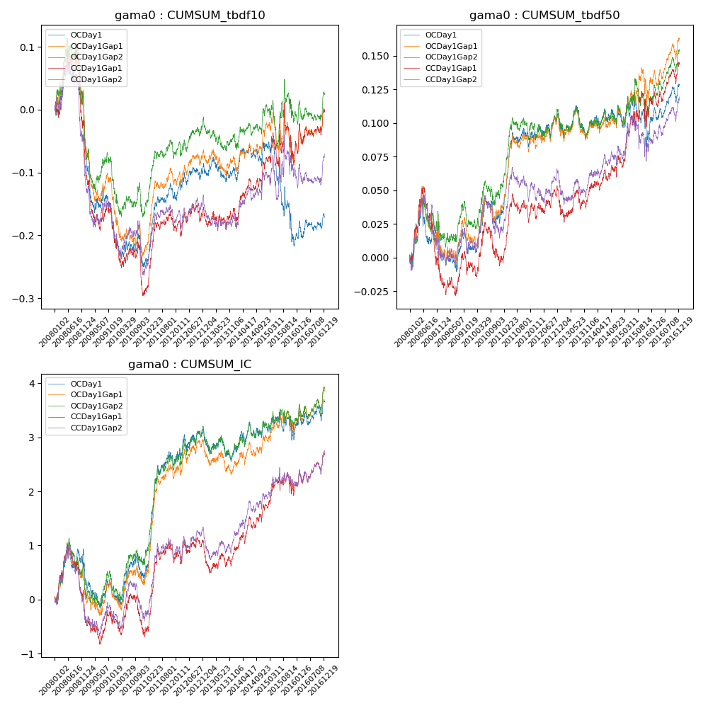

**因子换手率:** 6.85%

**截面指标_OCDay1:**

|  |  |  |  |  |  |  |  |  |
| --- | --- | --- | --- | --- | --- | --- | --- | --- |
| year | annret_tbdf10 | sharpe_tbdf10 | maxdd_tbdf10 | annret_tbdf50 | sharpe_tbdf50 | maxdd_tbdf50 | mean_IC | tstat_IC |
| 2008 | -0.06 | -0.85 | -0.15 | 0.0 | 0.16 | -0.04 | 0.0 | 0.62 |
| 2009 | -0.15 | -3.17 | -0.23 | 0.0 | 0.09 | -0.06 | -0.0 | -0.79 |
| 2010 | -0.04 | -0.9 | -0.14 | 0.02 | 1.0 | -0.05 | 0.0 | 0.85 |
| 2011 | 0.11 | 3.2 | -0.1 | 0.06 | 3.58 | -0.04 | 0.01 | 4.99 |
| 2012 | 0.04 | 1.13 | -0.13 | 0.01 | 0.73 | -0.07 | 0.0 | 0.94 |
| 2013 | 0.0 | 0.08 | -0.14 | -0.0 | -0.19 | -0.08 | -0.0 | -0.56 |
| 2014 | 0.03 | 0.8 | -0.14 | 0.01 | 0.52 | -0.07 | 0.0 | 1.04 |
| 2015 | -0.15 | -1.94 | -0.25 | -0.01 | -0.44 | -0.09 | -0.0 | -0.25 |
| 2016 | 0.04 | 1.29 | -0.12 | 0.04 | 2.27 | -0.06 | 0.0 | 1.63 |

**截面指标_CCDay1Gap1:**

|  |  |  |  |  |  |  |  |  |
| --- | --- | --- | --- | --- | --- | --- | --- | --- |
| year | annret_tbdf10 | sharpe_tbdf10 | maxdd_tbdf10 | annret_tbdf50 | sharpe_tbdf50 | maxdd_tbdf50 | mean_IC | tstat_IC |
| 2008 | -0.09 | -1.24 | -0.17 | -0.02 | -0.44 | -0.07 | -0.0 | -0.68 |
| 2009 | -0.12 | -2.47 | -0.19 | 0.01 | 0.41 | -0.06 | -0.0 | -0.04 |
| 2010 | -0.08 | -1.73 | -0.17 | 0.0 | 0.03 | -0.06 | -0.0 | -0.58 |
| 2011 | 0.1 | 3.0 | -0.09 | 0.04 | 2.23 | -0.05 | 0.01 | 3.53 |
| 2012 | 0.02 | 0.52 | -0.13 | 0.01 | 0.33 | -0.06 | 0.0 | 0.08 |
| 2013 | 0.01 | 0.27 | -0.14 | 0.01 | 0.53 | -0.06 | 0.0 | 0.29 |
| 2014 | 0.07 | 1.81 | -0.14 | 0.02 | 1.22 | -0.05 | 0.0 | 2.01 |
| 2015 | 0.01 | 0.12 | -0.12 | 0.04 | 1.15 | -0.06 | 0.0 | 0.67 |
| 2016 | 0.08 | 1.89 | -0.11 | 0.03 | 1.9 | -0.05 | 0.0 | 1.91 |

**风格暴露:**

|  |  |  |  |  |
| --- | --- | --- | --- | --- |
|  | long | short | corr_OCDay1 | corr_CCDay1Gap1 |
| liquidity10 | 0.02 | -0.02 | -0.01 | -0.03 |
| liquidity20 | 0.02 | -0.02 | 0.0 | -0.03 |
| liquidity5 | 0.02 | -0.02 | -0.01 | -0.05 |
| logmktcap | 0.0 | 0.0 | -0.01 | 0.01 |
| momentum15 | -0.0 | 0.01 | -0.01 | -0.08 |
| momentum30 | -0.01 | 0.01 | 0.02 | -0.06 |
| momentum5 | 0.0 | 0.0 | -0.01 | -0.03 |
| retvolatility30 | 0.02 | -0.01 | -0.0 | 0.0 |