Factors Report 20080102-20161230

**1. gama1**

**截面指标累计曲线:**

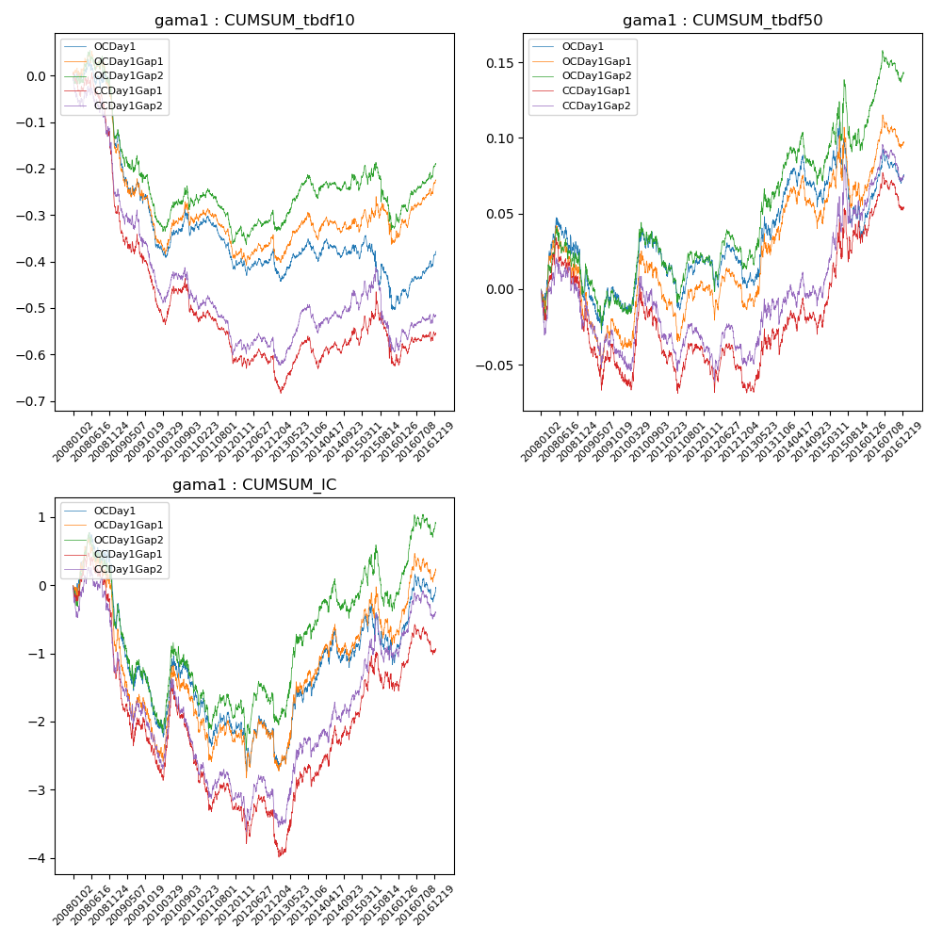

**因子换手率:** 8.06%

**截面指标_OCDay1:**

|  |  |  |  |  |  |  |  |  |
| --- | --- | --- | --- | --- | --- | --- | --- | --- |
| year | annret_tbdf10 | sharpe_tbdf10 | maxdd_tbdf10 | annret_tbdf50 | sharpe_tbdf50 | maxdd_tbdf50 | mean_IC | tstat_IC |
| 2008 | -0.12 | -1.61 | -0.14 | 0.01 | 0.16 | -0.04 | -0.0 | -0.49 |
| 2009 | -0.22 | -3.57 | -0.22 | -0.02 | -0.62 | -0.08 | -0.01 | -2.67 |
| 2010 | -0.0 | -0.03 | -0.09 | 0.03 | 1.07 | -0.05 | 0.0 | 0.39 |
| 2011 | -0.08 | -2.28 | -0.12 | 0.0 | 0.19 | -0.08 | -0.0 | -1.07 |
| 2012 | 0.0 | 0.06 | -0.06 | -0.02 | -0.93 | -0.07 | -0.0 | -0.83 |
| 2013 | 0.03 | 0.81 | -0.07 | 0.05 | 1.98 | -0.05 | 0.0 | 1.96 |
| 2014 | 0.02 | 0.4 | -0.08 | 0.0 | 0.03 | -0.05 | 0.0 | 1.01 |
| 2015 | -0.14 | -1.63 | -0.18 | -0.02 | -0.47 | -0.08 | -0.0 | -0.07 |
| 2016 | 0.12 | 3.16 | -0.05 | 0.04 | 2.3 | -0.05 | 0.0 | 2.5 |

**截面指标_CCDay1Gap1:**

|  |  |  |  |  |  |  |  |  |
| --- | --- | --- | --- | --- | --- | --- | --- | --- |
| year | annret_tbdf10 | sharpe_tbdf10 | maxdd_tbdf10 | annret_tbdf50 | sharpe_tbdf50 | maxdd_tbdf50 | mean_IC | tstat_IC |
| 2008 | -0.25 | -3.4 | -0.23 | -0.02 | -0.59 | -0.05 | -0.0 | -1.9 |
| 2009 | -0.2 | -3.34 | -0.19 | -0.04 | -1.35 | -0.08 | -0.01 | -2.37 |
| 2010 | -0.06 | -1.04 | -0.08 | 0.01 | 0.44 | -0.04 | -0.0 | -0.35 |
| 2011 | -0.1 | -2.73 | -0.12 | -0.0 | -0.08 | -0.08 | -0.0 | -1.64 |
| 2012 | -0.04 | -0.87 | -0.06 | -0.02 | -1.09 | -0.08 | -0.0 | -1.0 |
| 2013 | 0.05 | 1.14 | -0.06 | 0.04 | 1.24 | -0.06 | 0.0 | 1.74 |
| 2014 | 0.06 | 1.35 | -0.11 | 0.01 | 0.44 | -0.06 | 0.0 | 1.94 |
| 2015 | -0.07 | -0.84 | -0.16 | 0.06 | 1.37 | -0.06 | 0.0 | 0.9 |
| 2016 | 0.06 | 1.42 | -0.1 | 0.02 | 0.9 | -0.07 | 0.0 | 1.33 |

**风格暴露:**

|  |  |  |  |  |
| --- | --- | --- | --- | --- |
|  | long | short | corr_OCDay1 | corr_CCDay1Gap1 |
| liquidity10 | 0.01 | -0.0 | 0.09 | 0.08 |
| liquidity20 | 0.01 | -0.0 | 0.1 | 0.09 |
| liquidity5 | 0.01 | -0.0 | 0.1 | 0.1 |
| logmktcap | 0.03 | -0.03 | -0.09 | -0.07 |
| momentum15 | -0.0 | 0.01 | 0.05 | 0.08 |
| momentum30 | -0.0 | 0.01 | 0.08 | 0.12 |
| momentum5 | -0.0 | 0.01 | 0.03 | 0.06 |
| retvolatility30 | -0.01 | 0.02 | 0.14 | 0.11 |