Factors Report 20080102-20161230

**1. gama2**

**截面指标累计曲线:**

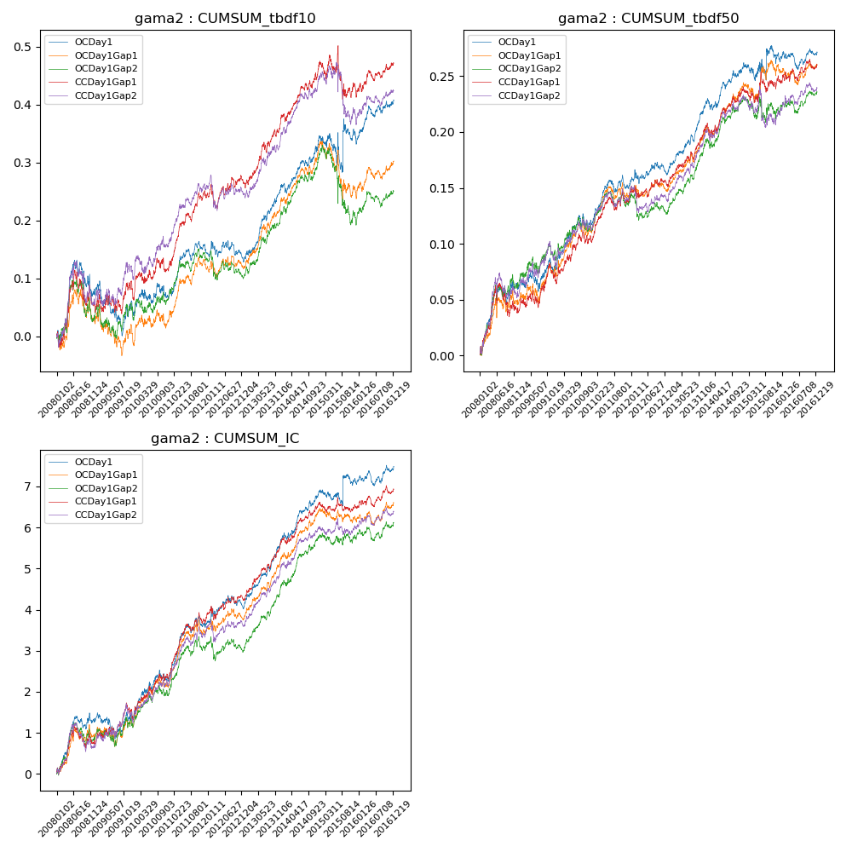

**因子换手率:** 8.14%

**截面指标_OCDay1:**

|  |  |  |  |  |  |  |  |  |
| --- | --- | --- | --- | --- | --- | --- | --- | --- |
| year | annret_tbdf10 | sharpe_tbdf10 | maxdd_tbdf10 | annret_tbdf50 | sharpe_tbdf50 | maxdd_tbdf50 | mean_IC | tstat_IC |
| 2008 | 0.08 | 1.36 | -0.06 | 0.06 | 2.4 | -0.02 | 0.01 | 2.71 |
| 2009 | -0.02 | -0.45 | -0.19 | 0.02 | 0.95 | -0.07 | 0.0 | 0.39 |
| 2010 | 0.01 | 0.29 | -0.14 | 0.04 | 1.63 | -0.07 | 0.0 | 1.66 |
| 2011 | 0.07 | 2.25 | -0.12 | 0.03 | 2.22 | -0.06 | 0.01 | 3.21 |
| 2012 | -0.01 | -0.32 | -0.14 | 0.01 | 0.57 | -0.06 | 0.0 | 0.99 |
| 2013 | 0.13 | 4.14 | -0.12 | 0.06 | 4.22 | -0.06 | 0.01 | 4.69 |
| 2014 | 0.08 | 2.25 | -0.13 | 0.03 | 2.03 | -0.07 | 0.0 | 3.07 |
| 2015 | -0.01 | -0.06 | -0.17 | 0.01 | 0.26 | -0.07 | 0.0 | 0.29 |
| 2016 | 0.08 | 2.44 | -0.12 | 0.01 | 0.44 | -0.07 | 0.0 | 1.25 |

**截面指标_CCDay1Gap1:**

|  |  |  |  |  |  |  |  |  |
| --- | --- | --- | --- | --- | --- | --- | --- | --- |
| year | annret_tbdf10 | sharpe_tbdf10 | maxdd_tbdf10 | annret_tbdf50 | sharpe_tbdf50 | maxdd_tbdf50 | mean_IC | tstat_IC |
| 2008 | 0.06 | 0.93 | -0.06 | 0.04 | 1.45 | -0.03 | 0.0 | 1.72 |
| 2009 | 0.02 | 0.38 | -0.13 | 0.02 | 0.98 | -0.07 | 0.0 | 1.09 |
| 2010 | 0.04 | 0.93 | -0.12 | 0.04 | 1.73 | -0.07 | 0.0 | 2.35 |
| 2011 | 0.12 | 3.68 | -0.11 | 0.04 | 2.51 | -0.06 | 0.01 | 3.63 |
| 2012 | 0.02 | 0.58 | -0.14 | 0.01 | 0.34 | -0.07 | 0.0 | 0.9 |
| 2013 | 0.12 | 3.33 | -0.13 | 0.05 | 3.49 | -0.06 | 0.01 | 4.21 |
| 2014 | 0.09 | 2.51 | -0.13 | 0.03 | 2.09 | -0.07 | 0.0 | 2.67 |
| 2015 | -0.05 | -0.79 | -0.17 | 0.01 | 0.38 | -0.07 | -0.0 | -0.27 |
| 2016 | 0.06 | 1.81 | -0.12 | 0.01 | 0.82 | -0.07 | 0.0 | 1.4 |

**风格暴露:**

|  |  |  |  |  |
| --- | --- | --- | --- | --- |
|  | long | short | corr_OCDay1 | corr_CCDay1Gap1 |
| liquidity10 | -0.0 | 0.01 | 0.07 | 0.04 |
| liquidity20 | -0.0 | 0.01 | 0.07 | 0.04 |
| liquidity5 | -0.0 | 0.01 | 0.05 | 0.04 |
| logmktcap | 0.0 | 0.01 | -0.04 | 0.03 |
| momentum15 | -0.01 | 0.01 | 0.03 | 0.01 |
| momentum30 | -0.01 | 0.02 | 0.06 | 0.02 |
| momentum5 | -0.0 | 0.01 | -0.02 | 0.0 |
| retvolatility30 | -0.02 | 0.02 | 0.06 | 0.03 |