Factors Report 20080102-20161230

**1. gentic0_0**

**截面指标累计曲线:**

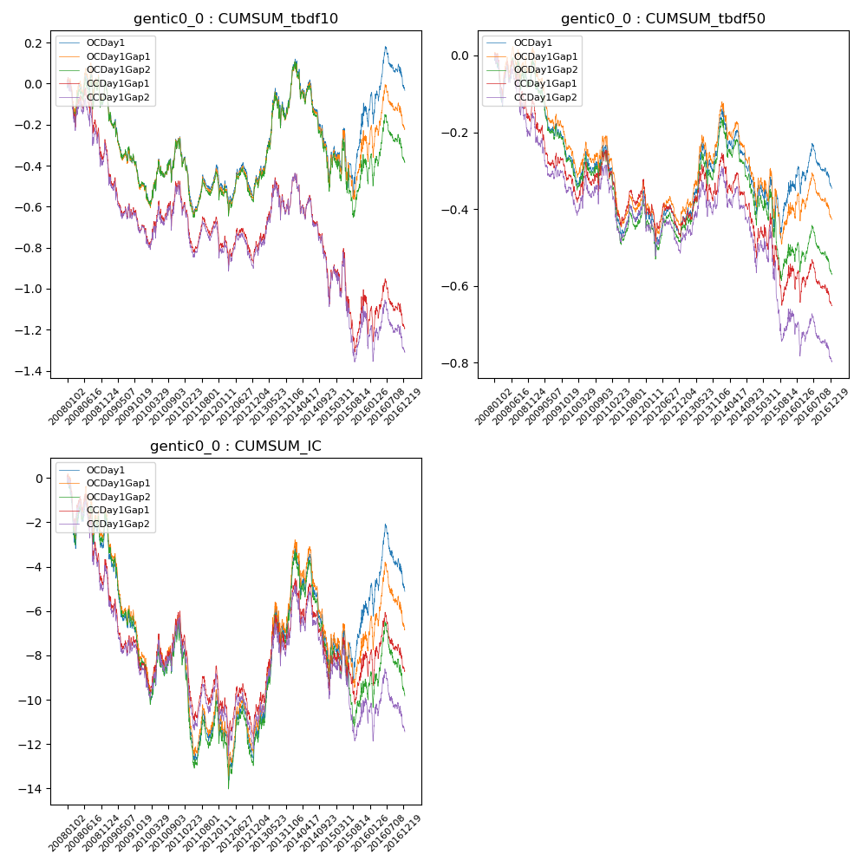

**因子换手率:** 3.27%

**截面指标_OCDay1:**

|  |  |  |  |  |  |  |  |  |
| --- | --- | --- | --- | --- | --- | --- | --- | --- |
| year | annret_tbdf10 | sharpe_tbdf10 | maxdd_tbdf10 | annret_tbdf50 | sharpe_tbdf50 | maxdd_tbdf50 | mean_IC | tstat_IC |
| 2008 | 0.0 | 0.02 | -0.18 | -0.02 | -0.16 | -0.13 | -0.01 | -0.87 |
| 2009 | -0.49 | -3.57 | -0.41 | -0.25 | -3.62 | -0.23 | -0.03 | -4.12 |
| 2010 | 0.23 | 1.3 | -0.11 | 0.03 | 0.3 | -0.08 | 0.01 | 0.87 |
| 2011 | -0.15 | -1.23 | -0.31 | -0.13 | -1.97 | -0.21 | -0.01 | -1.95 |
| 2012 | -0.07 | -0.56 | -0.19 | -0.07 | -1.07 | -0.13 | -0.01 | -0.89 |
| 2013 | 0.52 | 2.71 | -0.17 | 0.24 | 2.6 | -0.08 | 0.03 | 3.12 |
| 2014 | -0.51 | -2.93 | -0.47 | -0.21 | -2.47 | -0.24 | -0.02 | -2.06 |
| 2015 | 0.32 | 1.14 | -0.3 | 0.07 | 0.54 | -0.15 | 0.01 | 1.17 |
| 2016 | 0.14 | 0.85 | -0.2 | -0.0 | -0.06 | -0.11 | 0.0 | 0.51 |

**截面指标_CCDay1Gap1:**

|  |  |  |  |  |  |  |  |  |
| --- | --- | --- | --- | --- | --- | --- | --- | --- |
| year | annret_tbdf10 | sharpe_tbdf10 | maxdd_tbdf10 | annret_tbdf50 | sharpe_tbdf50 | maxdd_tbdf50 | mean_IC | tstat_IC |
| 2008 | -0.3 | -1.43 | -0.34 | -0.12 | -1.19 | -0.17 | -0.02 | -1.93 |
| 2009 | -0.39 | -2.72 | -0.36 | -0.19 | -2.64 | -0.19 | -0.02 | -2.92 |
| 2010 | 0.2 | 1.12 | -0.12 | 0.06 | 0.64 | -0.08 | 0.01 | 1.12 |
| 2011 | -0.22 | -1.74 | -0.29 | -0.1 | -1.54 | -0.18 | -0.01 | -1.78 |
| 2012 | -0.1 | -0.81 | -0.17 | -0.08 | -1.3 | -0.12 | -0.01 | -0.87 |
| 2013 | 0.31 | 1.58 | -0.18 | 0.14 | 1.49 | -0.09 | 0.02 | 2.31 |
| 2014 | -0.54 | -2.88 | -0.48 | -0.21 | -2.33 | -0.24 | -0.01 | -1.79 |
| 2015 | -0.09 | -0.32 | -0.41 | -0.06 | -0.5 | -0.22 | 0.0 | 0.43 |
| 2016 | -0.06 | -0.36 | -0.22 | -0.08 | -1.1 | -0.11 | -0.0 | -0.23 |

**风格暴露:**

|  |  |  |  |  |
| --- | --- | --- | --- | --- |
|  | long | short | corr_OCDay1 | corr_CCDay1Gap1 |
| liquidity10 | -0.24 | 0.25 | 0.28 | 0.27 |
| liquidity20 | -0.25 | 0.26 | 0.27 | 0.27 |
| liquidity5 | -0.24 | 0.25 | 0.29 | 0.27 |
| logmktcap | -0.49 | 0.5 | 0.04 | 0.0 |
| momentum15 | -0.07 | 0.08 | 0.15 | 0.14 |
| momentum30 | -0.19 | 0.19 | 0.24 | 0.22 |
| momentum5 | 0.02 | -0.01 | 0.05 | 0.04 |
| retvolatility30 | -0.41 | 0.41 | 0.4 | 0.39 |