Factors Report 20080102-20161230

**1. gentic1_0**

**截面指标累计曲线:**

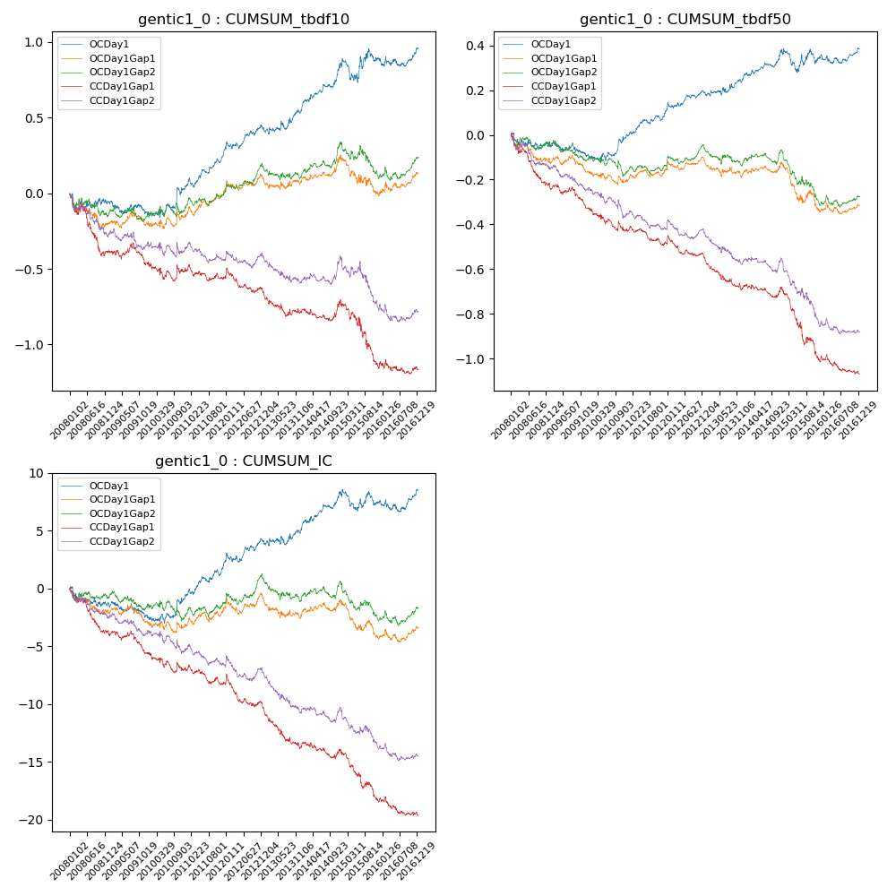

**因子换手率:** 62.76%

**截面指标_OCDay1:**

|  |  |  |  |  |  |  |  |  |
| --- | --- | --- | --- | --- | --- | --- | --- | --- |
| year | annret_tbdf10 | sharpe_tbdf10 | maxdd_tbdf10 | annret_tbdf50 | sharpe_tbdf50 | maxdd_tbdf50 | mean_IC | tstat_IC |
| 2008 | -0.06 | -0.48 | -0.11 | -0.04 | -0.68 | -0.07 | -0.01 | -1.15 |
| 2009 | -0.08 | -1.02 | -0.09 | -0.06 | -1.24 | -0.06 | -0.01 | -1.2 |
| 2010 | 0.19 | 1.96 | -0.05 | 0.1 | 1.84 | -0.03 | 0.01 | 1.7 |
| 2011 | 0.24 | 3.43 | -0.06 | 0.11 | 2.83 | -0.02 | 0.01 | 2.94 |
| 2012 | 0.14 | 2.0 | -0.05 | 0.08 | 2.18 | -0.03 | 0.01 | 1.78 |
| 2013 | 0.13 | 1.43 | -0.05 | 0.06 | 1.16 | -0.02 | 0.0 | 0.95 |
| 2014 | 0.31 | 3.91 | -0.02 | 0.13 | 2.99 | -0.02 | 0.01 | 3.3 |
| 2015 | 0.03 | 0.19 | -0.15 | -0.02 | -0.29 | -0.1 | -0.0 | -0.57 |
| 2016 | 0.07 | 0.81 | -0.06 | 0.03 | 0.8 | -0.04 | 0.0 | 0.98 |

**截面指标_CCDay1Gap1:**

|  |  |  |  |  |  |  |  |  |
| --- | --- | --- | --- | --- | --- | --- | --- | --- |
| year | annret_tbdf10 | sharpe_tbdf10 | maxdd_tbdf10 | annret_tbdf50 | sharpe_tbdf50 | maxdd_tbdf50 | mean_IC | tstat_IC |
| 2008 | -0.38 | -3.13 | -0.35 | -0.24 | -4.18 | -0.22 | -0.02 | -3.79 |
| 2009 | -0.08 | -0.94 | -0.14 | -0.09 | -1.99 | -0.1 | -0.01 | -1.74 |
| 2010 | -0.05 | -0.51 | -0.12 | -0.1 | -1.71 | -0.1 | -0.01 | -1.34 |
| 2011 | -0.04 | -0.54 | -0.1 | -0.06 | -1.58 | -0.08 | -0.0 | -1.33 |
| 2012 | -0.11 | -1.49 | -0.15 | -0.07 | -1.82 | -0.1 | -0.01 | -2.26 |
| 2013 | -0.12 | -1.43 | -0.15 | -0.13 | -2.68 | -0.13 | -0.01 | -3.02 |
| 2014 | 0.06 | 0.74 | -0.08 | -0.01 | -0.13 | -0.06 | -0.0 | -0.51 |
| 2015 | -0.4 | -2.42 | -0.37 | -0.31 | -3.55 | -0.28 | -0.02 | -3.2 |
| 2016 | -0.04 | -0.5 | -0.09 | -0.07 | -1.91 | -0.08 | -0.01 | -1.75 |

**风格暴露:**

|  |  |  |  |  |
| --- | --- | --- | --- | --- |
|  | long | short | corr_OCDay1 | corr_CCDay1Gap1 |
| liquidity10 | -0.2 | 0.19 | 0.05 | 0.07 |
| liquidity20 | -0.08 | 0.07 | -0.03 | 0.02 |
| liquidity5 | -0.26 | 0.24 | 0.1 | 0.13 |
| logmktcap | -0.19 | 0.19 | 0.22 | 0.21 |
| momentum15 | -0.47 | 0.47 | 0.37 | 0.38 |
| momentum30 | -0.27 | 0.27 | 0.25 | 0.26 |
| momentum5 | -0.3 | 0.31 | 0.38 | 0.34 |
| retvolatility30 | -0.03 | 0.01 | -0.09 | -0.05 |