Factors Report 20080102-20161230

**1. gentic1_1**

**截面指标累计曲线:**

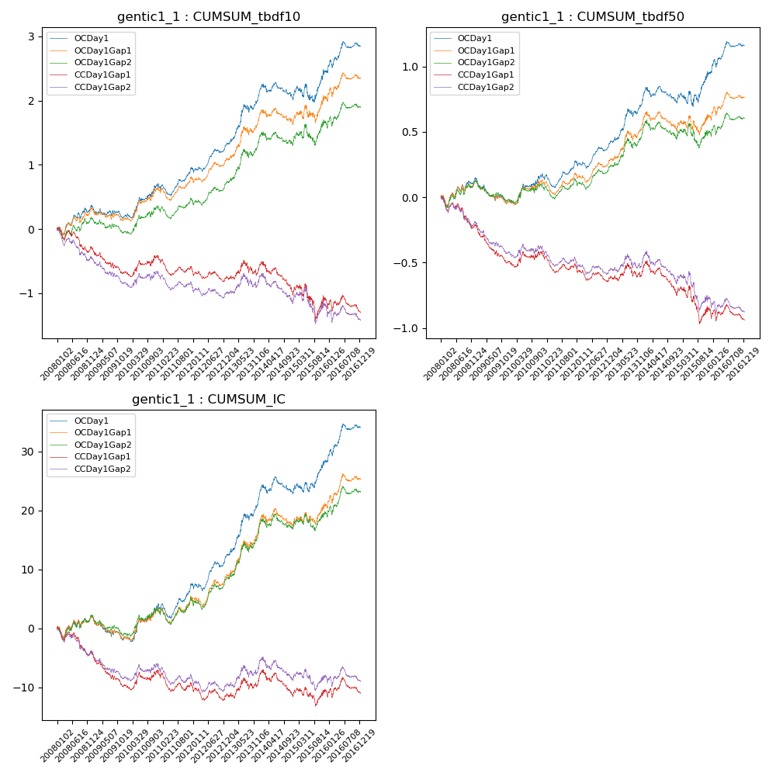

**因子换手率:** 36.77%

**截面指标_OCDay1:**

|  |  |  |  |  |  |  |  |  |
| --- | --- | --- | --- | --- | --- | --- | --- | --- |
| year | annret_tbdf10 | sharpe_tbdf10 | maxdd_tbdf10 | annret_tbdf50 | sharpe_tbdf50 | maxdd_tbdf50 | mean_IC | tstat_IC |
| 2008 | 0.36 | 2.22 | -0.12 | 0.14 | 1.67 | -0.08 | 0.01 | 1.18 |
| 2009 | -0.16 | -1.18 | -0.19 | -0.18 | -2.7 | -0.18 | -0.01 | -2.41 |
| 2010 | 0.51 | 2.79 | -0.07 | 0.21 | 2.35 | -0.03 | 0.02 | 2.74 |
| 2011 | 0.24 | 1.9 | -0.17 | 0.09 | 1.5 | -0.1 | 0.01 | 1.95 |
| 2012 | 0.36 | 3.16 | -0.07 | 0.14 | 2.57 | -0.05 | 0.02 | 3.02 |
| 2013 | 0.81 | 3.87 | -0.12 | 0.35 | 3.57 | -0.06 | 0.04 | 4.26 |
| 2014 | -0.08 | -0.51 | -0.24 | -0.03 | -0.42 | -0.12 | 0.0 | 0.33 |
| 2015 | 0.43 | 1.38 | -0.26 | 0.23 | 1.55 | -0.11 | 0.02 | 2.08 |
| 2016 | 0.41 | 2.27 | -0.12 | 0.22 | 2.58 | -0.06 | 0.02 | 3.03 |

**截面指标_CCDay1Gap1:**

|  |  |  |  |  |  |  |  |  |
| --- | --- | --- | --- | --- | --- | --- | --- | --- |
| year | annret_tbdf10 | sharpe_tbdf10 | maxdd_tbdf10 | annret_tbdf50 | sharpe_tbdf50 | maxdd_tbdf50 | mean_IC | tstat_IC |
| 2008 | -0.3 | -1.89 | -0.33 | -0.22 | -2.61 | -0.23 | -0.02 | -2.69 |
| 2009 | -0.38 | -2.71 | -0.35 | -0.28 | -4.2 | -0.26 | -0.02 | -3.82 |
| 2010 | 0.25 | 1.39 | -0.09 | 0.07 | 0.83 | -0.06 | 0.01 | 1.34 |
| 2011 | -0.23 | -1.93 | -0.26 | -0.12 | -2.01 | -0.15 | -0.01 | -1.84 |
| 2012 | -0.11 | -1.0 | -0.16 | -0.08 | -1.47 | -0.11 | -0.01 | -1.08 |
| 2013 | 0.16 | 0.75 | -0.22 | 0.07 | 0.68 | -0.1 | 0.01 | 1.31 |
| 2014 | -0.41 | -2.34 | -0.42 | -0.19 | -2.33 | -0.24 | -0.01 | -1.6 |
| 2015 | -0.14 | -0.45 | -0.44 | -0.14 | -1.02 | -0.26 | 0.0 | 0.23 |
| 2016 | -0.14 | -0.76 | -0.24 | -0.05 | -0.62 | -0.12 | 0.0 | 0.0 |

**风格暴露:**

|  |  |  |  |  |
| --- | --- | --- | --- | --- |
|  | long | short | corr_OCDay1 | corr_CCDay1Gap1 |
| liquidity10 | -0.74 | 0.74 | 0.56 | 0.54 |
| liquidity20 | -0.66 | 0.66 | 0.53 | 0.52 |
| liquidity5 | -0.83 | 0.83 | 0.59 | 0.56 |
| logmktcap | -0.28 | 0.29 | -0.09 | -0.14 |
| momentum15 | -0.52 | 0.53 | 0.35 | 0.31 |
| momentum30 | -0.57 | 0.58 | 0.43 | 0.36 |
| momentum5 | -0.47 | 0.47 | 0.22 | 0.19 |
| retvolatility30 | -0.89 | 0.9 | 0.64 | 0.63 |