Factors Report 20080102-20161230

**1. gentic2_7**

**截面指标累计曲线:**

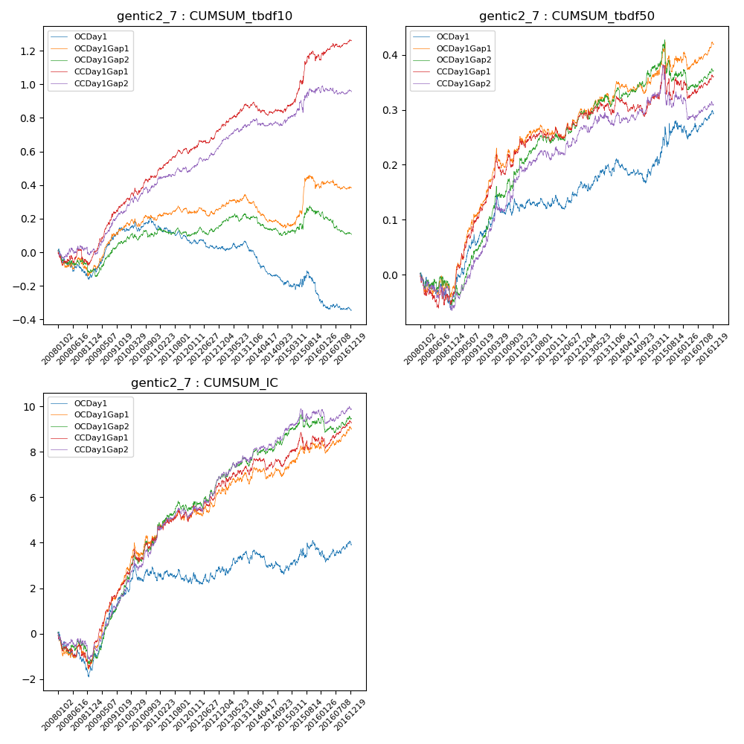

**因子换手率:** 41.41%

**截面指标_OCDay1:**

|  |  |  |  |  |  |  |  |  |
| --- | --- | --- | --- | --- | --- | --- | --- | --- |
| year | annret_tbdf10 | sharpe_tbdf10 | maxdd_tbdf10 | annret_tbdf50 | sharpe_tbdf50 | maxdd_tbdf50 | mean_IC | tstat_IC |
| 2008 | -0.14 | -1.85 | -0.17 | -0.04 | -0.92 | -0.07 | -0.01 | -2.15 |
| 2009 | 0.28 | 4.37 | -0.02 | 0.12 | 3.53 | -0.02 | 0.01 | 4.93 |
| 2010 | 0.01 | 0.14 | -0.06 | 0.04 | 1.19 | -0.04 | 0.0 | 1.06 |
| 2011 | -0.08 | -1.77 | -0.09 | 0.0 | 0.11 | -0.02 | -0.0 | -0.25 |
| 2012 | -0.04 | -0.88 | -0.06 | 0.03 | 1.39 | -0.03 | 0.0 | 0.73 |
| 2013 | -0.02 | -0.37 | -0.06 | 0.04 | 1.43 | -0.02 | 0.0 | 1.3 |
| 2014 | -0.19 | -4.19 | -0.19 | -0.01 | -0.4 | -0.04 | -0.0 | -1.18 |
| 2015 | -0.08 | -0.82 | -0.14 | 0.08 | 1.36 | -0.04 | 0.0 | 0.85 |
| 2016 | -0.08 | -1.75 | -0.08 | 0.03 | 0.97 | -0.03 | 0.0 | 0.41 |

**截面指标_CCDay1Gap1:**

|  |  |  |  |  |  |  |  |  |
| --- | --- | --- | --- | --- | --- | --- | --- | --- |
| year | annret_tbdf10 | sharpe_tbdf10 | maxdd_tbdf10 | annret_tbdf50 | sharpe_tbdf50 | maxdd_tbdf50 | mean_IC | tstat_IC |
| 2008 | -0.05 | -0.56 | -0.09 | -0.04 | -0.89 | -0.06 | -0.01 | -1.78 |
| 2009 | 0.34 | 5.35 | -0.02 | 0.17 | 5.04 | -0.01 | 0.01 | 5.91 |
| 2010 | 0.16 | 2.71 | -0.04 | 0.09 | 2.48 | -0.04 | 0.01 | 3.01 |
| 2011 | 0.14 | 3.22 | -0.03 | 0.02 | 0.78 | -0.02 | 0.0 | 1.46 |
| 2012 | 0.16 | 3.48 | -0.02 | 0.04 | 1.65 | -0.02 | 0.01 | 2.73 |
| 2013 | 0.15 | 2.78 | -0.03 | 0.02 | 0.76 | -0.02 | 0.0 | 1.55 |
| 2014 | -0.04 | -0.93 | -0.08 | 0.0 | 0.13 | -0.04 | 0.0 | 0.36 |
| 2015 | 0.32 | 3.18 | -0.06 | 0.04 | 0.77 | -0.06 | 0.0 | 1.28 |
| 2016 | 0.09 | 1.72 | -0.03 | 0.01 | 0.26 | -0.03 | 0.0 | 1.38 |

**风格暴露:**

|  |  |  |  |  |
| --- | --- | --- | --- | --- |
|  | long | short | corr_OCDay1 | corr_CCDay1Gap1 |
| liquidity10 | -0.1 | 0.06 | 0.24 | 0.25 |
| liquidity20 | -0.06 | 0.04 | 0.21 | 0.21 |
| liquidity5 | -0.08 | 0.05 | 0.23 | 0.22 |
| logmktcap | -0.0 | 0.01 | -0.13 | -0.16 |
| momentum15 | -0.22 | 0.22 | 0.35 | 0.36 |
| momentum30 | -0.15 | 0.15 | 0.29 | 0.28 |
| momentum5 | -0.05 | 0.05 | 0.12 | 0.17 |
| retvolatility30 | -0.04 | 0.01 | 0.16 | 0.15 |