Factors Report 20080102-20161230

**1. gentic2_9**

**截面指标累计曲线:**

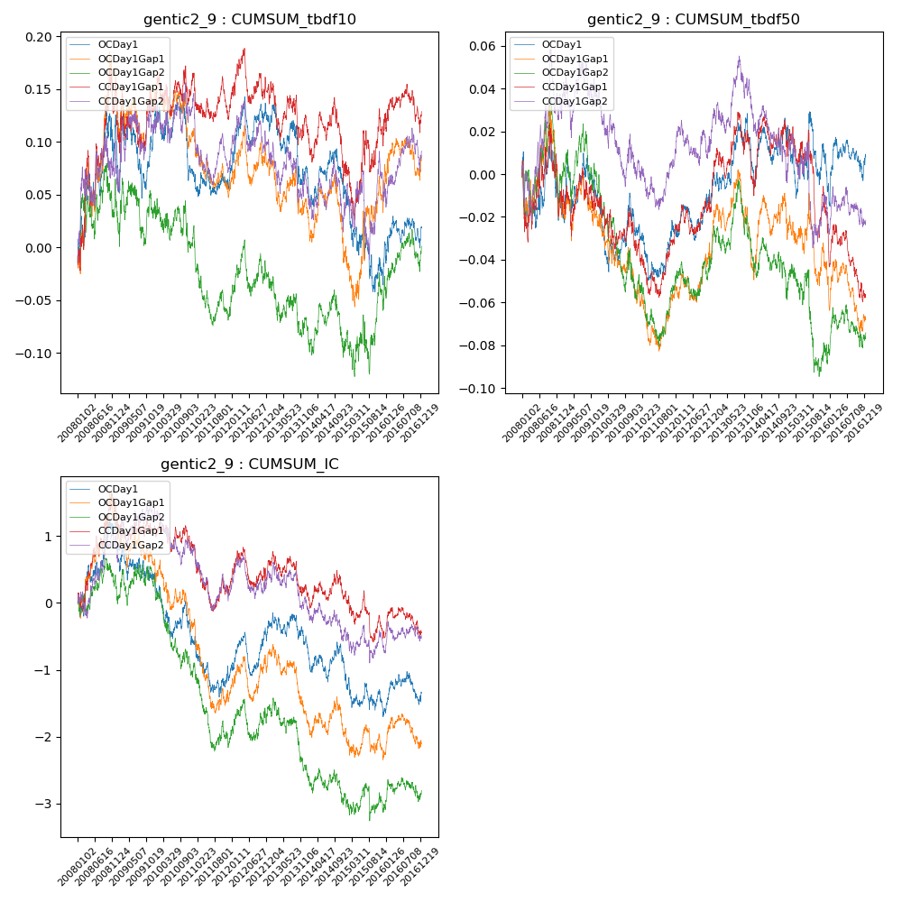

**因子换手率:** 39.02%

**截面指标_OCDay1:**

|  |  |  |  |  |  |  |  |  |
| --- | --- | --- | --- | --- | --- | --- | --- | --- |
| year | annret_tbdf10 | sharpe_tbdf10 | maxdd_tbdf10 | annret_tbdf50 | sharpe_tbdf50 | maxdd_tbdf50 | mean_IC | tstat_IC |
| 2008 | 0.11 | 1.2 | -0.06 | -0.02 | -0.39 | -0.04 | 0.0 | 1.28 |
| 2009 | 0.01 | 0.11 | -0.08 | 0.0 | 0.02 | -0.03 | -0.0 | -1.03 |
| 2010 | -0.04 | -0.75 | -0.08 | -0.01 | -0.43 | -0.03 | -0.0 | -1.64 |
| 2011 | 0.0 | 0.0 | -0.03 | 0.0 | 0.12 | -0.03 | -0.0 | -0.85 |
| 2012 | 0.05 | 1.16 | -0.05 | 0.02 | 1.38 | -0.02 | 0.0 | 1.55 |
| 2013 | -0.05 | -0.87 | -0.07 | 0.01 | 0.63 | -0.01 | -0.0 | -0.63 |
| 2014 | -0.02 | -0.54 | -0.05 | 0.0 | 0.07 | -0.02 | -0.0 | -1.01 |
| 2015 | -0.09 | -1.28 | -0.09 | -0.02 | -0.67 | -0.04 | -0.0 | -1.19 |
| 2016 | 0.06 | 1.31 | -0.03 | 0.02 | 0.74 | -0.02 | 0.0 | 0.84 |

**截面指标_CCDay1Gap1:**

|  |  |  |  |  |  |  |  |  |
| --- | --- | --- | --- | --- | --- | --- | --- | --- |
| year | annret_tbdf10 | sharpe_tbdf10 | maxdd_tbdf10 | annret_tbdf50 | sharpe_tbdf50 | maxdd_tbdf50 | mean_IC | tstat_IC |
| 2008 | 0.14 | 1.57 | -0.05 | -0.01 | -0.23 | -0.04 | 0.01 | 1.99 |
| 2009 | -0.01 | -0.08 | -0.05 | -0.0 | -0.15 | -0.02 | -0.0 | -0.34 |
| 2010 | 0.02 | 0.36 | -0.04 | -0.02 | -0.88 | -0.03 | -0.0 | -0.65 |
| 2011 | -0.02 | -0.41 | -0.05 | 0.01 | 0.61 | -0.03 | -0.0 | -0.94 |
| 2012 | -0.0 | -0.06 | -0.05 | 0.03 | 1.44 | -0.01 | 0.0 | 0.52 |
| 2013 | -0.02 | -0.37 | -0.06 | 0.01 | 0.24 | -0.02 | -0.0 | -0.8 |
| 2014 | -0.05 | -1.06 | -0.08 | 0.01 | 0.41 | -0.02 | -0.0 | -0.24 |
| 2015 | 0.03 | 0.36 | -0.05 | -0.04 | -1.42 | -0.05 | -0.0 | -1.24 |
| 2016 | 0.03 | 0.72 | -0.05 | -0.03 | -1.47 | -0.04 | 0.0 | 0.24 |

**风格暴露:**

|  |  |  |  |  |
| --- | --- | --- | --- | --- |
|  | long | short | corr_OCDay1 | corr_CCDay1Gap1 |
| liquidity10 | -0.25 | -0.27 | -0.02 | -0.01 |
| liquidity20 | -0.27 | -0.28 | -0.01 | -0.01 |
| liquidity5 | -0.24 | -0.26 | -0.04 | -0.02 |
| logmktcap | 0.57 | 0.64 | -0.01 | -0.0 |
| momentum15 | 0.01 | 0.01 | -0.05 | -0.01 |
| momentum30 | 0.01 | 0.01 | -0.04 | 0.0 |
| momentum5 | 0.01 | 0.01 | -0.02 | 0.01 |
| retvolatility30 | -0.21 | -0.2 | -0.0 | 0.01 |