Factors Report 20080102-20161230

**1. gentic3_8**

**截面指标累计曲线:**

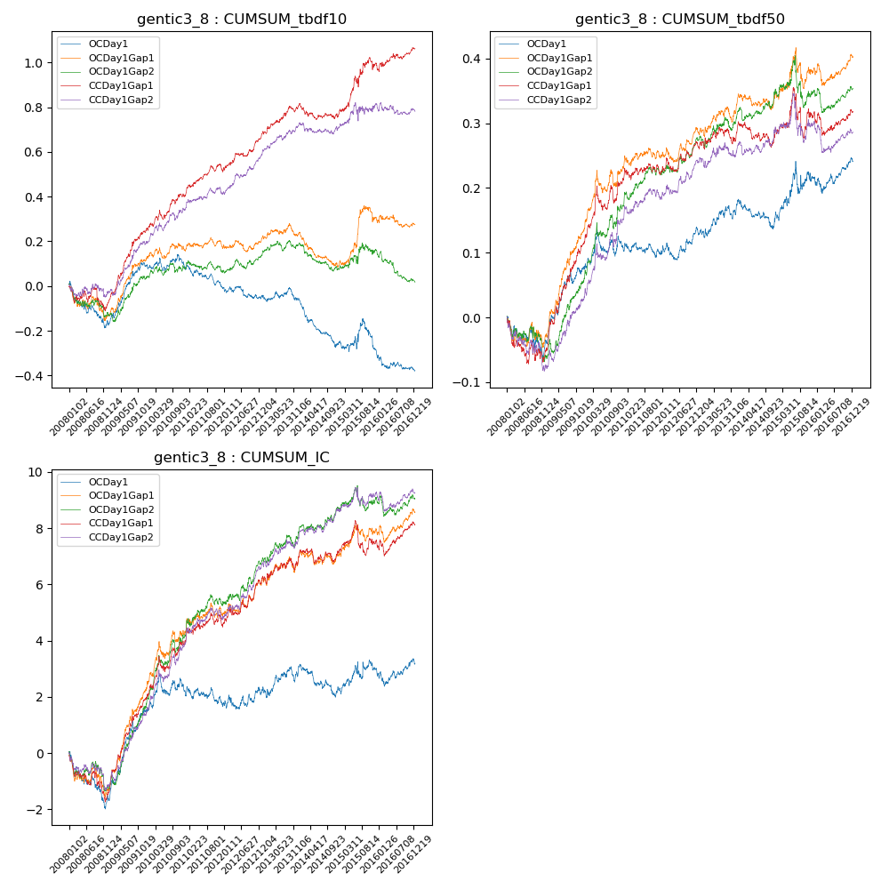

**因子换手率:** 41.33%

**截面指标_OCDay1:**

|  |  |  |  |  |  |  |  |  |
| --- | --- | --- | --- | --- | --- | --- | --- | --- |
| year | annret_tbdf10 | sharpe_tbdf10 | maxdd_tbdf10 | annret_tbdf50 | sharpe_tbdf50 | maxdd_tbdf50 | mean_IC | tstat_IC |
| 2008 | -0.17 | -2.19 | -0.19 | -0.04 | -0.92 | -0.06 | -0.01 | -2.25 |
| 2009 | 0.26 | 4.11 | -0.02 | 0.11 | 3.48 | -0.02 | 0.01 | 4.73 |
| 2010 | -0.01 | -0.11 | -0.06 | 0.03 | 0.92 | -0.04 | 0.0 | 0.96 |
| 2011 | -0.09 | -2.22 | -0.1 | -0.01 | -0.48 | -0.02 | -0.0 | -0.8 |
| 2012 | -0.04 | -0.83 | -0.06 | 0.03 | 1.25 | -0.03 | 0.0 | 0.68 |
| 2013 | -0.01 | -0.23 | -0.06 | 0.05 | 1.52 | -0.02 | 0.0 | 1.41 |
| 2014 | -0.2 | -4.4 | -0.2 | -0.01 | -0.46 | -0.05 | -0.0 | -1.38 |
| 2015 | -0.04 | -0.38 | -0.14 | 0.05 | 0.95 | -0.05 | 0.0 | 0.67 |
| 2016 | -0.08 | -1.72 | -0.08 | 0.03 | 1.1 | -0.03 | 0.0 | 0.42 |

**截面指标_CCDay1Gap1:**

|  |  |  |  |  |  |  |  |  |
| --- | --- | --- | --- | --- | --- | --- | --- | --- |
| year | annret_tbdf10 | sharpe_tbdf10 | maxdd_tbdf10 | annret_tbdf50 | sharpe_tbdf50 | maxdd_tbdf50 | mean_IC | tstat_IC |
| 2008 | -0.08 | -0.89 | -0.11 | -0.05 | -1.27 | -0.07 | -0.01 | -2.1 |
| 2009 | 0.33 | 5.4 | -0.02 | 0.17 | 5.06 | -0.01 | 0.01 | 5.96 |
| 2010 | 0.15 | 2.62 | -0.04 | 0.1 | 2.45 | -0.04 | 0.01 | 3.01 |
| 2011 | 0.11 | 2.58 | -0.04 | 0.01 | 0.56 | -0.02 | 0.0 | 1.14 |
| 2012 | 0.16 | 3.63 | -0.02 | 0.04 | 1.54 | -0.02 | 0.01 | 2.7 |
| 2013 | 0.14 | 2.74 | -0.03 | 0.03 | 0.82 | -0.03 | 0.0 | 1.54 |
| 2014 | -0.05 | -1.14 | -0.07 | -0.0 | -0.01 | -0.04 | 0.0 | 0.14 |
| 2015 | 0.23 | 2.3 | -0.05 | 0.03 | 0.61 | -0.08 | 0.0 | 0.62 |
| 2016 | 0.07 | 1.31 | -0.03 | 0.0 | 0.0 | -0.04 | 0.0 | 1.14 |

**风格暴露:**

|  |  |  |  |  |
| --- | --- | --- | --- | --- |
|  | long | short | corr_OCDay1 | corr_CCDay1Gap1 |
| liquidity10 | -0.08 | 0.08 | 0.22 | 0.24 |
| liquidity20 | -0.05 | 0.05 | 0.19 | 0.19 |
| liquidity5 | -0.07 | 0.06 | 0.22 | 0.23 |
| logmktcap | -0.0 | 0.01 | -0.08 | -0.1 |
| momentum15 | -0.22 | 0.23 | 0.37 | 0.41 |
| momentum30 | -0.15 | 0.15 | 0.3 | 0.33 |
| momentum5 | -0.05 | 0.06 | 0.14 | 0.19 |
| retvolatility30 | -0.03 | 0.02 | 0.13 | 0.12 |