Factors Report 20080102-20161230

**1. genticT77_1_10**

**截面指标累计曲线:**

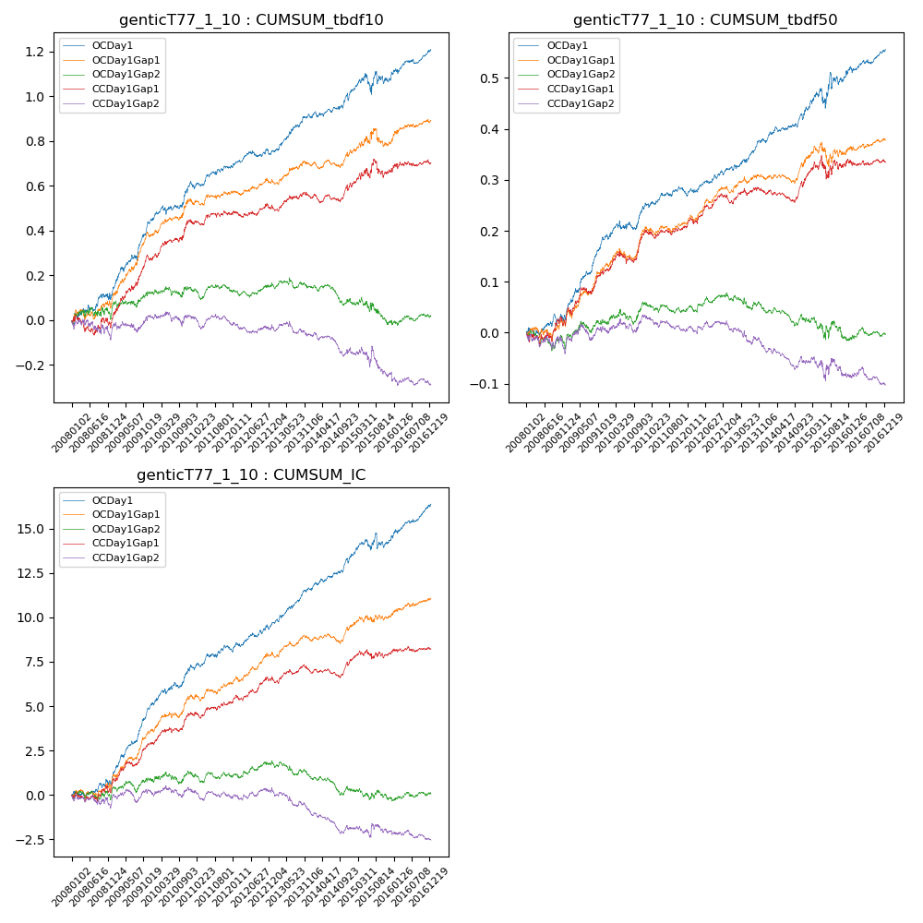

**因子换手率:** 46.3%

**截面指标_OCDay1:**

|  |  |  |  |  |  |  |  |  |
| --- | --- | --- | --- | --- | --- | --- | --- | --- |
| year | annret_tbdf10 | sharpe_tbdf10 | maxdd_tbdf10 | annret_tbdf50 | sharpe_tbdf50 | maxdd_tbdf50 | mean_IC | tstat_IC |
| 2008 | 0.12 | 1.47 | -0.03 | 0.04 | 1.16 | -0.02 | 0.0 | 1.27 |
| 2009 | 0.33 | 5.42 | -0.02 | 0.15 | 5.36 | -0.01 | 0.02 | 6.96 |
| 2010 | 0.16 | 2.58 | -0.04 | 0.06 | 2.11 | -0.02 | 0.01 | 3.05 |
| 2011 | 0.08 | 1.76 | -0.02 | 0.02 | 0.95 | -0.02 | 0.0 | 1.55 |
| 2012 | 0.06 | 1.56 | -0.03 | 0.05 | 2.5 | -0.01 | 0.01 | 2.75 |
| 2013 | 0.16 | 3.49 | -0.02 | 0.06 | 2.76 | -0.01 | 0.01 | 4.02 |
| 2014 | 0.11 | 2.25 | -0.03 | 0.06 | 2.6 | -0.01 | 0.01 | 3.41 |
| 2015 | 0.06 | 0.58 | -0.09 | 0.07 | 1.26 | -0.04 | 0.0 | 0.87 |
| 2016 | 0.13 | 2.83 | -0.02 | 0.05 | 2.46 | -0.01 | 0.01 | 3.83 |

**截面指标_CCDay1Gap1:**

|  |  |  |  |  |  |  |  |  |
| --- | --- | --- | --- | --- | --- | --- | --- | --- |
| year | annret_tbdf10 | sharpe_tbdf10 | maxdd_tbdf10 | annret_tbdf50 | sharpe_tbdf50 | maxdd_tbdf50 | mean_IC | tstat_IC |
| 2008 | 0.0 | 0.05 | -0.09 | 0.04 | 0.92 | -0.02 | 0.0 | 0.81 |
| 2009 | 0.27 | 4.18 | -0.03 | 0.09 | 3.11 | -0.02 | 0.01 | 3.93 |
| 2010 | 0.17 | 2.67 | -0.02 | 0.08 | 2.76 | -0.02 | 0.01 | 2.82 |
| 2011 | 0.04 | 0.84 | -0.02 | 0.01 | 0.37 | -0.02 | 0.0 | 1.26 |
| 2012 | 0.04 | 0.84 | -0.03 | 0.06 | 2.99 | -0.01 | 0.01 | 2.66 |
| 2013 | 0.04 | 0.82 | -0.03 | 0.01 | 0.31 | -0.02 | 0.0 | 0.71 |
| 2014 | 0.05 | 1.16 | -0.04 | 0.03 | 1.36 | -0.02 | 0.0 | 1.49 |
| 2015 | 0.06 | 0.68 | -0.08 | 0.02 | 0.49 | -0.05 | 0.0 | 0.49 |
| 2016 | 0.04 | 0.77 | -0.02 | 0.01 | 0.37 | -0.01 | 0.0 | 0.59 |

**风格暴露:**

|  |  |  |  |  |
| --- | --- | --- | --- | --- |
|  | long | short | corr_OCDay1 | corr_CCDay1Gap1 |
| liquidity10 | -0.01 | 0.01 | 0.0 | 0.04 |
| liquidity20 | -0.01 | 0.01 | 0.01 | 0.05 |
| liquidity5 | -0.0 | 0.0 | -0.01 | 0.08 |
| logmktcap | 0.0 | 0.01 | 0.01 | 0.0 |
| momentum15 | 0.01 | -0.0 | 0.01 | 0.12 |
| momentum30 | -0.0 | 0.01 | -0.01 | 0.1 |
| momentum5 | 0.05 | -0.04 | -0.08 | 0.03 |
| retvolatility30 | -0.01 | 0.01 | 0.02 | 0.06 |