Factors Report 20080102-20161230

**1. genticT77_1_15**

**截面指标累计曲线:**

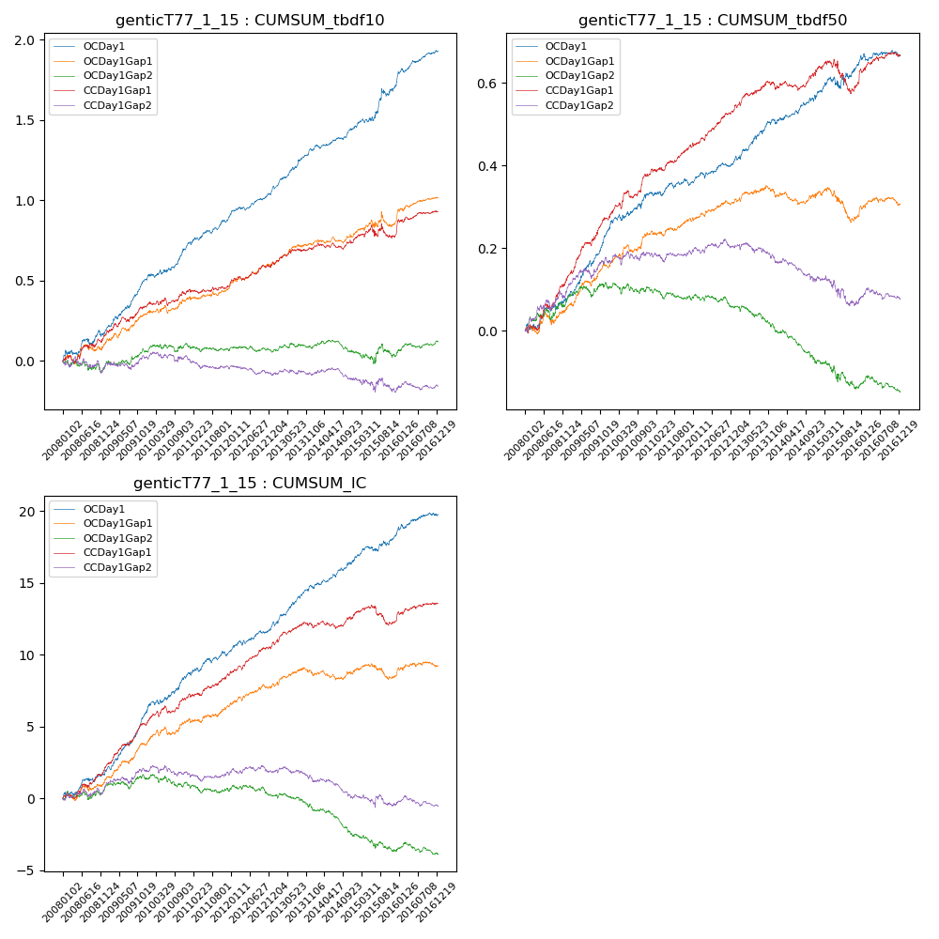

**因子换手率:** 74.68%

**截面指标_OCDay1:**

|  |  |  |  |  |  |  |  |  |
| --- | --- | --- | --- | --- | --- | --- | --- | --- |
| year | annret_tbdf10 | sharpe_tbdf10 | maxdd_tbdf10 | annret_tbdf50 | sharpe_tbdf50 | maxdd_tbdf50 | mean_IC | tstat_IC |
| 2008 | 0.17 | 2.06 | -0.04 | 0.08 | 2.11 | -0.02 | 0.01 | 2.32 |
| 2009 | 0.33 | 5.55 | -0.02 | 0.17 | 5.81 | -0.01 | 0.02 | 6.53 |
| 2010 | 0.23 | 3.66 | -0.03 | 0.09 | 2.65 | -0.02 | 0.01 | 3.63 |
| 2011 | 0.17 | 3.68 | -0.02 | 0.03 | 1.06 | -0.02 | 0.01 | 2.45 |
| 2012 | 0.15 | 3.64 | -0.02 | 0.05 | 2.41 | -0.01 | 0.01 | 3.05 |
| 2013 | 0.26 | 5.32 | -0.02 | 0.1 | 3.75 | -0.01 | 0.01 | 4.57 |
| 2014 | 0.14 | 3.56 | -0.02 | 0.06 | 2.22 | -0.01 | 0.01 | 3.22 |
| 2015 | 0.26 | 2.68 | -0.05 | 0.08 | 1.69 | -0.03 | 0.01 | 2.42 |
| 2016 | 0.22 | 4.35 | -0.03 | 0.02 | 0.84 | -0.02 | 0.01 | 2.41 |

**截面指标_CCDay1Gap1:**

|  |  |  |  |  |  |  |  |  |
| --- | --- | --- | --- | --- | --- | --- | --- | --- |
| year | annret_tbdf10 | sharpe_tbdf10 | maxdd_tbdf10 | annret_tbdf50 | sharpe_tbdf50 | maxdd_tbdf50 | mean_IC | tstat_IC |
| 2008 | 0.16 | 2.0 | -0.05 | 0.13 | 3.24 | -0.01 | 0.01 | 3.14 |
| 2009 | 0.19 | 2.98 | -0.03 | 0.15 | 4.76 | -0.01 | 0.01 | 5.03 |
| 2010 | 0.09 | 1.52 | -0.05 | 0.11 | 3.42 | -0.02 | 0.01 | 2.91 |
| 2011 | 0.05 | 1.01 | -0.02 | 0.07 | 2.91 | -0.01 | 0.01 | 2.81 |
| 2012 | 0.12 | 2.64 | -0.02 | 0.09 | 4.06 | -0.01 | 0.01 | 3.52 |
| 2013 | 0.1 | 2.15 | -0.02 | 0.06 | 2.31 | -0.01 | 0.01 | 2.44 |
| 2014 | 0.06 | 1.38 | -0.04 | 0.04 | 1.46 | -0.02 | 0.0 | 1.55 |
| 2015 | 0.03 | 0.35 | -0.09 | -0.03 | -0.72 | -0.08 | -0.0 | -0.65 |
| 2016 | 0.14 | 2.66 | -0.02 | 0.07 | 2.58 | -0.01 | 0.01 | 2.36 |

**风格暴露:**

|  |  |  |  |  |
| --- | --- | --- | --- | --- |
|  | long | short | corr_OCDay1 | corr_CCDay1Gap1 |
| liquidity10 | 0.06 | -0.06 | -0.11 | -0.12 |
| liquidity20 | 0.01 | -0.01 | -0.07 | -0.08 |
| liquidity5 | 0.1 | -0.09 | -0.15 | -0.12 |
| logmktcap | -0.0 | 0.01 | 0.0 | 0.05 |
| momentum15 | 0.26 | -0.25 | -0.3 | -0.24 |
| momentum30 | 0.13 | -0.13 | -0.22 | -0.19 |
| momentum5 | 0.28 | -0.27 | -0.32 | -0.23 |
| retvolatility30 | 0.01 | -0.01 | -0.06 | -0.06 |