Factors Report 20080102-20161230

**1. genticT77_1_20**

**截面指标累计曲线:**

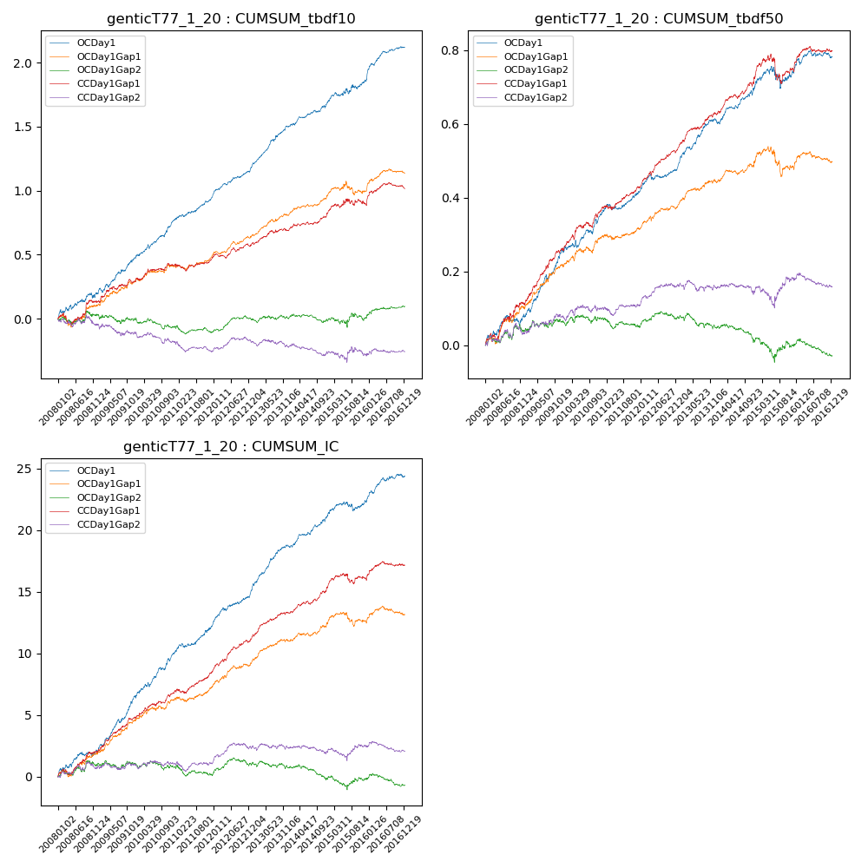

**因子换手率:** 70.81%

**截面指标_OCDay1:**

|  |  |  |  |  |  |  |  |  |
| --- | --- | --- | --- | --- | --- | --- | --- | --- |
| year | annret_tbdf10 | sharpe_tbdf10 | maxdd_tbdf10 | annret_tbdf50 | sharpe_tbdf50 | maxdd_tbdf50 | mean_IC | tstat_IC |
| 2008 | 0.2 | 2.24 | -0.04 | 0.08 | 2.15 | -0.03 | 0.01 | 2.73 |
| 2009 | 0.27 | 4.15 | -0.03 | 0.18 | 5.19 | -0.01 | 0.02 | 5.97 |
| 2010 | 0.3 | 5.23 | -0.03 | 0.1 | 3.0 | -0.02 | 0.01 | 4.76 |
| 2011 | 0.19 | 4.17 | -0.02 | 0.06 | 2.63 | -0.02 | 0.01 | 3.69 |
| 2012 | 0.23 | 5.3 | -0.01 | 0.07 | 3.31 | -0.02 | 0.01 | 4.69 |
| 2013 | 0.33 | 6.24 | -0.01 | 0.12 | 4.74 | -0.01 | 0.02 | 6.15 |
| 2014 | 0.19 | 4.09 | -0.02 | 0.09 | 3.52 | -0.01 | 0.01 | 4.2 |
| 2015 | 0.16 | 2.0 | -0.04 | 0.04 | 0.7 | -0.06 | 0.0 | 1.43 |
| 2016 | 0.26 | 5.03 | -0.02 | 0.04 | 1.7 | -0.02 | 0.01 | 3.48 |

**截面指标_CCDay1Gap1:**

|  |  |  |  |  |  |  |  |  |
| --- | --- | --- | --- | --- | --- | --- | --- | --- |
| year | annret_tbdf10 | sharpe_tbdf10 | maxdd_tbdf10 | annret_tbdf50 | sharpe_tbdf50 | maxdd_tbdf50 | mean_IC | tstat_IC |
| 2008 | 0.14 | 1.43 | -0.09 | 0.11 | 2.8 | -0.02 | 0.01 | 2.78 |
| 2009 | 0.16 | 2.54 | -0.03 | 0.14 | 4.78 | -0.01 | 0.01 | 4.49 |
| 2010 | 0.12 | 2.16 | -0.02 | 0.11 | 3.52 | -0.02 | 0.01 | 3.55 |
| 2011 | 0.07 | 1.4 | -0.06 | 0.06 | 2.76 | -0.01 | 0.01 | 3.12 |
| 2012 | 0.1 | 2.29 | -0.03 | 0.11 | 5.32 | -0.01 | 0.01 | 4.9 |
| 2013 | 0.12 | 2.21 | -0.02 | 0.09 | 3.88 | -0.01 | 0.01 | 4.12 |
| 2014 | 0.13 | 2.8 | -0.02 | 0.1 | 3.96 | -0.01 | 0.01 | 4.02 |
| 2015 | 0.06 | 0.74 | -0.05 | 0.01 | 0.3 | -0.08 | 0.0 | 0.83 |
| 2016 | 0.13 | 2.37 | -0.05 | 0.06 | 2.17 | -0.02 | 0.0 | 2.22 |

**风格暴露:**

|  |  |  |  |  |
| --- | --- | --- | --- | --- |
|  | long | short | corr_OCDay1 | corr_CCDay1Gap1 |
| liquidity10 | 0.08 | -0.07 | -0.13 | -0.12 |
| liquidity20 | 0.04 | -0.03 | -0.1 | -0.08 |
| liquidity5 | 0.12 | -0.11 | -0.17 | -0.12 |
| logmktcap | -0.0 | 0.01 | 0.06 | 0.02 |
| momentum15 | 0.25 | -0.24 | -0.31 | -0.27 |
| momentum30 | 0.18 | -0.17 | -0.27 | -0.21 |
| momentum5 | 0.3 | -0.29 | -0.34 | -0.24 |
| retvolatility30 | 0.01 | -0.01 | -0.08 | -0.01 |