Factors Report 20080102-20161230

**1. genticT77_1_25**

**截面指标累计曲线:**

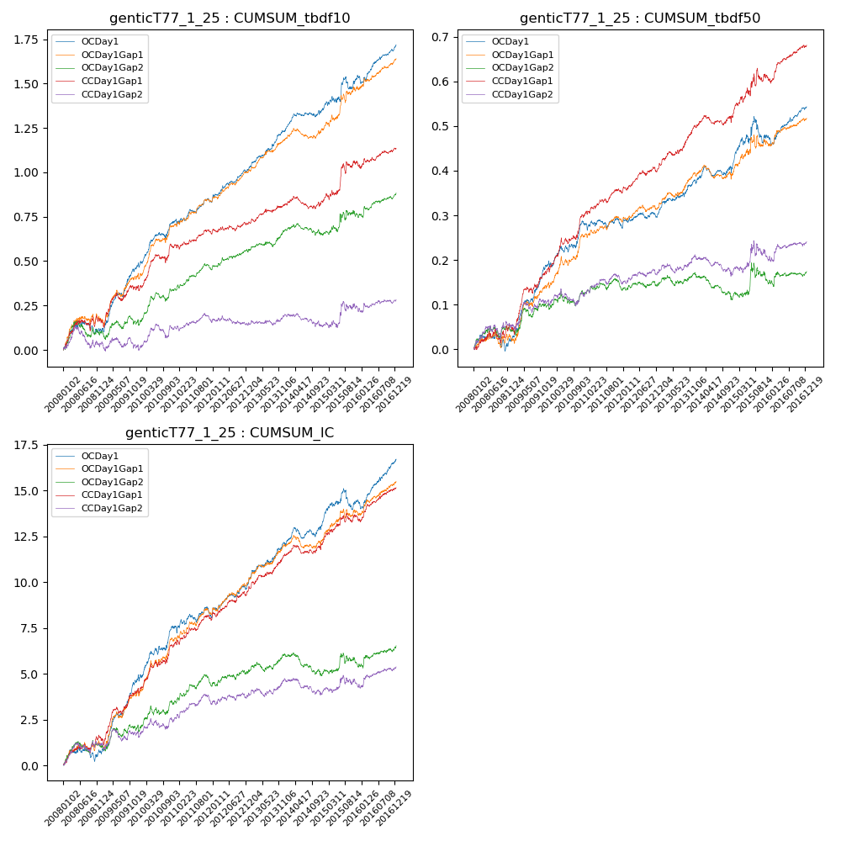

**因子换手率:** 37.16%

**截面指标_OCDay1:**

|  |  |  |  |  |  |  |  |  |
| --- | --- | --- | --- | --- | --- | --- | --- | --- |
| year | annret_tbdf10 | sharpe_tbdf10 | maxdd_tbdf10 | annret_tbdf50 | sharpe_tbdf50 | maxdd_tbdf50 | mean_IC | tstat_IC |
| 2008 | 0.11 | 1.39 | -0.07 | 0.02 | 0.53 | -0.04 | 0.0 | 0.99 |
| 2009 | 0.37 | 4.99 | -0.02 | 0.17 | 5.35 | -0.01 | 0.02 | 5.54 |
| 2010 | 0.25 | 3.79 | -0.04 | 0.09 | 2.77 | -0.01 | 0.01 | 3.65 |
| 2011 | 0.11 | 2.3 | -0.03 | -0.01 | -0.33 | -0.02 | 0.0 | 0.82 |
| 2012 | 0.18 | 4.2 | -0.02 | 0.03 | 1.66 | -0.01 | 0.01 | 3.34 |
| 2013 | 0.23 | 4.23 | -0.01 | 0.07 | 3.18 | -0.01 | 0.01 | 3.86 |
| 2014 | 0.11 | 2.37 | -0.03 | 0.02 | 0.98 | -0.02 | 0.0 | 1.64 |
| 2015 | 0.19 | 2.03 | -0.07 | 0.07 | 1.33 | -0.06 | 0.01 | 1.42 |
| 2016 | 0.18 | 3.69 | -0.04 | 0.07 | 3.25 | -0.02 | 0.01 | 4.39 |

**截面指标_CCDay1Gap1:**

|  |  |  |  |  |  |  |  |  |
| --- | --- | --- | --- | --- | --- | --- | --- | --- |
| year | annret_tbdf10 | sharpe_tbdf10 | maxdd_tbdf10 | annret_tbdf50 | sharpe_tbdf50 | maxdd_tbdf50 | mean_IC | tstat_IC |
| 2008 | 0.17 | 1.94 | -0.06 | 0.05 | 1.44 | -0.03 | 0.01 | 2.29 |
| 2009 | 0.18 | 2.39 | -0.05 | 0.13 | 3.81 | -0.02 | 0.01 | 3.61 |
| 2010 | 0.24 | 3.39 | -0.05 | 0.13 | 3.8 | -0.02 | 0.01 | 3.59 |
| 2011 | 0.06 | 1.39 | -0.03 | 0.05 | 2.4 | -0.01 | 0.01 | 2.55 |
| 2012 | 0.06 | 1.36 | -0.03 | 0.06 | 2.79 | -0.01 | 0.01 | 3.03 |
| 2013 | 0.11 | 2.16 | -0.02 | 0.09 | 3.81 | -0.01 | 0.01 | 3.48 |
| 2014 | 0.02 | 0.36 | -0.07 | 0.02 | 0.85 | -0.02 | 0.0 | 1.1 |
| 2015 | 0.2 | 2.09 | -0.06 | 0.08 | 1.63 | -0.03 | 0.01 | 1.96 |
| 2016 | 0.09 | 1.89 | -0.02 | 0.08 | 3.76 | -0.01 | 0.01 | 3.9 |

**风格暴露:**

|  |  |  |  |  |
| --- | --- | --- | --- | --- |
|  | long | short | corr_OCDay1 | corr_CCDay1Gap1 |
| liquidity10 | 0.08 | -0.08 | -0.18 | -0.17 |
| liquidity20 | 0.06 | -0.06 | -0.16 | -0.16 |
| liquidity5 | 0.1 | -0.1 | -0.19 | -0.18 |
| logmktcap | -0.0 | 0.01 | 0.08 | 0.09 |
| momentum15 | 0.18 | -0.17 | -0.16 | -0.2 |
| momentum30 | 0.17 | -0.17 | -0.15 | -0.14 |
| momentum5 | 0.16 | -0.15 | -0.15 | -0.11 |
| retvolatility30 | 0.04 | -0.03 | -0.12 | -0.12 |