Factors Report 20080102-20161230

**1. genticT77_1_30**

**截面指标累计曲线:**

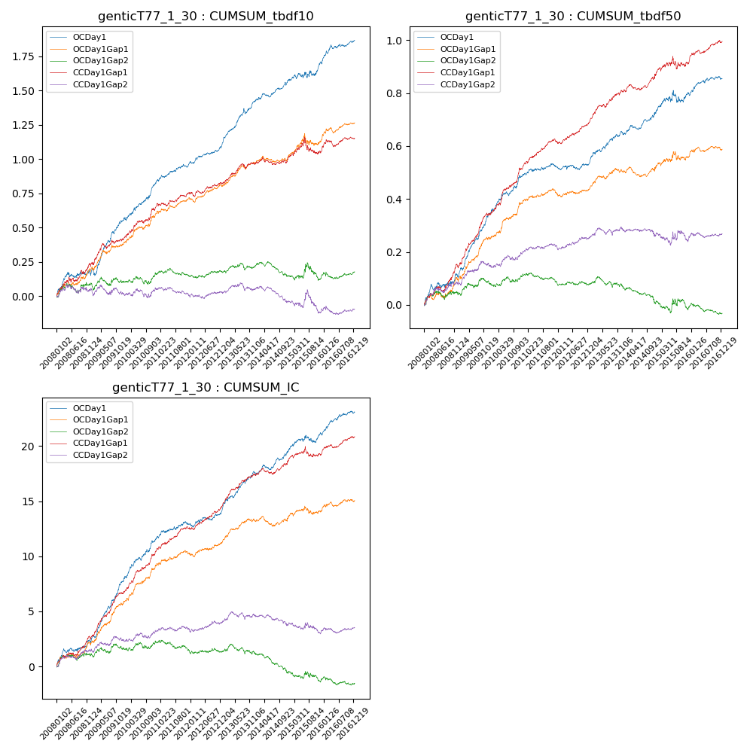

**因子换手率:** 66.41%

**截面指标_OCDay1:**

|  |  |  |  |  |  |  |  |  |
| --- | --- | --- | --- | --- | --- | --- | --- | --- |
| year | annret_tbdf10 | sharpe_tbdf10 | maxdd_tbdf10 | annret_tbdf50 | sharpe_tbdf50 | maxdd_tbdf50 | mean_IC | tstat_IC |
| 2008 | 0.16 | 2.13 | -0.04 | 0.11 | 2.54 | -0.02 | 0.01 | 2.86 |
| 2009 | 0.39 | 5.57 | -0.05 | 0.24 | 6.92 | -0.01 | 0.02 | 7.34 |
| 2010 | 0.28 | 4.26 | -0.03 | 0.15 | 4.17 | -0.02 | 0.02 | 4.81 |
| 2011 | 0.14 | 3.24 | -0.02 | 0.03 | 1.25 | -0.01 | 0.01 | 2.13 |
| 2012 | 0.15 | 3.75 | -0.02 | 0.02 | 1.02 | -0.02 | 0.01 | 2.37 |
| 2013 | 0.31 | 5.52 | -0.04 | 0.11 | 3.77 | -0.01 | 0.01 | 4.87 |
| 2014 | 0.15 | 3.32 | -0.03 | 0.07 | 2.6 | -0.02 | 0.01 | 3.1 |
| 2015 | 0.13 | 1.56 | -0.04 | 0.08 | 1.55 | -0.04 | 0.01 | 2.08 |
| 2016 | 0.16 | 3.24 | -0.03 | 0.06 | 2.26 | -0.01 | 0.01 | 3.48 |

**截面指标_CCDay1Gap1:**

|  |  |  |  |  |  |  |  |  |
| --- | --- | --- | --- | --- | --- | --- | --- | --- |
| year | annret_tbdf10 | sharpe_tbdf10 | maxdd_tbdf10 | annret_tbdf50 | sharpe_tbdf50 | maxdd_tbdf50 | mean_IC | tstat_IC |
| 2008 | 0.23 | 3.0 | -0.04 | 0.15 | 4.09 | -0.02 | 0.01 | 3.93 |
| 2009 | 0.18 | 2.65 | -0.04 | 0.19 | 5.54 | -0.01 | 0.02 | 5.74 |
| 2010 | 0.25 | 3.83 | -0.02 | 0.19 | 5.42 | -0.01 | 0.02 | 5.63 |
| 2011 | 0.1 | 2.19 | -0.02 | 0.09 | 3.97 | -0.01 | 0.01 | 3.71 |
| 2012 | 0.07 | 1.52 | -0.03 | 0.08 | 3.57 | -0.01 | 0.01 | 3.73 |
| 2013 | 0.14 | 2.74 | -0.03 | 0.11 | 4.15 | -0.01 | 0.01 | 4.77 |
| 2014 | 0.05 | 1.13 | -0.05 | 0.06 | 2.29 | -0.02 | 0.01 | 2.35 |
| 2015 | 0.05 | 0.51 | -0.12 | 0.04 | 0.89 | -0.05 | 0.0 | 0.76 |
| 2016 | 0.1 | 1.92 | -0.05 | 0.08 | 3.32 | -0.01 | 0.01 | 3.28 |

**风格暴露:**

|  |  |  |  |  |
| --- | --- | --- | --- | --- |
|  | long | short | corr_OCDay1 | corr_CCDay1Gap1 |
| liquidity10 | 0.1 | -0.09 | -0.24 | -0.22 |
| liquidity20 | 0.06 | -0.06 | -0.2 | -0.19 |
| liquidity5 | 0.14 | -0.13 | -0.27 | -0.22 |
| logmktcap | -0.01 | 0.01 | 0.05 | 0.1 |
| momentum15 | 0.25 | -0.24 | -0.31 | -0.3 |
| momentum30 | 0.3 | -0.29 | -0.28 | -0.26 |
| momentum5 | 0.32 | -0.32 | -0.34 | -0.25 |
| retvolatility30 | 0.06 | -0.06 | -0.16 | -0.14 |