Factors Report 20080102-20161230

**1. genticT77_1_5**

**截面指标累计曲线:**

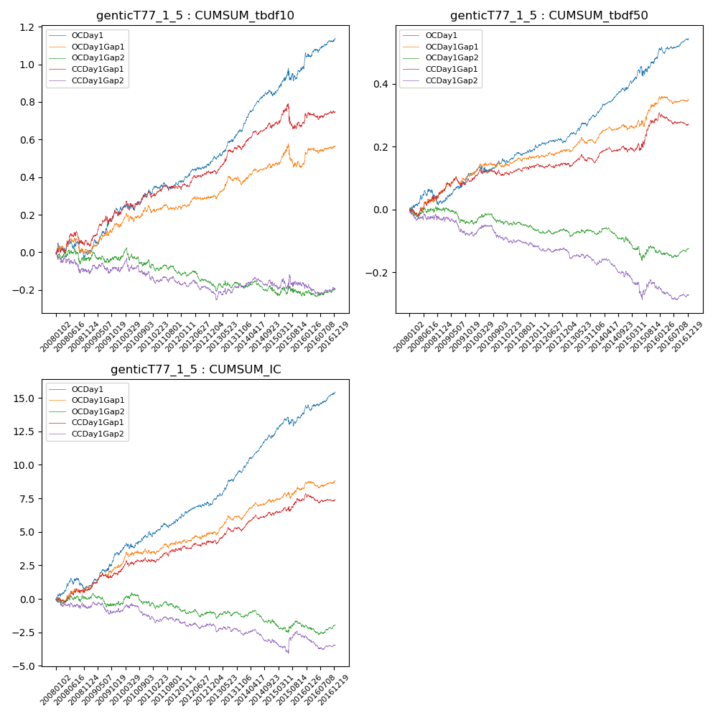

**因子换手率:** 64.06%

**截面指标_OCDay1:**

|  |  |  |  |  |  |  |  |  |
| --- | --- | --- | --- | --- | --- | --- | --- | --- |
| year | annret_tbdf10 | sharpe_tbdf10 | maxdd_tbdf10 | annret_tbdf50 | sharpe_tbdf50 | maxdd_tbdf50 | mean_IC | tstat_IC |
| 2008 | -0.01 | -0.11 | -0.09 | 0.03 | 0.62 | -0.05 | 0.0 | 1.14 |
| 2009 | 0.22 | 3.29 | -0.03 | 0.09 | 2.91 | -0.01 | 0.01 | 3.55 |
| 2010 | 0.12 | 1.87 | -0.04 | 0.05 | 1.47 | -0.02 | 0.01 | 2.2 |
| 2011 | 0.05 | 1.15 | -0.04 | 0.03 | 1.47 | -0.02 | 0.0 | 1.98 |
| 2012 | 0.1 | 2.52 | -0.01 | 0.02 | 1.12 | -0.01 | 0.0 | 1.67 |
| 2013 | 0.17 | 3.67 | -0.02 | 0.08 | 3.73 | -0.01 | 0.01 | 4.65 |
| 2014 | 0.19 | 4.21 | -0.03 | 0.09 | 4.51 | -0.01 | 0.01 | 5.55 |
| 2015 | 0.14 | 1.62 | -0.07 | 0.1 | 2.03 | -0.03 | 0.01 | 2.03 |
| 2016 | 0.16 | 2.88 | -0.02 | 0.06 | 2.55 | -0.02 | 0.01 | 2.87 |

**截面指标_CCDay1Gap1:**

|  |  |  |  |  |  |  |  |  |
| --- | --- | --- | --- | --- | --- | --- | --- | --- |
| year | annret_tbdf10 | sharpe_tbdf10 | maxdd_tbdf10 | annret_tbdf50 | sharpe_tbdf50 | maxdd_tbdf50 | mean_IC | tstat_IC |
| 2008 | 0.04 | 0.51 | -0.07 | 0.05 | 1.33 | -0.02 | 0.0 | 0.95 |
| 2009 | 0.17 | 2.52 | -0.04 | 0.04 | 1.54 | -0.03 | 0.01 | 2.31 |
| 2010 | 0.12 | 1.91 | -0.05 | 0.02 | 0.6 | -0.02 | 0.0 | 1.63 |
| 2011 | 0.02 | 0.55 | -0.03 | 0.03 | 1.43 | -0.01 | 0.0 | 1.66 |
| 2012 | 0.08 | 1.87 | -0.02 | 0.01 | 0.28 | -0.01 | 0.0 | 0.91 |
| 2013 | 0.13 | 2.61 | -0.02 | 0.01 | 0.26 | -0.03 | 0.0 | 1.71 |
| 2014 | 0.13 | 2.88 | -0.03 | 0.04 | 1.87 | -0.02 | 0.01 | 2.8 |
| 2015 | 0.01 | 0.06 | -0.13 | 0.09 | 1.9 | -0.02 | 0.0 | 1.36 |
| 2016 | 0.06 | 1.23 | -0.04 | -0.01 | -0.54 | -0.04 | 0.0 | 0.1 |

**风格暴露:**

|  |  |  |  |  |
| --- | --- | --- | --- | --- |
|  | long | short | corr_OCDay1 | corr_CCDay1Gap1 |
| liquidity10 | -0.02 | 0.02 | 0.03 | -0.01 |
| liquidity20 | -0.01 | 0.01 | 0.03 | -0.01 |
| liquidity5 | -0.03 | 0.03 | 0.04 | 0.01 |
| logmktcap | 0.0 | 0.0 | -0.02 | 0.06 |
| momentum15 | -0.05 | 0.06 | 0.06 | 0.02 |
| momentum30 | -0.04 | 0.04 | 0.05 | 0.02 |
| momentum5 | -0.03 | 0.04 | 0.05 | 0.04 |
| retvolatility30 | -0.01 | 0.01 | -0.0 | -0.01 |