Factors Report 20080102-20161230

**1. genticT77_2_10**

**截面指标累计曲线:**

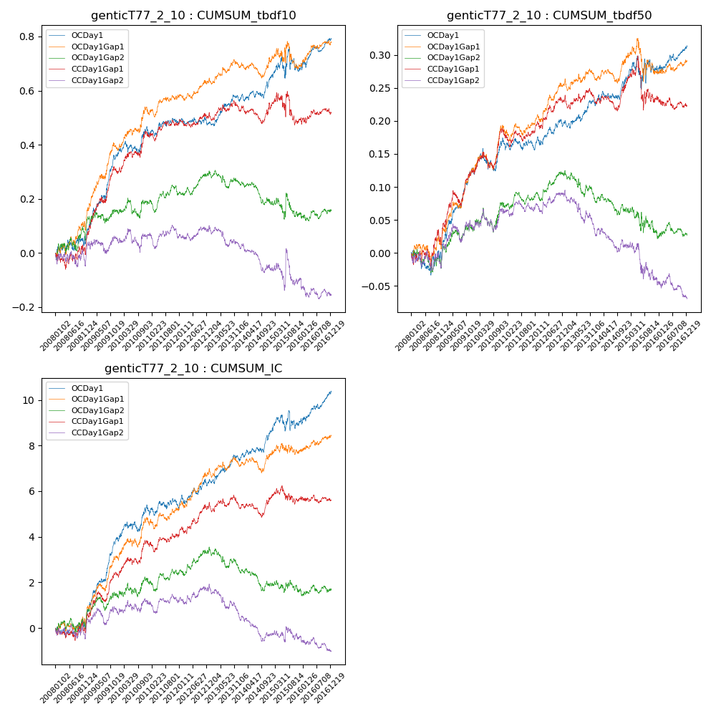

**因子换手率:** 41.04%

**截面指标_OCDay1:**

|  |  |  |  |  |  |  |  |  |
| --- | --- | --- | --- | --- | --- | --- | --- | --- |
| year | annret_tbdf10 | sharpe_tbdf10 | maxdd_tbdf10 | annret_tbdf50 | sharpe_tbdf50 | maxdd_tbdf50 | mean_IC | tstat_IC |
| 2008 | 0.06 | 0.71 | -0.04 | 0.01 | 0.23 | -0.04 | 0.0 | 0.53 |
| 2009 | 0.3 | 4.72 | -0.02 | 0.12 | 4.11 | -0.01 | 0.01 | 5.79 |
| 2010 | 0.1 | 1.49 | -0.05 | 0.04 | 1.47 | -0.03 | 0.01 | 1.86 |
| 2011 | 0.03 | 0.59 | -0.03 | -0.01 | -0.69 | -0.02 | 0.0 | 0.02 |
| 2012 | -0.01 | -0.12 | -0.03 | 0.04 | 1.95 | -0.01 | 0.0 | 1.93 |
| 2013 | 0.09 | 1.92 | -0.02 | 0.03 | 1.51 | -0.01 | 0.0 | 2.02 |
| 2014 | 0.08 | 1.71 | -0.03 | 0.03 | 1.43 | -0.01 | 0.0 | 2.11 |
| 2015 | 0.04 | 0.35 | -0.08 | 0.02 | 0.35 | -0.05 | 0.0 | 0.51 |
| 2016 | 0.11 | 2.35 | -0.02 | 0.03 | 1.68 | -0.01 | 0.01 | 2.59 |

**截面指标_CCDay1Gap1:**

|  |  |  |  |  |  |  |  |  |
| --- | --- | --- | --- | --- | --- | --- | --- | --- |
| year | annret_tbdf10 | sharpe_tbdf10 | maxdd_tbdf10 | annret_tbdf50 | sharpe_tbdf50 | maxdd_tbdf50 | mean_IC | tstat_IC |
| 2008 | 0.04 | 0.52 | -0.06 | 0.03 | 0.79 | -0.03 | 0.0 | 0.35 |
| 2009 | 0.26 | 3.95 | -0.02 | 0.09 | 3.15 | -0.02 | 0.01 | 3.4 |
| 2010 | 0.14 | 2.14 | -0.02 | 0.06 | 2.18 | -0.03 | 0.01 | 2.36 |
| 2011 | 0.04 | 0.88 | -0.03 | -0.0 | -0.06 | -0.03 | 0.0 | 0.55 |
| 2012 | 0.04 | 0.84 | -0.03 | 0.05 | 2.28 | -0.01 | 0.01 | 2.46 |
| 2013 | 0.02 | 0.43 | -0.03 | -0.0 | -0.09 | -0.02 | -0.0 | -0.09 |
| 2014 | 0.0 | 0.07 | -0.06 | 0.02 | 1.06 | -0.02 | 0.0 | 0.7 |
| 2015 | -0.05 | -0.37 | -0.12 | -0.02 | -0.46 | -0.08 | -0.0 | -0.01 |
| 2016 | 0.03 | 0.55 | -0.02 | -0.01 | -0.44 | -0.02 | -0.0 | -0.13 |

**风格暴露:**

|  |  |  |  |  |
| --- | --- | --- | --- | --- |
|  | long | short | corr_OCDay1 | corr_CCDay1Gap1 |
| liquidity10 | -0.01 | 0.0 | -0.0 | 0.02 |
| liquidity20 | -0.01 | 0.0 | -0.0 | 0.02 |
| liquidity5 | -0.0 | -0.0 | -0.01 | 0.05 |
| logmktcap | -0.0 | 0.01 | 0.02 | 0.01 |
| momentum15 | 0.01 | -0.01 | 0.02 | 0.1 |
| momentum30 | -0.0 | 0.0 | -0.01 | 0.09 |
| momentum5 | 0.04 | -0.04 | -0.08 | 0.03 |
| retvolatility30 | -0.01 | 0.01 | 0.03 | 0.05 |