Factors Report 20080102-20161230

**1. genticT77_2_15**

**截面指标累计曲线:**

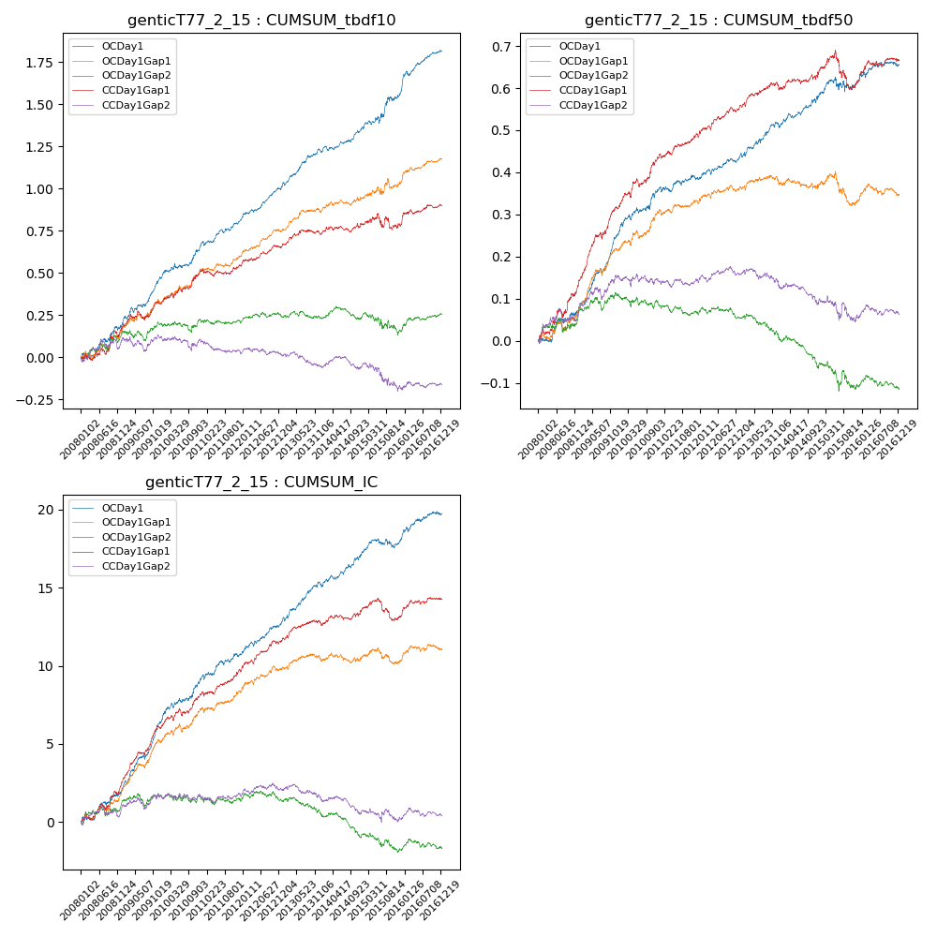

**因子换手率:** 61.6%

**截面指标_OCDay1:**

|  |  |  |  |  |  |  |  |  |
| --- | --- | --- | --- | --- | --- | --- | --- | --- |
| year | annret_tbdf10 | sharpe_tbdf10 | maxdd_tbdf10 | annret_tbdf50 | sharpe_tbdf50 | maxdd_tbdf50 | mean_IC | tstat_IC |
| 2008 | 0.18 | 2.41 | -0.04 | 0.07 | 1.98 | -0.02 | 0.01 | 2.83 |
| 2009 | 0.29 | 4.79 | -0.03 | 0.19 | 6.66 | -0.02 | 0.02 | 7.05 |
| 2010 | 0.21 | 3.4 | -0.03 | 0.1 | 3.06 | -0.01 | 0.01 | 3.88 |
| 2011 | 0.14 | 3.15 | -0.03 | 0.02 | 1.03 | -0.01 | 0.01 | 2.4 |
| 2012 | 0.19 | 4.65 | -0.02 | 0.05 | 2.47 | -0.01 | 0.01 | 3.56 |
| 2013 | 0.21 | 4.39 | -0.02 | 0.08 | 3.2 | -0.01 | 0.01 | 4.05 |
| 2014 | 0.13 | 3.06 | -0.03 | 0.06 | 2.47 | -0.01 | 0.01 | 3.23 |
| 2015 | 0.23 | 2.72 | -0.04 | 0.04 | 0.87 | -0.04 | 0.0 | 1.41 |
| 2016 | 0.24 | 4.73 | -0.03 | 0.04 | 1.51 | -0.01 | 0.01 | 2.71 |

**截面指标_CCDay1Gap1:**

|  |  |  |  |  |  |  |  |  |
| --- | --- | --- | --- | --- | --- | --- | --- | --- |
| year | annret_tbdf10 | sharpe_tbdf10 | maxdd_tbdf10 | annret_tbdf50 | sharpe_tbdf50 | maxdd_tbdf50 | mean_IC | tstat_IC |
| 2008 | 0.16 | 1.79 | -0.04 | 0.14 | 3.31 | -0.02 | 0.01 | 3.19 |
| 2009 | 0.16 | 2.37 | -0.05 | 0.18 | 5.73 | -0.02 | 0.02 | 5.75 |
| 2010 | 0.19 | 3.39 | -0.03 | 0.12 | 3.6 | -0.02 | 0.01 | 3.35 |
| 2011 | 0.04 | 0.89 | -0.04 | 0.06 | 2.43 | -0.01 | 0.01 | 2.82 |
| 2012 | 0.1 | 2.53 | -0.02 | 0.06 | 2.84 | -0.01 | 0.01 | 3.4 |
| 2013 | 0.08 | 1.67 | -0.03 | 0.05 | 2.38 | -0.01 | 0.0 | 2.21 |
| 2014 | 0.06 | 1.22 | -0.04 | 0.03 | 1.25 | -0.01 | 0.0 | 1.6 |
| 2015 | 0.0 | 0.05 | -0.09 | -0.02 | -0.48 | -0.09 | -0.0 | -0.47 |
| 2016 | 0.11 | 2.19 | -0.02 | 0.05 | 2.14 | -0.02 | 0.0 | 2.18 |

**风格暴露:**

|  |  |  |  |  |
| --- | --- | --- | --- | --- |
|  | long | short | corr_OCDay1 | corr_CCDay1Gap1 |
| liquidity10 | 0.06 | -0.06 | -0.13 | -0.12 |
| liquidity20 | 0.02 | -0.02 | -0.08 | -0.08 |
| liquidity5 | 0.1 | -0.1 | -0.17 | -0.12 |
| logmktcap | -0.0 | 0.01 | -0.02 | 0.06 |
| momentum15 | 0.24 | -0.23 | -0.34 | -0.25 |
| momentum30 | 0.13 | -0.13 | -0.27 | -0.17 |
| momentum5 | 0.26 | -0.26 | -0.38 | -0.2 |
| retvolatility30 | 0.02 | -0.02 | -0.07 | -0.06 |