Factors Report 20080102-20161230

**1. genticT77_2_20**

**截面指标累计曲线:**

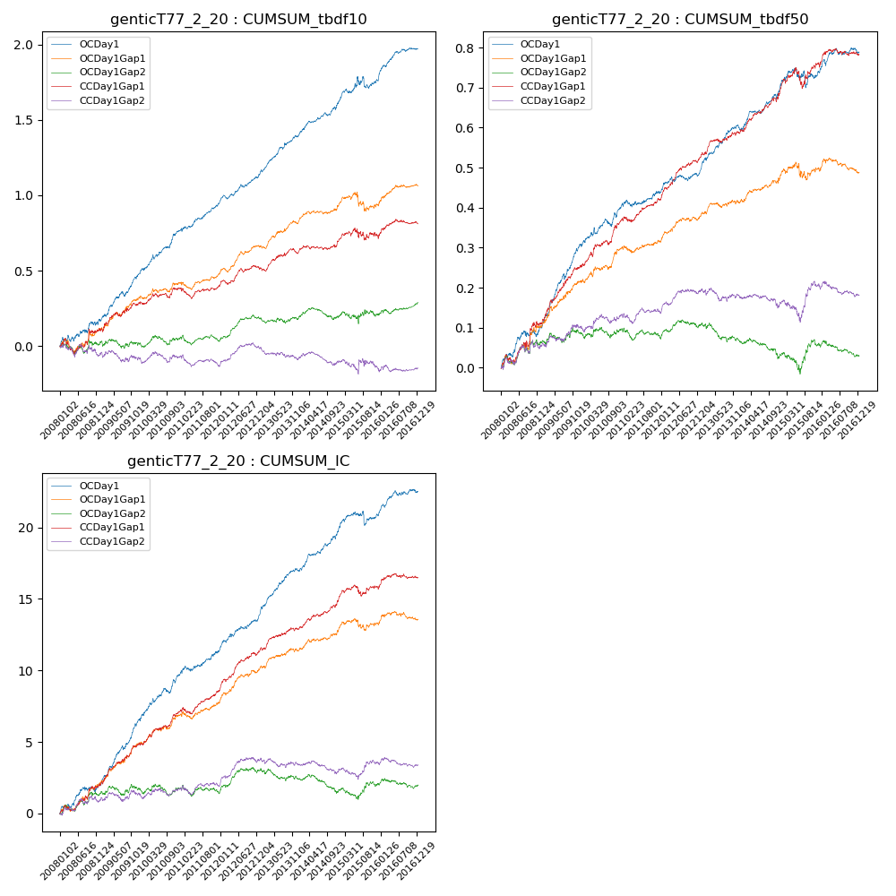

**因子换手率:** 58.71%

**截面指标_OCDay1:**

|  |  |  |  |  |  |  |  |  |
| --- | --- | --- | --- | --- | --- | --- | --- | --- |
| year | annret_tbdf10 | sharpe_tbdf10 | maxdd_tbdf10 | annret_tbdf50 | sharpe_tbdf50 | maxdd_tbdf50 | mean_IC | tstat_IC |
| 2008 | 0.17 | 2.09 | -0.04 | 0.1 | 2.76 | -0.02 | 0.01 | 2.75 |
| 2009 | 0.31 | 5.17 | -0.03 | 0.2 | 6.49 | -0.01 | 0.02 | 6.69 |
| 2010 | 0.29 | 4.57 | -0.03 | 0.09 | 2.93 | -0.02 | 0.01 | 4.36 |
| 2011 | 0.19 | 4.02 | -0.02 | 0.04 | 1.6 | -0.02 | 0.01 | 2.7 |
| 2012 | 0.19 | 4.6 | -0.03 | 0.05 | 2.4 | -0.01 | 0.01 | 4.23 |
| 2013 | 0.26 | 5.18 | -0.01 | 0.11 | 4.47 | -0.01 | 0.01 | 5.86 |
| 2014 | 0.22 | 4.61 | -0.02 | 0.09 | 3.68 | -0.01 | 0.01 | 4.81 |
| 2015 | 0.15 | 1.45 | -0.08 | 0.05 | 1.04 | -0.05 | 0.0 | 1.22 |
| 2016 | 0.21 | 4.51 | -0.02 | 0.05 | 2.1 | -0.02 | 0.01 | 2.95 |

**截面指标_CCDay1Gap1:**

|  |  |  |  |  |  |  |  |  |
| --- | --- | --- | --- | --- | --- | --- | --- | --- |
| year | annret_tbdf10 | sharpe_tbdf10 | maxdd_tbdf10 | annret_tbdf50 | sharpe_tbdf50 | maxdd_tbdf50 | mean_IC | tstat_IC |
| 2008 | 0.11 | 1.11 | -0.1 | 0.11 | 2.25 | -0.02 | 0.01 | 2.56 |
| 2009 | 0.17 | 2.55 | -0.03 | 0.14 | 4.54 | -0.01 | 0.01 | 4.45 |
| 2010 | 0.1 | 1.87 | -0.03 | 0.12 | 3.85 | -0.01 | 0.01 | 4.02 |
| 2011 | 0.02 | 0.36 | -0.07 | 0.05 | 2.43 | -0.01 | 0.01 | 2.69 |
| 2012 | 0.12 | 2.64 | -0.03 | 0.11 | 5.26 | -0.01 | 0.01 | 5.09 |
| 2013 | 0.11 | 1.9 | -0.04 | 0.06 | 2.62 | -0.01 | 0.01 | 3.0 |
| 2014 | 0.07 | 1.61 | -0.03 | 0.1 | 3.88 | -0.01 | 0.01 | 3.92 |
| 2015 | 0.03 | 0.28 | -0.08 | 0.07 | 1.53 | -0.05 | 0.0 | 1.27 |
| 2016 | 0.09 | 1.88 | -0.03 | 0.03 | 1.15 | -0.02 | 0.0 | 1.45 |

**风格暴露:**

|  |  |  |  |  |
| --- | --- | --- | --- | --- |
|  | long | short | corr_OCDay1 | corr_CCDay1Gap1 |
| liquidity10 | 0.09 | -0.08 | -0.16 | -0.13 |
| liquidity20 | 0.05 | -0.04 | -0.12 | -0.09 |
| liquidity5 | 0.12 | -0.12 | -0.21 | -0.16 |
| logmktcap | -0.0 | 0.01 | 0.02 | 0.0 |
| momentum15 | 0.24 | -0.24 | -0.38 | -0.33 |
| momentum30 | 0.18 | -0.18 | -0.33 | -0.24 |
| momentum5 | 0.29 | -0.29 | -0.4 | -0.28 |
| retvolatility30 | 0.02 | -0.02 | -0.06 | -0.02 |