Factors Report 20080102-20161230

**1. genticT77_2_25**

**截面指标累计曲线:**

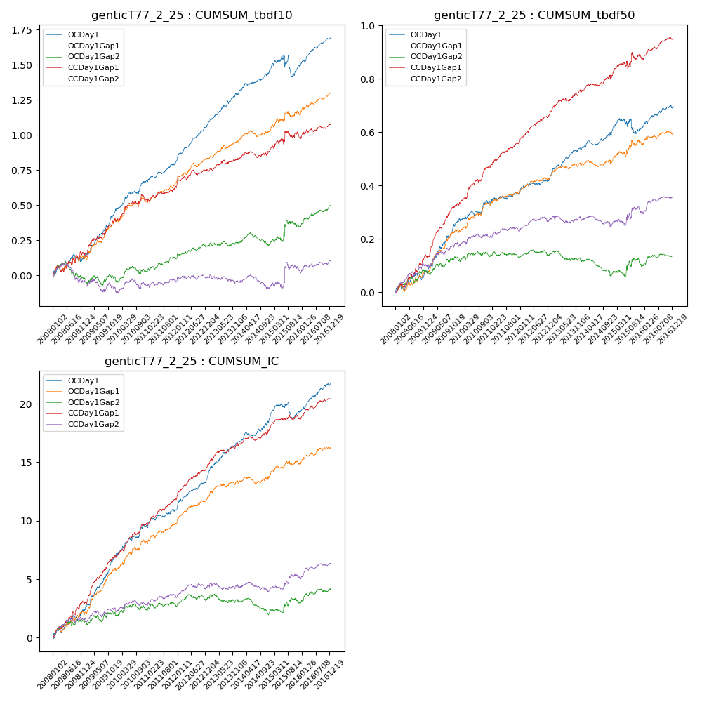

**因子换手率:** 56.98%

**截面指标_OCDay1:**

|  |  |  |  |  |  |  |  |  |
| --- | --- | --- | --- | --- | --- | --- | --- | --- |
| year | annret_tbdf10 | sharpe_tbdf10 | maxdd_tbdf10 | annret_tbdf50 | sharpe_tbdf50 | maxdd_tbdf50 | mean_IC | tstat_IC |
| 2008 | 0.13 | 1.61 | -0.06 | 0.07 | 1.97 | -0.03 | 0.01 | 3.07 |
| 2009 | 0.32 | 4.83 | -0.02 | 0.19 | 5.68 | -0.01 | 0.02 | 6.29 |
| 2010 | 0.22 | 3.39 | -0.03 | 0.07 | 2.08 | -0.02 | 0.01 | 3.36 |
| 2011 | 0.15 | 3.22 | -0.02 | 0.03 | 1.31 | -0.01 | 0.01 | 2.22 |
| 2012 | 0.26 | 6.08 | -0.01 | 0.07 | 2.91 | -0.01 | 0.01 | 4.63 |
| 2013 | 0.22 | 4.45 | -0.02 | 0.11 | 4.16 | -0.01 | 0.01 | 4.9 |
| 2014 | 0.15 | 3.24 | -0.02 | 0.05 | 1.75 | -0.02 | 0.01 | 2.87 |
| 2015 | 0.05 | 0.37 | -0.16 | 0.03 | 0.49 | -0.06 | 0.0 | 0.77 |
| 2016 | 0.2 | 4.7 | -0.01 | 0.08 | 3.4 | -0.01 | 0.01 | 4.44 |

**截面指标_CCDay1Gap1:**

|  |  |  |  |  |  |  |  |  |
| --- | --- | --- | --- | --- | --- | --- | --- | --- |
| year | annret_tbdf10 | sharpe_tbdf10 | maxdd_tbdf10 | annret_tbdf50 | sharpe_tbdf50 | maxdd_tbdf50 | mean_IC | tstat_IC |
| 2008 | 0.16 | 1.82 | -0.05 | 0.13 | 3.32 | -0.02 | 0.01 | 4.12 |
| 2009 | 0.25 | 3.41 | -0.03 | 0.2 | 5.95 | -0.01 | 0.02 | 5.81 |
| 2010 | 0.14 | 2.12 | -0.04 | 0.14 | 4.16 | -0.01 | 0.01 | 4.09 |
| 2011 | 0.09 | 1.95 | -0.03 | 0.09 | 4.05 | -0.01 | 0.01 | 4.02 |
| 2012 | 0.12 | 2.55 | -0.04 | 0.11 | 5.13 | -0.01 | 0.01 | 5.18 |
| 2013 | 0.08 | 1.51 | -0.03 | 0.09 | 3.31 | -0.01 | 0.01 | 3.27 |
| 2014 | 0.05 | 1.01 | -0.04 | 0.05 | 1.68 | -0.01 | 0.0 | 2.06 |
| 2015 | 0.1 | 1.06 | -0.05 | 0.07 | 1.33 | -0.03 | 0.0 | 1.57 |
| 2016 | 0.1 | 2.08 | -0.02 | 0.08 | 3.39 | -0.01 | 0.01 | 3.76 |

**风格暴露:**

|  |  |  |  |  |
| --- | --- | --- | --- | --- |
|  | long | short | corr_OCDay1 | corr_CCDay1Gap1 |
| liquidity10 | 0.1 | -0.09 | -0.16 | -0.16 |
| liquidity20 | 0.06 | -0.06 | -0.12 | -0.13 |
| liquidity5 | 0.14 | -0.13 | -0.19 | -0.16 |
| logmktcap | -0.0 | 0.01 | 0.05 | 0.05 |
| momentum15 | 0.25 | -0.25 | -0.32 | -0.29 |
| momentum30 | 0.22 | -0.22 | -0.28 | -0.23 |
| momentum5 | 0.31 | -0.3 | -0.34 | -0.23 |
| retvolatility30 | 0.03 | -0.02 | -0.09 | -0.08 |