Factors Report 20080102-20161230

**1. genticT77_2_30**

**截面指标累计曲线:**

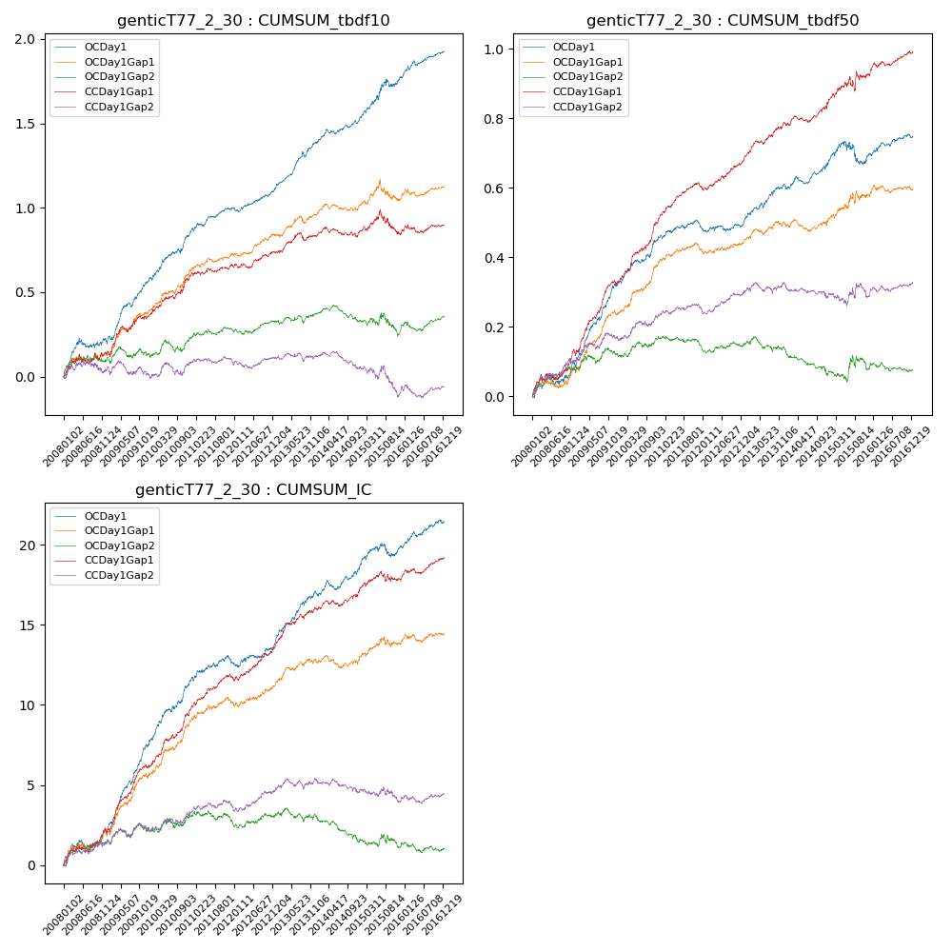

**因子换手率:** 55.54%

**截面指标_OCDay1:**

|  |  |  |  |  |  |  |  |  |
| --- | --- | --- | --- | --- | --- | --- | --- | --- |
| year | annret_tbdf10 | sharpe_tbdf10 | maxdd_tbdf10 | annret_tbdf50 | sharpe_tbdf50 | maxdd_tbdf50 | mean_IC | tstat_IC |
| 2008 | 0.21 | 2.63 | -0.06 | 0.09 | 2.07 | -0.03 | 0.01 | 2.62 |
| 2009 | 0.36 | 5.67 | -0.03 | 0.23 | 6.61 | -0.01 | 0.02 | 7.44 |
| 2010 | 0.29 | 4.39 | -0.03 | 0.14 | 4.16 | -0.01 | 0.02 | 5.16 |
| 2011 | 0.15 | 3.34 | -0.02 | 0.03 | 1.14 | -0.02 | 0.0 | 1.78 |
| 2012 | 0.12 | 2.91 | -0.03 | 0.02 | 0.75 | -0.02 | 0.01 | 2.13 |
| 2013 | 0.28 | 5.19 | -0.03 | 0.11 | 3.62 | -0.02 | 0.01 | 4.82 |
| 2014 | 0.13 | 3.16 | -0.03 | 0.06 | 2.19 | -0.02 | 0.01 | 2.52 |
| 2015 | 0.26 | 2.96 | -0.05 | 0.03 | 0.65 | -0.06 | 0.01 | 1.77 |
| 2016 | 0.15 | 3.46 | -0.03 | 0.05 | 2.15 | -0.01 | 0.01 | 2.87 |

**截面指标_CCDay1Gap1:**

|  |  |  |  |  |  |  |  |  |
| --- | --- | --- | --- | --- | --- | --- | --- | --- |
| year | annret_tbdf10 | sharpe_tbdf10 | maxdd_tbdf10 | annret_tbdf50 | sharpe_tbdf50 | maxdd_tbdf50 | mean_IC | tstat_IC |
| 2008 | 0.14 | 1.78 | -0.06 | 0.13 | 3.34 | -0.02 | 0.01 | 3.21 |
| 2009 | 0.21 | 2.99 | -0.04 | 0.2 | 5.61 | -0.01 | 0.02 | 5.43 |
| 2010 | 0.25 | 3.67 | -0.02 | 0.19 | 5.67 | -0.01 | 0.02 | 5.13 |
| 2011 | 0.06 | 1.24 | -0.02 | 0.09 | 3.88 | -0.01 | 0.01 | 3.57 |
| 2012 | 0.08 | 1.71 | -0.03 | 0.08 | 3.35 | -0.01 | 0.01 | 3.39 |
| 2013 | 0.1 | 1.83 | -0.05 | 0.11 | 3.78 | -0.01 | 0.01 | 4.01 |
| 2014 | 0.02 | 0.51 | -0.06 | 0.06 | 2.23 | -0.02 | 0.0 | 2.06 |
| 2015 | 0.01 | 0.06 | -0.14 | 0.09 | 1.53 | -0.04 | 0.0 | 1.06 |
| 2016 | 0.03 | 0.71 | -0.05 | 0.06 | 2.41 | -0.01 | 0.01 | 2.59 |

**风格暴露:**

|  |  |  |  |  |
| --- | --- | --- | --- | --- |
|  | long | short | corr_OCDay1 | corr_CCDay1Gap1 |
| liquidity10 | 0.11 | -0.1 | -0.25 | -0.23 |
| liquidity20 | 0.07 | -0.07 | -0.2 | -0.2 |
| liquidity5 | 0.15 | -0.14 | -0.28 | -0.23 |
| logmktcap | -0.0 | 0.01 | 0.04 | 0.08 |
| momentum15 | 0.25 | -0.24 | -0.35 | -0.35 |
| momentum30 | 0.29 | -0.28 | -0.32 | -0.29 |
| momentum5 | 0.32 | -0.32 | -0.36 | -0.25 |
| retvolatility30 | 0.07 | -0.06 | -0.14 | -0.15 |