Factors Report 20080102-20161230

**1. genticT77_2_5**

**截面指标累计曲线:**

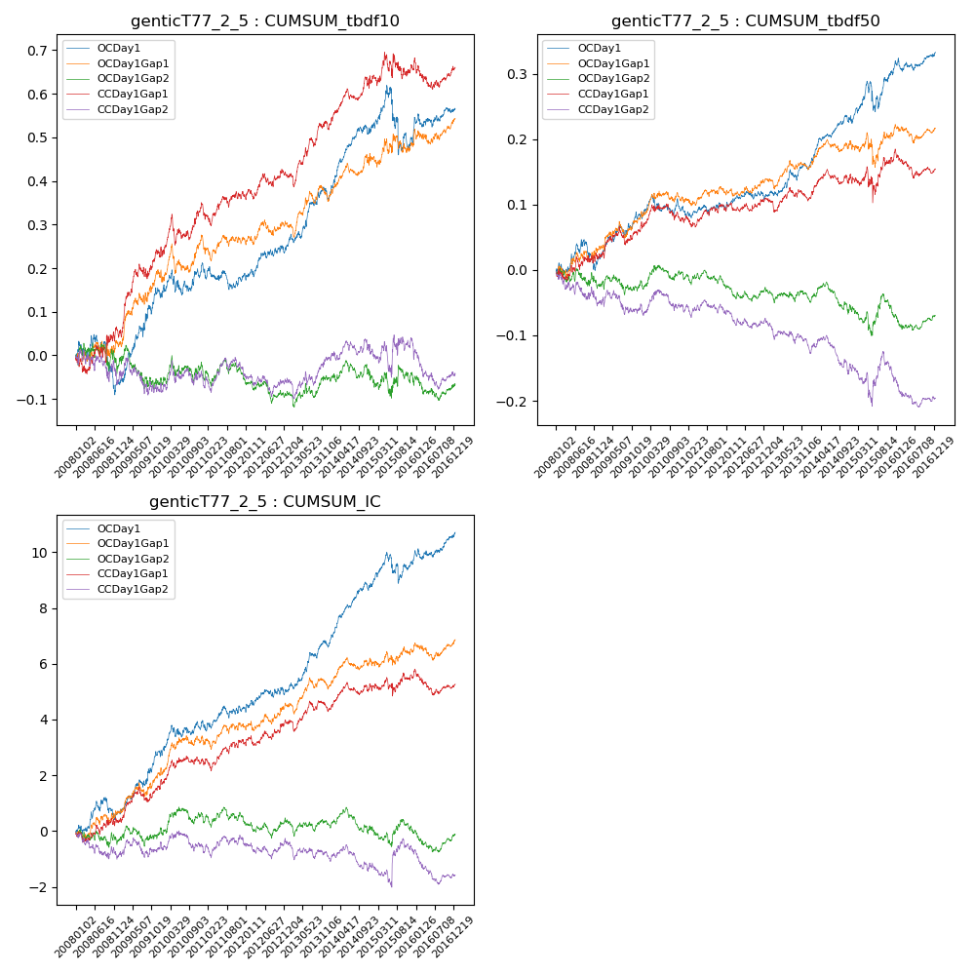

**因子换手率:** 53.34%

**截面指标_OCDay1:**

|  |  |  |  |  |  |  |  |  |
| --- | --- | --- | --- | --- | --- | --- | --- | --- |
| year | annret_tbdf10 | sharpe_tbdf10 | maxdd_tbdf10 | annret_tbdf50 | sharpe_tbdf50 | maxdd_tbdf50 | mean_IC | tstat_IC |
| 2008 | -0.06 | -0.74 | -0.13 | 0.02 | 0.45 | -0.05 | 0.0 | 0.91 |
| 2009 | 0.2 | 2.95 | -0.02 | 0.07 | 2.22 | -0.02 | 0.01 | 3.11 |
| 2010 | 0.07 | 1.1 | -0.06 | 0.01 | 0.41 | -0.03 | 0.0 | 1.64 |
| 2011 | -0.02 | -0.5 | -0.06 | 0.0 | 0.03 | -0.02 | 0.0 | 0.86 |
| 2012 | 0.06 | 1.48 | -0.02 | 0.02 | 0.84 | -0.01 | 0.0 | 1.04 |
| 2013 | 0.11 | 2.36 | -0.03 | 0.04 | 1.94 | -0.02 | 0.01 | 3.02 |
| 2014 | 0.15 | 3.59 | -0.02 | 0.08 | 3.76 | -0.01 | 0.01 | 4.5 |
| 2015 | -0.03 | -0.23 | -0.15 | 0.07 | 1.51 | -0.05 | 0.0 | 0.85 |
| 2016 | 0.08 | 1.55 | -0.03 | 0.03 | 1.54 | -0.02 | 0.0 | 2.13 |

**截面指标_CCDay1Gap1:**

|  |  |  |  |  |  |  |  |  |
| --- | --- | --- | --- | --- | --- | --- | --- | --- |
| year | annret_tbdf10 | sharpe_tbdf10 | maxdd_tbdf10 | annret_tbdf50 | sharpe_tbdf50 | maxdd_tbdf50 | mean_IC | tstat_IC |
| 2008 | 0.04 | 0.48 | -0.04 | 0.02 | 0.52 | -0.02 | 0.0 | 0.48 |
| 2009 | 0.2 | 3.16 | -0.03 | 0.05 | 1.63 | -0.03 | 0.01 | 2.35 |
| 2010 | 0.1 | 1.74 | -0.07 | 0.01 | 0.45 | -0.03 | 0.0 | 1.46 |
| 2011 | 0.02 | 0.44 | -0.05 | 0.02 | 0.69 | -0.02 | 0.0 | 1.12 |
| 2012 | 0.05 | 1.14 | -0.03 | 0.01 | 0.73 | -0.01 | 0.0 | 1.33 |
| 2013 | 0.11 | 2.29 | -0.03 | -0.0 | -0.03 | -0.02 | 0.0 | 0.91 |
| 2014 | 0.11 | 2.27 | -0.03 | 0.03 | 1.44 | -0.02 | 0.0 | 1.79 |
| 2015 | 0.03 | 0.35 | -0.06 | 0.03 | 0.47 | -0.05 | 0.0 | 0.38 |
| 2016 | 0.01 | 0.12 | -0.07 | -0.01 | -0.59 | -0.04 | -0.0 | -0.48 |

**风格暴露:**

|  |  |  |  |  |
| --- | --- | --- | --- | --- |
|  | long | short | corr_OCDay1 | corr_CCDay1Gap1 |
| liquidity10 | -0.02 | 0.01 | 0.01 | -0.02 |
| liquidity20 | -0.01 | 0.01 | 0.02 | -0.01 |
| liquidity5 | -0.03 | 0.02 | 0.01 | 0.04 |
| logmktcap | 0.0 | 0.0 | 0.03 | 0.1 |
| momentum15 | -0.04 | 0.04 | 0.04 | 0.07 |
| momentum30 | -0.03 | 0.03 | 0.03 | 0.07 |
| momentum5 | -0.02 | 0.02 | 0.0 | 0.06 |
| retvolatility30 | -0.01 | 0.01 | -0.01 | -0.02 |